Village Savings and Loan Associations (VS&LAs) in Africa
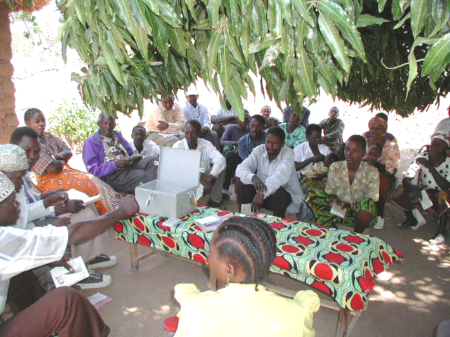

Programme
Guide 1

Version 1.5 – February 18th 2006
For Associations that
use Written Accounts

Written by Hugh Allen

Software developed by Chuck Waterfield
hugh@vsla.net
chuck@vsla.net
All rights reserved.

Table of Contents

Foreword 3
Notes to the User 5
Acknowledgements 6
Table of Acronyms 7

Part 1: Introduction 8
1 Background 9
2 Description of the methodology 13

Part 2: Field Operations Manual 19
1 Schedule of Operations 20
2 Preparatory Phase: Awareness Raising 24
a. Orientation of Community Leaders and Administration Officials 26
b. Introduction of VS&L to the Community 29
c. Preliminary Meeting with Clustered Groups of Potential Participants 32
3 Training Phase: Modules 1-6 37
a. Module 1: Groups, Leadership and Elections 39
b. Module 2: Development of Policies and Regulations Related to the Social Fund, and Savings and Credit activities 46
c. Module 3: Development of Association Constitution 58
d. Module 4: Written Record-Keeping and Managing a Meeting 66
e. Module 5: Meeting Procedures 92
f. Module 6: First Savings, Loan and Repayment Meetings 95
4 Supervision Phase: 97
a. Intensive 99
b. Development 101
c. Maturity 102
d. Module 7: Action Audit (Share-out) and Graduation 103

Part 3: Programme Management 106
1 Operational Administration 107
2 Management Information System 113

Part 4: Annexes 127
Annex 1 Constitution 129
Annex 2 Game Money 130
Annex 3 Impact Evaluation 138
Annex 4 Area Mapping 140
Annex 5 Payout for Member Leaving the Programme in Mid-cycle 142
Annex 6 Efficiency Norms/Benchmarks 143
Annex 7 Drawings of Typical Cash Box 144

Foreword
In the last twenty years, micro-finance has firmly established itself, not only in the lexicon of development practice, but also in the public mind. The Grameen Bank, with its nearly three million clients, is a household name and the handful of programmes that pioneered lending to the poor some twenty years ago has mushroomed into an industry. Increasing sophistication of methodologies and professional practice are the norm. Mainstream financial institutions are beginning to offer micro-finance products, and Micro Finance Institutions (MFIs) are establishing themselves as formal-sector financial intermediaries.
However, in Africa it is becoming clear that while many banks and MFIs provide valuable services to the poor, they are most successful in economically dynamic urban areas, where borrowing requirements are high and the costs of reaching clients is low. Most of the people who live in rural areas and in urban slums (and particularly the very poor) receive no services at all. Thus, there is still a very large gap between the needs of the poor for financial services and the ability of banks and MFIs to provide these services. Moreover, the gap cannot be filled by these types of institutions because, in most cases, they will never be able to cover their costs.
In addition to the gap in service delivery, there is also a gap between the products that MFIs can offer and those that are needed by the poor. MFIs tend to emphasise credit. Most are unable to offer savings services, because they are not licensed to take deposits. The conventional belief is that credit is the most important service that an MFI can offer, because it provides the means by which the poor can invest their way out of poverty. But this view is increasingly being challenged by practitioners, who observe that many poor people prefer to build their assets through savings rather than increase their risk exposure by taking out loans.
Consequently, there need to be alternative models that are able to provide the rural poor – and the urban very poor - with savings services as well as insurance and credit that can be delivered cost-effectively. Such a model must provide a secure place to save and the opportunity to borrow in modest amounts. It must also provide convenient access to these services, be easy to understand and transparent in its operations. It should also be inexpensive to set up and, preferably, locally managed.
In the last 14 years CARE International has developed and extensively tested such a model. Originally applied in Maradi, Niger, in 1991, the Village Savings and Loan (VS&L) methodology has now been replicated in 18 countries in Africa, 2 in Asia and 2 in Latin America. About 865,000 people participate in CARE’s VS&L programmes, and the cost per member averages $20-50: approximately 15% of the cost needed to develop a typical MFI client in Africa. As a result, there is increasing interest in the model among other development agencies. For example, Oxfam USA, CRS in Africa, Plan International, PACT and World Vision are adopting and developing their own versions of the methodology and cooperating with each other on tools and results.
CARE’s experience with VS&L has matured over the years. Starting out with a very basic approach, designed only for impoverished and uneducated rural women, it has now developed new variations for both literate and non-literate people, thoroughly tested in remote rural areas, market towns, peri-urban settlements and urban slums. Using this experience CARE has refined the tools that are needed to implement successful programmes operating at a wide range of scale.
We believe that the VS&L model has the potential to reach much larger numbers of the poor, because it can be implemented in a variety of institutional settings, from multi-sector rural development projects to stand-alone financial services projects. It can also be successfully integrated into the operations of institutions dealing with agriculture, HIV/AIDS and health. Successful implementation does not need highly trained experts, large budgets and long time frames to reach sustainability. Furthermore, Associations formed through this model provide the basic building blocks on which future integration into the formal financial sector through networks and federations may be possible.
This manual explains the methodology, the training and the management systems needed to implement a VS&L programme. We hope that these materials will make this exciting methodology available to a broader audience of governments, donors and practitioners who recognise the limitations of formal and semi-formal financial institutions to meet the financial needs of the poor and are in search of an approach that complements existing provision.

Hugh Allen
Solingen, Germany
Charles Waterfield,
Lancaster County, Pa. USA
February 2006
Notes to the User

The Guides: General
- Programme Guide 1 is for use with literate Associations, while Programme Guide 2 is for use with non-literate Associations.
- The Guides are supplied with an MIS that is specific to each Guide. Thus, Programme Guide 1 is accompanied by an Excel MIS entitled ‘Programme Level MIS 1.01 Literate’
- The MIS is supplied as a blank template, but the Guides come accompanied with an example of an MIS with a typical set of data filled in. This shows a programme with 4 Field Officers, each one of whom has his/her own worksheet. For programmes dealing with literate Associations this Excel file is entitled ‘Programme Level MIS 1.01 Literate Sample’
- The Guides are also supplied with an Excel file entitled ‘Yield Table’ that enables the Field Officer to prepare specific examples of yields on savings for each Association under training. This is shown as a hard copy on page 55: Table 12: Return on Savings Invested in Loan Funds
- Throughout the manual we have used Tanzanian currency, (Shillings or TShs) in all the examples. The rate of exchange to the US dollar at the time of writing is approximately 1,100.
- The MIS system is available as a separate package that accompanies this manual. It runs on Excel. Version 10 or better is advised.
- All examples and records are based on real cases, but names are fictitious.
- The words ‘Association’ and ‘Group’ are almost interchangeable. Where we use the word ‘Association’ we refer to an established Village Savings and Loan Association. Where we use the word ‘Group’ we refer to the pre-training stage of an Association’s development or to other types of community-based organisation.

- Wherever we wish to stress a point in the manual we use the following symbol:

- Wherever we wish to note that implementers and Associations who use the methodology can consider different methodological options, we use the following symbol:

Contacting the Authors
- The manuals are an updated release and, despite the many reviews to which they have been subjected before publication, may contain errors. We will be grateful to users if they can alert us to any that they discover.
- Clarifications can be sought of the authors of any points that are not clear, and a dialogue on the VS&L methodology is welcomed: we are anxious to learn of others’ experience in starting up and running such programmes. For matters that pertain to the methodology and its history and also to the text, please contact Hugh Allen on hugh@vsla.net For clarifications pertaining to the MIS please contact Chuck Waterfield on chuck@vsla.net

Acknowledgements

This Programme Guide is designed to help microfinance practitioners set up Village Savings and Loan Associations (VS&LAs) in the challenging environment of rural Africa and in urban slums and squatter settlements. The Programme Guides (1&2) have been developed over 15 years through collaboration with a number of agencies (principally CARE, CRS and Oxfam) and, in late 2004, it was decided to write a set of manuals for a wider audience that were generic in approach but distilled the experience of programmes in 20 African countries. The authors take responsibility for the content of the manuals but would like to acknowledge those who have contributed to their evolution.
Credit for the original development of the methodology in Niger in 1991 belongs to Moira Eknes, of CARE Norge, whose persistence in the face of considerable scepticism has been vindicated by the extraordinary success of the model throughout Africa.
Her work would not have succeeded as well as it did without the enthusiastic support of Rekki Moussa, who continues working with CARE’s Mata Masu Dubara (MMD) programme to this day and has presided over an expansion throughout the country that has resulted in the creation of more than 6,000 Associations serving 182.000 members.
Brian Larson, at the time CARE Niger’s Assistant Country Director for Programming, developed the first comprehensive training manual for MMD, on which this current version is substantially based. Brian has also been instrumental in spreading the approach to Latin America and we are grateful to him for his review of our work. His comments and suggestions were economical and much to the point.
Further development of the methodology has occurred in Tanzania, where George Mkoma first pioneered a successful shareholding approach in Zanzibar and, later, in Mwanza Region. A similar development has taken place in Kailahun, Sierra Leone, through Oxfam, with the support and encouragement of Ellie Kemp and Jonathan Napier.
Additional input includes:
- CARE Kenya, which funded a review of the progress made by its Group Savings and Lending (GS&L) VS&L programmes in January 2005
- CARE and Oxfam Sierra Leone, who provided the opportunity to complete the second manual in the series in February 2005.
- CRS’ East Africa Regional Technical Adviser Guy Vanmeenen who organised an all-Africa VS&L workshop in early 2005 for which the first version of these manuals were prepared
Our especial thanks go to Alfred Hamadziripi of CARE Zimbabwe’s Kupfuma Ishungu project. He inherited a project in disarray and turned it into one of CARE’s most successful VS&L programmes in Africa, with over 60,000 clients in just 6 years, operating in one of the world’s least hospitable economies for micro finance. Adapting the methodology from Niger, he greatly improved efficiencies and provided the first tangible evidence that MMD could adapt itself across borders, contrasting cultures and extraordinarily different economic environments. The boost he provided gave us the confidence to pursue aggressive growth in many other countries and promote what we have learnt to the wider development community.
Table of Acronyms

AOB Any Other Business
APR Annual Percentage Rate
ASCA Accumulating Savings and Credit Association
BRAC Bangladesh Rural Advancement Committee
CARE Cooperative for Assistance and Relief Everywhere
CRS Catholic Relief Services
CBO Community Based Organisation
DEO District Education Officer
FO Field Officer
GS&L Group Savings and Loan. (CARE Kenya’s VS&L methodology)
MIS Management Information System
MMD Mata Masu Dubara (Hausa for “Women on the Move”)
MFIs Micro Finance Institutions
M&E Monitoring and Evaluation
NABARD National Bank for Agricultural and Rural Development
NGO Non-Governmental Organisation
ROSCA Rotating Savings and Credit Association
TShs Tanzania Shillings
VS&L Village Savings and Loan
VS&LA Village Savings and Loan Association
VSLA Village Savings and Loan Associates

Part 1: Introduction

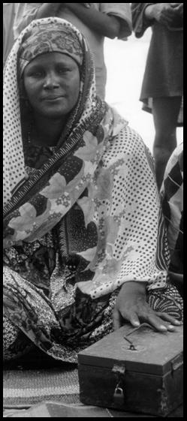

1.1 Background
In 1991, CARE International in Niger launched its first ''Mata Masu Dubara'' (Women on the Move), or MMD, project in the Département of Maradi, on the border with Nigeria. The goal was to help women participants cope with the numerous responsibilities that they faced in a challenging economic and social environment. This was to be done by providing groups of women training in crafts production and other small economic activities to increase household income. In addition, participants contributed individual savings to a loan fund, which, in turn, made small loans to members. Soon this came to be the dominant activity and craft training was dropped. After 14 years the programme has grown to be the largest financial services system in Niger with some 182,000 women organised into more than 6,000 Associations throughout the country. It mobilises and manages more than $3.0 million in savings at any one time and more than 90% of the Associations are independent of CARE and fully sustainable.
MMD promotes local participants’ Savings and Loan Associations that build on the traditional Rotating Savings and Credit Association (ROSCA) methodology. Kenyan Merry-go-rounds and West African Osusus are ROSCAs, as are Mozambican Xitiques and Ethiopian Iqqubs. They enable poor people to save enough money to buy useful items for the household and make opportunistic business investments. But they have their limitations. While they provide a popular and simple means of savings, they tend to be rigid in the way that they work, providing either pre-determined or unpredictable access to accumulated savings and are unable to offer insurance. It is not very common that ROSCAs provide money at the right time and in useful amounts for micro enterprise development.
The approach developed by CARE Niger builds on the ROSCA model and creates Accumulating Savings and Credit Associations (ASCAs), a generic term for community-based savings clubs. CARE calls these Village Savings and Loan Associations (VS&LAs), to indicate their likely scale and the predominant type of participant. Like an ASCA, a VS&LA is a self-selected group of people, (usually unregistered) who pool their money into a fund from which members can borrow. The money is paid back with interest, causing the fund to grow. The regular savings contributions to the Association are deposited with an end date in mind for distribution of all or part of the total funds (including interest earnings) to the individual members, usually on the basis of a formula that links payout to the amount saved. This lump sum distribution provides a large amount of money that members can then use as they want, without restriction.
CARE’s VS&L programmes now reach about 507,000 people 18 countries in Africa. A further 333,000 are in India. More than 70% of the participants are women.
VS&LAs are usually more attractive to participants than ROSCAs, because they offer interest on savings and provide micro-insurance and loans in useful and varying amounts, usually in excess of the borrower’s savings, at times that are convenient to the borrower and for varying lengths of time. In this way the funds are constantly working, earning interest and not just sitting idle in a bank, or being directed towards consumption. The savings, insurance and loan facilities allow the members to meet their small, short-term financial needs for income generating activities, social obligations and emergencies without having to borrow from a money lender, take an expensive supplier advance, or rely on their relatives. This offers a tremendous boost to social security. VS&LAs are not as widespread as ROSCAs because they are more complex to administer and require a system of record-keeping. It is for this reason that organisations such as CARE have an important role to play in facilitating the spread of the methodology.

Should an Association Keep Written Records or Not?
It is necessary for a VS&LA to keep records: to track savings and insurance deposits; to know how much money borrowers owe to the Association and to calculate how much each person is owed when distribution of the Association’s assets is made at the end of an operating cycle. Recognising that VS&LA members may or may not be able to read and write and keep written records, two options exist. One is to use written records, the other not to do so. This manual (Training Manual 1) describes the methodology used for Associations whose members have literacy and numeracy skills and thus are able to keep simple written records. Programme Guide 2 provides guidance for programmes that promote VS&LAs that do not use written accounts.
Both manuals recommend the use of Member Share Passbooks, in order to provide a personal statement of net investment and to provide a double check on the record-keeping system – effectively reducing its necessity and importance. But for Associations whose members cannot keep written records, the Share Passbooks have proven to be a reliable and effective tool for financial management, when used in conjunction with memorisation of ending cash balances.
The trade-off between maintaining written accounts and not doing so is that Associations that keep accounts can, theoretically, offer savings and loan products that are better adapted to the changing needs of their members than those that do not. With an accounting system it is possible to:
- Allow savings contributions that differ between members
- Allow savings contributions that may differ from meeting to meeting for individual members
- Allow loan terms that are of varied length
- Allow variable interest rates for different types of loans
But, having said this, it is also true that members of Associations that do not keep written accounts generally know more about the state of the Association’s financial affairs than those that do, because members tend to pay more attention to what is going on. In Niger, fully 2/3 of the more than 6,000 Associations do not keep written records.
In sum, maintaining written accounts permits greater flexibility and variety of savings and credit services on offer, because members can save according to their capacity and borrow according to their need, for lengths of time that are adapted to their livelihood and business cash flows. But the complexity of doing so is considerable. For Associations that do not have literate members, or very few, it has proven practical to use a simplified system, in which cash balances are memorised and Member Share Passbooks record both savings and individual loan liability. Systems that do not use written accounts have the additional advantage of simplicity and improved transparency. The choice to use one system or another will mainly depend on the capacity of participants and their preferences. But for VS&L programmes it is probably better to promote the memory-based system of accounting, unless there is a proven capacity and emphatic preference to do otherwise.
Shareholding
In the past, both literate and non literate VS&L groups have recorded savings and loan balances in cash, but in the last four years, CARE has started to experiment with savings in the form of shares. The results have been consistently positive and, as a result, shareholding is now a standard part of the methodology. If written records are kept it is not essential to use the shareholding approach and records can be written solely in cash values by the Association Secretary.
The original reason for saving in the form of shares was to allow variable savings rates in groups that traditionally set a fixed contribution per member. By allowing shares to be bought, variable savings could be easily administered, but in set amounts (such as units of TShs 500) that would allow for easy calculation of balances and benefits. It quickly became clear that this was a popular concept and it became standard practice in Tanzania, Kenya and Uganda for Associations to allow their members to buy between 1 and 5 shares at each meeting. This 1:5 ratio was to prevent very large differences emerging in the contribution levels of each member, while still allowing for a range of different savings between members and to accommodate varying income streams at different times of the year.
A major collateral benefit of the share technology was the simplification of the shareout process at the end of the operating cycle. Before the introduction of shares and when savings varied between members, the individual contributions had to be converted to a percentage of the whole and the individual percentages multiplied by the value of the amount to be distributed. It has proven to be much simpler to establish the value of a single share and then distribute on the basis of the number of shares owned by each member.
The use of Member Share Passbooks has also permitted a greater sense of real asset ownership; created a parallel set of verifying asset and liability records to the Association accounts and, most important of all, permitted variable savings and variable length loans in groups that do not keep written accounts. This was previously not possible.
Table 1: Strengths and Limitations of the VS&L Methodology

Strengths of the methodology | Limitations of the methodology
- It is based on savings, which means that members work with their assets and not with loan liabilities (debts). This increases their livelihood security and reduces their exposure to risks.  - Interest earned on loans goes to the Association and not to an external service provider. This increases the amount of investment capital available to the community.  - VS&LAs are immediately profitable (not merely sustainable) and are fully autonomous.  - Financial services (including a limited level of insurance) are offered in the participants’ village/neighbourhood and managed by the participants themselves.  - Transactions are quick, simple and transparent.  - Systems of accounting are secure, clear and simple.  - Using lock-boxes or lockable canvas pouches ensures that transactions are confined to meetings of the entire Association and that money is safe.  - The distribution system allows participants to acquire useful lump sums of capital at a predictable time that can be invested in longer-term activities or meet large, predictable expenses.  - Evaluations carried out in Niger and Zimbabwe show very large increases in:  - household assets, mainly owned by women  - household economic security  - personal self-confidence  - social capital/participation.  - Attractive to women. The average level of participation of women in a programme where both men and women can participate is between 25 - 70%, averaging about 55%  - The most common benefit of the programme is an increase in women’s social capital and accumulation of female-controlled semi-liquid property, such as small livestock and household goods | - The amount of money available for loans is small, especially at the beginning of the operating cycle. It is limited by the participants’ capacity to save: some consider this an advantage because it prevents over-borrowing, especially in the early stages of an Association’s life.  - The short loan period that is normal during the first few cycles limits investment in long-term activities and fixed-asset investment.  - Loan funds are not always available at appropriate times.  - The Associations that choose to distribute all of their savings at the ‘Share-out/Action Audit’ are obliged to start saving again, and, once again, have little capital available for loans for several months.

1.2 Description of the Methodology
This manual is focussed on how to train Associations in the application of the VS&L methodology. Before engaging in training, it is important that Field Officers (FOs) clearly understand the methodology and its central place in programme design and execution. Ideally this can be achieved by visiting VS&LA programmes in other countries, such as Kenya, Tanzania, Zanzibar, Zimbabwe and Niger, where CARE has succeeded in transferring similar versions of the approach, or in India where VS&LAs are known as Self-Help Groups. CARE’s VS&L programmes in Tanzania and Zimbabwe have developed the methodology to a much greater degree of sophistication than in most other places and are best visited if most of the target-group Associations have a high proportion of literate members. CARE Malawi, CARE Mali and CARE Niger are best visited if the methodology will be used for Associations with very low levels of literacy.
General Principles
It is useful for VS&L programme managers to bear in mind first principles of micro finance design. This is best summarised by Stuart Rutherford in his influential book “The Poor and Their Money”. He observes that micro finance clients seek products that:
“…allow savings and loan access as often as needed and in useful amounts matched to need. They also need delivery systems that are local, simple quick and flexible.”
In other words, the best micro finance programmes are those that put the client first instead of keeping it simple for the implementing agency.
While there has often been considerable methodological adaptation as the VS&L model is implemented in new countries, there has been a tendency for each country programme to be standardised, especially in terms of:
- Association size
- savings contributions
- length of loan term
- meeting frequency
This is now changing as the value of flexibility becomes clearer, and this manual stresses the need not to impose a one-size-fits-all template, while adhering strictly to the basic principle of VS&LAs, which is to assist CBOs become autonomous and profitable, using locally mobilised savings as the principle source of insurance and loan funds. While respecting this criterion as inviolable it is important to allow the methodology to be adapted to local traditions, needs and norms, such as the frequency of meetings, savings amounts, lengths of loan terms. It must also accept a wide variety of Association sizes. The outline of the general principles and methodology that follows suggests this flexibility and help is provided throughout the manuals to accommodate it. The general description of the methodology that follows applies equally to programmes that work with Associations that keep written records and those that do not.

The basic principle of the VS&L system is that members of a self-selected group form an Association and save money, which is the source of loan capital from which they can borrow. The purpose of a VS&LA is, principally, to provide savings and simple insurance facilities in a community that does not have access to formal sector financial services, but when the amount of money saved by the membership is sufficient, any of them can borrow from this source and must repay the loan with interest. This allows the fund to grow
VS&LAs are autonomous and self-managing. This is fundamental to their mode of operation and objectives. This cannot be compromised, because a VS&L Association’s goal is institutional and financial independence. This does not mean that the Association cannot borrow from an MFI or other agency, but that any relationship that reduces the Association’s ability to control its own affairs needs to be approached very cautiously.
All transactions are carried out at meetings in front of the Association, to ensure transparency and accountability. This also ensures that all the members are able to witness who has saved and who has not, who has borrowed and who has not and what this means in terms of net worth, at least once a month (more often for Associations that meet more frequently). To ensure that transactions do not take place outside Association meetings, a lockable cash box or heavy-duty lockable canvas pouch is used, to prevent unauthorised cash movement and the risk that records might be tampered with.
The cycle of savings and lending is usually time bound. Members agree to save and to borrow as they wish from the accumulated savings of the Association for a limited period of time. At the end of this period the accumulated savings, interest earnings and earnings from other economic activities undertaken by the Association, are shared out amongst the membership in proportion to the amount that each member has saved throughout the cycle. VS&LAs that adopt this approach are known as time-bound.
All Associations keep records: some keep written accounts; some depend on memorisation.
How the Methodology Works
VS&LAs are made up of as few as 5 and as many as 30 members. The members are self-selected, usually from amongst the adult population. Membership is open both to women and to men, but at least two of the 5 Committee members elected should be female in the case of mixed Associations. Members who hold public office (such as Chiefs, MPs or other administrative officials) should not be eligible for Committee positions, but their advice may be sought. If Associations are larger than 25 members, they are encouraged to divide into smaller sub-Associations.
VS&LAs meet on a regular basis, at intervals that they select. This may be weekly, fortnightly or monthly. In no case, however, does an Association meet less frequently than once every month.
VS&LAs are comprised of a General Assembly and a Management Committee. The General Assembly is the supreme body from which the Management Committee is elected and from which it derives its authority. Each member has only one vote.
The Management Committee of a VS&LA consists of 5 people: a Chairperson, Secretary, Treasurer and two Money Counters.
Committee members are subject to annual re-election at the start of a new cycle. They may be removed at extraordinary meetings.
VS&LAs agree on a set of rules, or a Constitution, to guide their activities. An Association Constitution performs two functions: first to provide a framework for governance, dispute resolution and disciplinary action and secondly to specify how a Social Fund will operate and the terms and conditions of savings and lending. Each member of the General Assembly may be assigned one or more rules to remember, on which they are likely to be questioned at meetings. This has the effect of reinforcing the rules, so that after some months every member is aware of the regulations. After the first operating cycle this memorisation procedure can be reduced in frequency or eliminated, because by that time every member is aware of the rules and it is no longer necessary.
VS&LAs agree on an operating cycle. Before starting to save or to lend, Associations agree on how long they will operate before terminating savings and lending activities and sharing out all or part of the accumulated funds. This is termed ‘the cycle’. The length of this cycle is decided by the Association, but should not be less than 6 months, or longer than a year.
VS&LA members meet regularly and contribute to an Association fund in the form of a fixed minimum sum. The amount is set by the Association, and is such as to allow the poorest members reliably and regularly to pay and enables the member to buy a share in the Association, recorded as a stamp in the member’s Share Passbook. At the start of a new cycle and with the unanimous consent of the members, the value of a share can be increased or decreased. In fact, nearly all members find it hard to meet the minimum share purchase requirement throughout the entire cycle and considerable flexibility in contribution levels, even below the minimum, is common, especially at lean periods of the year..
Suspension of contributions. Making due allowance for the fact that income cannot be reliably predicted, an Association may allow a member not to contribute to the Association’s fund for a limited period.
Anyone needing support from the Social Fund, or a loan, puts forward his or her request publicly to the Association. Approval of a Social Fund benefit, or a loan, rests with the General Assembly and may be immediately disbursed. Loans and benefits are provided for purposes that are agreed to by the Association, as noted in its Constitution/by-laws.
The Associations set loan terms. During the first cycle it is usual that loan terms do not exceed three months and in fact may be shorter, but this may change in subsequent cycles.
The size of a loan available to a member can be linked to the total value of his/her shares. The Association may decide that the amount a member can borrow may be no more than a multiple of the total face value of their shares. This prevents the risk that a member may borrow far more than they have saved, and then abscond or be overwhelmed by too much credit. At the same time, it is important that the maximum amount that a member can borrow is in excess of his or her savings, so as to maximise the percentage of funds in use.
Interest is charged on loans and falls due every four weeks/month. It must be paid at that time, regardless of the length of loan term. The amount of interest charged varies from Association to Association, fixed as they decide. Loans retired early do not continue to attract interest to the originally agreed end-date, but interest must be paid in full for every month or part-month that any part of the loan remains unpaid.
Loan principal repayments are made when due, or earlier as the borrower wishes. The period of loan repayment may vary as the Association decides, but the full amount of the principal sum lent to the member must be reimbursed at this time, or earlier. If the borrower makes late payment beyond the end of the agreed loan period he or she may be fined and must pay any accrued interest, while the principal sum is rolled over to the next reimbursement meeting.
When the operating cycle comes to an end, the Association shares out the total value of its financial assets amongst the members. As the end of the cycle approaches, no new loans are issued and old loans are repaid. When all of the Association’s cash is on hand, the money is shared out amongst the members on the basis of a formula linked to the number of each person’s shares, as a proportion of the whole. At this time the Association may disband and those who do not wish to continue as members may leave and new members may be invited to join. Associations may decide to retain a part of their Loan Fund, so as to be able to maintain a useful level of loan disbursement at the start of the next cycle.
Once a new cycle begins, members can agree to change the minimum value of a share. Thus, for example, an Association may decide to increase the minimum contribution from TShs 500 to TShs 1,000.
Members are free to decide on a suspension of share purchase to accommodate lean periods of the year. It is often the case that under challenging economic circumstances, Associations suspend their share purchase (contributions) by mutual agreement; meaning that the entire Association stops buying shares. This can be because, at certain times of the year, it is hard to raise the weekly contribution, or because there is such a demand for agricultural labour that there is no time to attend meetings. While it is important to ensure financial discipline and regular share purchase, it is a reality that rural incomes are unstable and variable. Thus, a rigid requirement to maintain share purchase cannot be imposed on the Associations, since this may lead to individuals and Associations abandoning the scheme. Regardless of the suspension, loans must continue to be repaid. Thus, meetings will continue (to allow for the repayment and disbursement of loans), but there will be no share purchase.
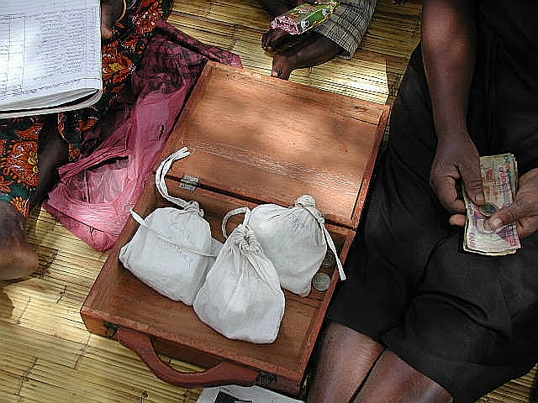
A VS&LA may decide to create a Social Fund (or it may not). If it does so, it must agree on a regular, fixed contribution, with everyone contributing the same amount. The Social Fund can incorporate a number of purposes: emergency assistance, educational costs for orphans, funeral expenses etc. To accommodate this, it is important to understand that the Social Fund is set up to cover expenses that cannot be exactly predicted. It is not the purpose of this fund to grow, but to be set at a level that covers costs. Thus, it must be anticipated that the Social Fund will be depleted and will need replenishment and cannot therefore be included in the end-of-cycle Share-out/Action Audit; must not be mixed with the Loan Funds and must be physically separated from other cash in the cash box/pouch.
The procedures that govern Association meetings are described in section 2.3.d, from Page 87
1.3 A Note to Field Officers

This “Note to Field Officers” is a reminder of the principal attributes that field staff working with VS&LAs must possess.
The Field Officers are facilitators. They ensure the stability of the Association by assisting the participants to organise themselves in a self-directed way. Their major role is helping the participants to understand their interest in mobilising their resources through a Village Savings and Loan Association. Their major objective is to build awareness and confidence so that participants adopt the system, and keep it within their control.

General principles and methods of working
- Create a relaxed atmosphere and deal with the following constraints that the participants may be experiencing:
- Timidity, fear of speaking in public
- Lack of experience in working with a group
- Gender repression
- Distrust of those in power
- Feelings of powerlessness
- Conflicts of interests
- Gain the confidence of the participants, and encourage their active involvement
- Help the participants to understand that, united, they are stronger and more capable of resolving their problems than they are individually
- Train the participants to run the Association and generally to:
- Plan and organise
- Make decisions
- Take responsibility
- Manage procedure
- Administer written records and Member Share Passbooks
- Be creative in helping the participants to resolve their conflicts of interest, or other interpersonal conflicts.
- Above all be confident. The VS&L methodology has proven to be the most successful poverty focused financial services programme to be implemented by CARE International worldwide. There are over 450,000 people using it in 18 countries in Africa alone. It has worked wherever it has been tried, so neither you nor your clients are going to experience failure.

Part 2: Field Operations Manual

2.1 Schedule of Operations

VS&L programmes are implemented in three phases.

- The Preparatory Phase, which covers activities that are necessary before a Field Officer starts to train an Association. It usually lasts between 1 – 3 weeks.
- The Training Phase, which covers the activities that take place when an Association self-selects and receives training from the Field Officer. This lasts between 6 days and six weeks, depending on client preferences.
- The Supervision Phase, which covers the time period during which the Field Officer supervises the operations of an Association. It lasts about 44 weeks and is divided into three parts: intensive (lasting 16 weeks), development, (also lasting 16 weeks), and maturity lasting a further 12 weeks.
These time periods are flexible. Scheduling difficulties may cause any one phase to last longer than planned (particularly the preparatory and training phases) and sometimes it may be necessary to extend a phase because the Field Officer is not satisfied with an Association’s grasp of a topic (or procedures) and decides to repeat part of the training. Associations may also grow very rapidly in confidence and quickly increase the value of their performing assets (loan fund). When this happens they may want to depart from the methodology and Field Officer input may be needed to guide the process of evolution in prudent ways that still allow them to achieve their goals.
As already noted, it is usually necessary to adapt the methodology to local customs and preferences. Some Associations (especially in moderate-density rural and peri-urban areas) prefer to meet weekly. People in high-density urban areas may prefer to meet monthly (because they are forced to be economically active and cannot spare too much time for meetings). People in low-density rural areas may prefer to meet monthly (because it takes a lot of time to walk to meetings). Others prefer to meet fortnightly. Since most projects will be operating within geographical boundaries that tend to be socio-economically homogenous they may prefer to opt for a standard recommended time period between meetings. Whatever the case, programme planners need to be ready to accommodate different frequencies of meeting, but ought not to extend unduly the total time period required for supervision and training. The tables that follow on the next three pages suggest how Field Officers can approach scheduling of visits to Associations that meet weekly, those that meet fortnightly and those that meet monthly.
The majority of VS&LAs in Africa meet and save weekly and borrow monthly. This reduces the length of time spent in meetings (savings/share purchase meetings are short); permits people to save small amounts regularly; allows share purchase contributions to accumulate into a useful amount for borrowing and still permits moderately frequent access to loans. The use of the Social Fund for emergency loans or grants takes care of unexpected and urgent needs.

Table 2: Schematic of Field Officer Meetings and Association Meetings – Associations Meeting Weekly
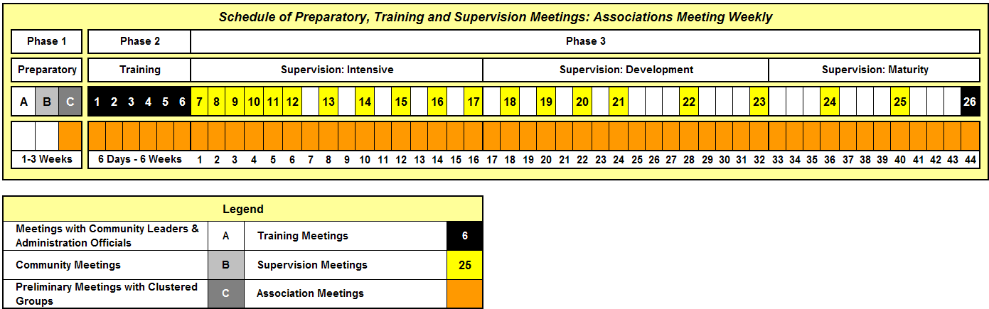

The schematic above has two shaded rows. The lower (brown) row shows on a weekly basis how often Associations meet: in this case every week. The upper row shows that the Field Officer starts off by meeting with Community Leaders and Administration Officials (A). The next meeting is a Community meeting (B) and the third is the first meeting attended by groups that are interested in learning more about the VS&L methodology and, potentially, receiving training (C). The next training block (1-6) occurs over a period that can vary from 6 days to 6 weeks, depending on the convenience of members. It is important to recognise that the schedule of training meetings is not necessarily the same as regular Association meetings. Thus, Associations that meet daily for the training may opt to meet monthly thereafter, once they begin savings and lending.
In the case of Associations that decide to meet weekly, once the training is over, the Field Officer meets the Association thereafter every week for 6 weeks during the Intensive part of the Supervision phase, (7-12) but decreases his/her attendance to once every fortnight for the remainder of the Intensive part of the Supervision phase (13-17). The Development part of the Supervision phase continues for a while with this fortnightly attendance, but decreases the frequency with which the Field Officer meets the Association as he/she becomes confident that they know what they are doing (21-23). The final Maturity part of the Supervision phase requires only three visits (24-26) and is much the same for all Associations, whether meeting weekly, fortnightly or monthly. The total number of Field Officer visits, before the Association is made fully independent, is, then, 26 for an Association that meets weekly.

Table 3: Schematic of Field Officer Meetings and Association Meetings – Associations Meeting Fortnightly
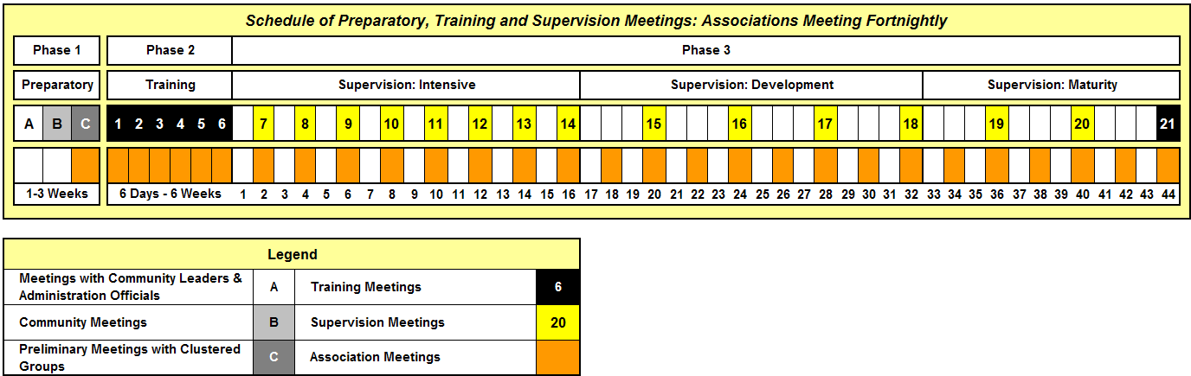

The schematic above shows that the Field Officer pursues exactly the same schedule for the preparatory and maturity periods, but, once again, offers flexibility in terms of the training phase. Thereafter the Field Officer attends all of the next 8 fortnightly meetings, reducing the frequency of attendance during the Development part of the Supervision phase. It is important that the Field Officer attends at least six Association meetings during the Intensive part of the Supervision phase so that any errors of procedure or record keeping are caught. The total number of Field Officer visits, before the Association is made fully independent, is 21 for an Association that meets fortnightly. Wherever possible it is a good idea to suggest fortnightly meetings. This is because a two week cycle still offers frequent opportunities to save and to borrow, but calls for less time on the part of clients and enables the Field Officer to cover more Associations than when he/she has to attend weekly meetings. But the wishes and customs of the Association should be respected and programmes should not impose a schedule that is not compatible with their needs and preference.

Table 4: Schematic of Field Officer Meetings and Association Meetings – Associations Meeting Monthly
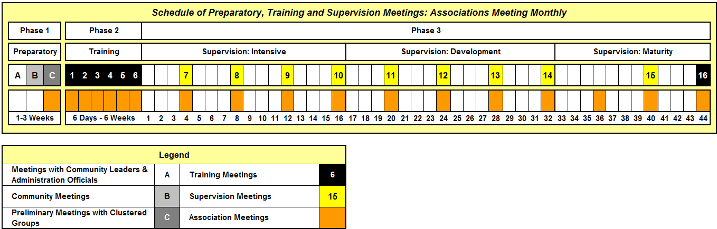
The schematic above shows the schedule of meetings for an Association that meets monthly. This shows that a Field Officer attends every meeting throughout both the Intensive and Development parts of the Supervision phase. This means, again, that 8 consecutive meetings receive the full attention of the Field Officer, so as to ensure that procedure and written record-keeping practice is of a high quality. A total of 16 meetings are attended by the Field Officer for Associations that meet monthly. It is necessary for the Field Officer to attend a higher proportion of meetings for Associations that meet monthly. It is also often the case that the FO may decide to extend the total supervision phase, because the contact is occasional and it is easy for members to forget procedure. In Zimbabwe, for example, supervision goes on for 16-18 months.
These schedules are illustrative and Field Officers can adapt them to what appears to work best, abiding by the principle that as time goes by Field Officer visits are less frequent and the Field Officer’s role becomes steadily less direct. They are typical of CARE’s programmes.
Note: Programme designers may be tempted to promote a monthly meeting schedule because this enables Field Officers to create a large number of groups. In principle this is not a bad thing, but it may result in clients not having the opportunity to save as often as they wish. Clients may prefer to meet weekly because it is simple to save TShs 80 a week, but practically impossible to save TShs 300 a month, when meeting monthly. Where monthly meetings are preferred it may be necessary to explore techniques to save more frequently, such as having weekly savings meetings and monthly credit meetings. Some groups may need help to develop daily savings options. It is more important to be able to save frequently than to borrow frequently.



2.2 Preparatory Phase: Awareness Raising

There are three steps involved in the Preparatory Phase:
- Orientation of Community Leaders and Administration officials
- Meetings with the community
- Preliminary meetings with clustered groups of potential participants

Table 5 on the following page illustrates the sequence of the three stages.

Table 5: Schematic of Preparatory Phase

Orientation of Community Leaders and Administration Officials

Introduction of VS&L to the Community

Preliminary Meeting with Clustered Groups of Potential Participants
Introduction of the Implementing Organisation;
What services the programme offers to communities;
How the methodology works;
The group-based delivery channel and;
How interested groups can contact the Implementing Organisation for further info.

Types of services to be developed and expected impact;
Step-by-step description of how the methodology works;
How the 3-phased training system works;
Individual self-selection
Group obligations and the Implementing Organisation’s obligations
Discussion of training schedule and selection of training site.
Preparatory Phase: Awareness Raising/Recruitment of Groups: Between 1 – 3 weeks
1.To obtain assent and support of Community Leaders and relevant Government officials
2.To understand economic and social issues that may influence the methodology and overall approach

Type of Meeting and who is involved

Overall Purpose of Meeting

Detailed Content of Meeting
To create general awareness in the community of the programme’s purpose, methodology and process
To offer the opportunity to register for training

To explore the usefulness of the proposed services
To ensure a detailed understanding of the methodology and training system
To clarify mutual expectations and obligations
To set up a schedule and venue for training
Introduction of the Implementing Organisation;
Project goals and objectives;
Target group to be served;
Services offered and;
Role of local leaders and administrators

Meetings at District level with Administration and Ministry officials. With traditional authorities at local levels
Likely to involve opinion leaders, who carry information back to communities and publicise the registration opportunity.
Up to 3 groups clustered at a meeting, which may involve between 50 - 100 people. Greater numbers will reduce the opportunity to be clear and to address specific concerns.

Comments
2.2.a First Meeting: Orientation of Community Leaders and Administration Officials
Who is Involved?
Objective: at the end of the session:
- The project is given permission to operate in the area
- The Field Officer becomes familiar with local leaders, Government officials and their representatives
- Leaders and officials understand the Implementing Organisation, what the project is trying to achieve and how it works
- The Field Officer develops a better understanding of the area and where the programme might start to work
- Community Leaders and Administration Officials agree to convene a public meeting to introduce the project to the community
Aproject should seek to inform Government administrators and line ministries at all levels as needed. Usually this will start at the level of Provinces/Regions/ Départements (or their local equivalent), and may not be necessary at higher levels. Relevant officials should then be contacted down to the level of the community. It is not important to set up a large-scale meeting involving all stakeholders, because this can be cumbersome and time-consuming, especially when the Implementing Organisation is already well known in the area. Contacts should preferably be made in a series of small meetings to facilitate understanding and agreement.
In addition to Government personnel whose work is directly relevant to the project, representatives of NGOs working in the area can be contacted. Most important of all will be community/ward level administrators. These are the people who will arrange a public meeting and who can be depended on to know the most important opinion leaders in the targeted community.
What is covered in these meetings?
- Introductions: The Field Officer introduces him/herself, the Field Officer’s project and the Implementing Organisation, where it is not known.
- Project purpose and goals: to build the capacity of community groups to be able to mobilise savings for three purposes:
- To increase household security through accumulation of assets (cash and property) through savings
- To increase household security through access to basic insurance services
- To offer loans to members for productive and emergency purposes
- Relevance of VS&LAs to the population:
- Absence of financial services accessible to the target group, both in terms of local availability and the barriers to making use of savings and loan services created by financial institutions (minimum deposits, bank charges, low interest on savings, complicated procedures, loans hard to come by, asset seizure in case of default)
- High cost, inadequacy and irregular availability of informal (money-lending) services
- The usefulness of having community resources to call on in the case of death, disease or natural disaster
- The importance of savings services in order to build assets
- The value of being able to access useful small loans for:
- meeting emergency needs and
- managing household cash-flow
- investment
- The proven capacity of VS&LAs to build self-respect, self-reliance and self-confidence
- History of the project and of similar projects in Africa. These have shown that this type of service is useful and in high demand. The potential scale of the project and the number of clients targeted should also be mentioned. About 541,000 people participate in VS&LAs in 18 countries in Africa, with a further 333,000 in India and 11,400 in Sri Lanka. The largest programme is in Niger, with 182,000 clients, followed by Benin with 121,000 and Zimbabwe with 62,000. Point out that these countries are very different. Some are Muslim, some are not; some work in places that are virtual deserts (Niger and Mali), while others work in very fertile areas of high population density (Tanzania and Kenya). This shows that the approach will probably work anywhere, including the proposed new site.
- The system of training:
There are 6 basic training modules:
Module 1: Groups, Leadership and Elections
Module 2: Development of Policies and Regulations Related to the Social Fund, and Savings and Credit activities
Module 3: Development of Association Constitution
Module 4: Written Record-Keeping and Managing a Meeting
Module 5: Meeting Procedures
Module 6: First Savings, Loan and Repayment Meetings
- Duration of the training: Training is carried out in six sessions, over a period that lasts as little as 6 days or as long as six weeks, depending on the ability of the Association members reliably to attend.
- Follow-up: This covers the length of time that the project expects to work with Associations and covers the three stages of supervision: Intensive; Development and Maturity. At most it will take a year before the Associations are fully independent.
- The Implementing Organisation’s expectations: What the project needs from Government and Community Leaders:
- Written permission for the project to work in the area
- Mobilisation of the community to attend a public meeting, at which the project’s goals and methodology will be explained and community groups invited to participate
- Identification of potential training venues and facilitating their use
- What Government and Community leaders may expect from the Implementing Organisation:
- Reliability
- Integrity
- Excellence
- Establishment of a sustainable service that enjoys community support and has an important economic impact. Women in particular can expect to benefit.
- What the Implementing Organisation needs from the community:
- Regular attendance and active participation
- Capacity to save regularly and to pay back loans on time
- Respect for the Association’s regulations
- Openness and feedback on the quality and relevance of the Implementing Organisation’s work
- Feedback: After the foregoing presentation the Field Officer asks those present to ask questions to clarify any points that remain unclear
- Public meeting arrangements: The Field Officer ensures that responsibility for arranging a public meeting is assigned and a date set at which the Field Officer can meet with the community. It is necessary only to arrange this at village or trading centre level, because if it is done at a level where thousands attend, it is likely to be overwhelming for the Field Officer and most people will be confused. The Field Officer must use his/her judgement and local knowledge to call for a public meeting where maybe 50-100 people can be expected to attend. The public meeting should bring together potential clients but, more importantly, local leaders and opinion formers (such as church leaders and prominent local business people) who can spread the word to their own communities. The date of this meeting should be agreed at this point, so that the Field Officer can schedule an appearance.
2.2.b Second Meeting: Introduction of VS&L to the Community
What is covered in this meeting?
Objective: at the end of the meeting:
- Members of the community will be aware of the services offered by the project
- The community will understand that the sole source of loan funds will be members’ savings, with no external loans being provided
- The community will understand that the methodology depends on the formation of groups of no less than 5 and no more than 30 members (preferably 10-25)
- The community will understand that training is required and will call for reliable attendance at each of the six sessions
- The community understands what next steps they must take in order to register with the project and participate further
The Field Officer’s first step is to organise a public meeting with the community in order to explain his/her presence in the community and what (s)he is doing. The Field Officer gives them the following information and explanations:
- The name of the organisation and the project, which employs him or her: The point of supplying these details is to avoid confusion with other organisations, especially those offering financial services.
- The nature of the Organisation: i.e. non-religious, non-political, and non-profit. Brief history in the country. List other projects implemented by the Organisation.
- The source of loan funds: All of the funds used to provide loans to the members of an Association come from the members’ own savings and not from an outside agency, MFI or bank. It is important to give this emphasis, because many people who attend are likely to want to receive loans. Many people will react negatively to this piece of information, but the FO can tell stories of the success of VS&L in other countries that are similar, or in the region.
- The aim and the spirit of VS&L: VS&L is a project for participants. It assists in the creation and training of Village Savings and Loan Associations using the participants’ own resources, with the objective of supporting income-generating activities. The Field Officer’s help will cease when the participants take charge of the Association themselves. The goal is independence and viability of the Association, through self-management, in about a year. The Field Officer emphasises that it is more desirable for existing groups/CBOs to undertake Social Fund, savings and loan activities than for new groups to be formed for the purpose. If no such groups exist, then new ones can be formed, but great care must be taken in the selection of members, who know and trust each other and whose reputation in the community for honesty and reliability is well established. It is not necessary that members of an Association are rich and prominent: indeed, it is preferable for groups to be composed of members who are of a fairly similar economic status.
- The operating principles: An Association is concerned with savings and lending. The savings consist of regular cash deposits contributed by all members at each meeting. These saving deposits (in the form of shares) constitute the fund from which very short-term loans with interest can be given to members. Associations also contribute to a Social Fund to help cope with unexpected emergencies. No outside funding will be provided. The size of the Association must be not less than 5 members and not more than 29, but preferably between 10 and 25. Existing groups are encouraged to participate; amalgamating or dividing where necessary to achieve the necessary scale. The attendees should be told that the most important aspect of the programme relates to the savings activities and that they can expect that they will get a better return on their money saved in this way than in any bank. It has been shown in other programmes that if a person saves for a year, they will get back at least 30% more than they save, and usually much more. They should also be told that loans starts off with very small amounts but grow according to the rate at which the loan fund grows.
- Where meetings are held: The members of the proposed Association choose where the meetings are to be held. The location can be the compound of a local mosque or church, a local school or other public building, the home of the Chairperson of the Association, or elsewhere. The important thing is that the location is big enough for all the members to be seated comfortably and that it is quiet, not too breezy and with enough space. It is the custom for mats to be laid on the ground and for refreshments to be provided, even if only fresh water.
- Participation in meetings: The members’ participation in meetings is of the utmost importance for the success of the Association. To participate means to attend the training meetings and all the other regular operational meetings and to be active in speaking out. The attendance of all members guarantees the correctness of the accounts. Likewise, meetings should not be interrupted by outsiders except under urgent circumstances.
- Training: The Field Officer explains that for the methodology to work, the Associations must be trained. They need to elect leaders and develop a Constitution and rules that relate to their savings and loan activities. In addition, they need to keep records, which can either be written, or based on a memorisation method that reliably allows members to save and to borrow without the use of written records. The training is divided into six separate sessions and each training session lasts for between 1 ½ to 2 ½ hours. The meetings can take place on consecutive days or can be organised twice a week or on a weekly basis. In each meeting one major topic will be covered, but some topics may need more than one meeting.
- Contact with the Field Officer: The Field Officer tells the assembly that (s)he will return to the community at an agreed time to determine if people are interested in participation. The purpose of this second meeting is to explain the methodology in detail and to outline the course of training that a group must undertake to become a fully fledged Association. The result will be a decision as to whether or not the groups that decide to attend this second meeting will participate and undergo the training. If they do so they must decide on a convenient schedule of meetings for the training and obligate everyone in the group to attend.
- Group responsibility prior to joining the project: Anyone who wants to join the project should, before the next meeting, participate in forming Associations of a suitable size. The Field Officer stresses the importance of members being selected on the basis of knowing and trusting each other, so as to avoid conflicts getting out of hand, because dealing with other people’s money is a very sensitive issue. The Field Officer will be ready to hold meetings when there is evidence that the Associations are formed and ready to participate. The Associations should not have elected a Chairperson or other officers at this point, unless it is a pre-existing one. The Field Officer makes it clear that leaders of VS&L Associations have to have specific skills and characteristics, and that leaders of groups that are doing other activities (such as agriculture) may not be best qualified to lead a VS&LA. It may, then, be the case that the Associations will choose a different leadership committee for VS&L activities and may not include all of the current membership (because some may not want to participate).
2.2.c Third Meeting: Preliminary Meetings with Clustered Groups of Potential Participants
Who is involved?
Objective: by the end of the meeting:
- The participants will have a detailed understanding of the methodology
- The participants will understand the usefulness of the proposed services
- The participants will have decided if they want to proceed with training
- If the participants want to proceed with training they will have arranged a schedule of meetings and a place to meet.
- The participants will decide if they wish to be trained to use written or memory-based records
The preliminary meeting is likely to involve more than one potential Association. At this time the groups have made no decision as to whether or not they will participate in the programme and the purpose of the meeting is not to undertake training. As such, it is practical to conduct a meeting with as many as 50 participants (2-3 groups). If the number of people attending is any larger it becomes unmanageable and does not provide the opportunity for everyone’s questions to be answered.
What is covered in this meeting?
The Field Officer starts by emphasising that the Association’s main activity is savings (in the form of shares) and lending from the money thus saved. (S)he explains the difference between the traditional ROSCA system and VS&L. Members’ share (savings) deposits create a pool of capital; it is this fund that then allows the disbursement of short-term loans, which are paid back with interest. This allows the fund to grow and allows for loans to be provided when they are needed, matched to the borrower’s needs. ROSCAs, by contrast, do not require the money given to an individual member to be reimbursed, so the fund can only benefit one person at a time and the amount of money mobilised is always the same, regardless of the recipient’s needs. The most important difference is that the VS&LA fund grows to a very large amount and is shared out amongst the members once every year, so every member benefits from a full year’s savings and the interest from borrowing. The Field Officer can quote examples of how people have benefited from the Shareout/Action Audit. Another important difference is that VS&L Associations offer insurance against unexpected emergencies, while ROSCAs usually do not.
The Field Officer provides detailed information on:
- The creation of an Association: The VS&L system requires the creation of a Village Savings and Loan Association of between 5 to 25 participants; probably people with similar interests and backgrounds. More than one Association can be created in a community if the need exists and pre-existing groups that are larger than this number can sub-divide for the purposes of savings and loan activities. To be successful, the Association will need a Management Committee of five members as well as Constitution, which they will develop for themselves with the Field Officer’s assistance.
- The characteristics of an Association: The Field Officer lays stress on the need for all of the members to have:
- Confidence in each other
- A knowledge of the character of all of the members
- A reputation for honesty
- A cooperative personality
- The ability to save regularly
- The ability to repay and treat loans seriously
The Field Officer stresses that the purpose of the meeting is to publicise the programme and make people aware that if they want to participate they need to be trained as a unified group, composed of people who are from the same sort of background, who are keen to save their money and learn how to manage the new Association’s affairs in a transparent and expert fashion. The Field Officer emphasises that before starting the training the members should therefore sort themselves out into groups of like-minded individuals who trust each other and who are sure that they can cooperate.
Since a group will form an Association that will be engaging in savings and loan activities, members of a pre-existing group need to understand that unless the group is already providing these services, the membership may not be composed of people all of whom meet these criteria, or who are necessarily interested in savings and lending as a group activity. In such a case the members should not feel that they are all obliged to participate in the VS&L programme.
3 The principles of the VS&L system:
  - VS&L works through groups of between 5 and 25 members called a Village Savings and Loan Association (VS&LA). Associations meet at regular intervals (weekly, fortnightly or monthly as convenient).
  - Members of a VS&LA pool their savings (in the form of shares) and individuals can borrow from these funds, at interest, initially for a minimum of four weeks and a maximum of 12 weeks (3 months). The amount of interest is decided by the Association itself. In subsequent cycles, loan terms may be longer (although not more than 12 months), but this will depend on the Association’s experience and decision.
Note: It is important to emphasise the difference between interest paid to a commercial lender and interest paid to the Association, especially to Muslim participants. Do not try to pretend that it is not interest, but explain that interest on loans helps the savings fund to grow and that it ends up back in the participants’ pockets, because they are sharing out their funds at the end of the cycle. Thus, by paying interest members are, in fact, increasing the amount that they save.
  - Savings and loan activities are carried out for a given period of time (called a “cycle”) after which the Association divides its assets (cash and goods) amongst the members. Members are free to leave the Association at that time and new members may be allowed to join. A new Management Committee is elected and a new cycle begins. A cycle is normally for a period that lasts between 8 months to a year but should not be less than 6 months.
  - All transactions are carried out in front of the General Assembly (the entire membership), and a lockable cash-box system is used. Such cash boxes are fitted with three locks and the keys given to Key Holders, to guarantee security and to prevent the holder of the box (the Treasurer) being able to open it up in the privacy of his/her home. Where security considerations give rise to fears that a cash box may attract violence or theft, a lockable canvas pouch can be used. The importance of the lockable cash box/pouch is not so much to guarantee security of the cash from thieves as to prevent unauthorised transactions taking place between meetings and to prevent the Treasurer from being tempted to make private use of the money.
  - All members are savers, buying shares at each meeting. The Association decides on a savings amount required of all members at every meeting. It must be set at a level that everyone in the Association is sure they can pay throughout the operating cycle.
  - There is a payout after each cycle in which the Association’s money is equally divided up amongst members, based on the total number of shares bought throughout the cycle. The money paid out is comprised of share contributions, interest earnings, fines and any profits from commercial activities the Association may have undertaken. Thus, the amount paid out to members will be more than the total cost of the shares they have bought.
  - Participation is open to all people in the community, without discrimination, but according to criteria that the Association itself may decide, such as gender, age, residence, common bond etc.
  - It is recommended that where the Association is composed of both men and women, at least two members of the Management Committee should be female.
  - Associations may be mixed or single sex, as the participants prefer.
  - The members are equal in voting power, regardless of saving amounts, and can elect or dismiss their own leaders and officers.
- The role of the Field Officer: The Field Officer’s role is that of facilitator. (S)he makes no decisions for the Association and does not handle the Association’s cash. Rather, the members assume complete responsibility for Association operations and management of the cash box/pouch. Initially the Field Officer will play an active role in assisting the Association in savings and loan operations, but will steadily take a less and less active role, becoming more of a technical resource to be called on from time to time when the Association encounters difficulties. His/her principal duty is to get the Association to take charge of its savings and loan activities as quickly as possible. (S)he is also responsible for facilitating access to other resources relevant to the Association’s principal concerns (i.e. primary health care, agricultural extension, information on HIV/AIDS etc.).
The duration of the Field Officer’s intervention is limited to a maximum of 1 year, and is divided into two stages:
- The first stage involves training. (S)he will visit a total of six times at intervals and times of the day that are convenient to the Association. This will be for a period that is as short as 6 days, with one training meeting every day, lasting up to 2 ½ hours, or as long as six weeks, with one meeting every week. Twice weekly meetings may also be considered. The Association will decide what is convenient for them, but the Field Officer will stress that the training should not take any longer than 6 weeks because this may lead to discouragement. Each meeting will involve covering a major training topic. The training covers the organisation and functioning of a Village Savings and Loan Association, as well as showing members how to manage their savings resources. The Field Officer cannot receive any financial or material benefit from the Association.
- The second stage involves follow-up and is known as the Supervision Phase. It is divided into three phases: Intensive, Development and Maturity.
- Intensive follow-up: During the training period the Association will decide if it wants to meet weekly, fortnightly or monthly and the Field Officer will attend all Association meetings for a further 16 weeks (16 meetings for Associations that meet weekly, 8 for those that meet fortnightly and 4 for those that meet monthly). The Field Officer will play an active role during this time in helping the Association to follow proper procedures and keep accurate records (either written or based on memorisation).
- Development follow-up: During this time the participants will run the Association themselves for at least another 16 weeks. The Field Officer will visit the Association less frequently (about 2/3 of the meetings). The purpose of this phase is to oversee the smooth operation of the Association, with the Field Officer acting solely as a technical resource in case of problems or disputes.
- Maturity follow-up: The last follow-up period, lasts 12 weeks. The Field Officer visits the Association two or three times during this period. The second of these visits after 8 weeks of the twelve-week period is to evaluate whether the Association is ready to function independently. If the Association’s performance is judged to be satisfactory it is officially recognised to be independent from the project and the final meeting at the end of the twelve weeks is comprised of an official “handover” at which the Association is formally recognised to be independent and capable of managing its own affairs without further support. It is usual for the first Share-out/Action Audit of the accumulated savings, interest and fines to take place at this meeting and for some form of celebration to be held.
5 The Members’ Commitments
The success of the Association depends upon active participation by the members. Active participation means attending all the training meetings as well as all regular meetings. The members’ presence guarantees the correctness of the accounts.
The Association needs certain equipment:
- Lockable cash box or heavy duty lockable canvas pouch
- Three good quality padlocks, each with two keys
- Record-keeping Journal
- Member Share Passbooks (1 for each member)
- Rubber stamp
- Ink-pad
- Ruler
- Two ball point pens
- Two pencils
- Eraser
- Calculator
- 4 plastic bowls, at least 30 cm in diameter and at least 15 cm deep (used for separating out the collection of savings contributions, loan repayments, fines and contributions to a Social Fund)
The project provides a ‘kit’ of this equipment to the Association, for which it must pay. If the Association does not intend to keep written records the Journal and writing materials are excluded.
The Association is responsible for selecting an area where the members can meet - a place that is quiet and provides shade. It is common for members to provide mats and water for refreshment. It is also useful to use a table so that if the Association keeps written records, record keeping is easy and so that the Management Committee can face the membership, lending a certain formality to the proceedings.
At the end of the preliminary meeting the participants decide if they are interested in creating an Association. If they agree to do so, the Field Officer makes a list of the participants and plans with them the day and the place of their first training meeting.
The participants must then agree with the Field Officer, which of the two training systems (literate or non-literate) they wish to follow:
- Training for Associations that want to keep written accounts
- Training for Associations that do not want to keep written accounts. The Field Officer makes it clear that while it is not necessary for people to be able to read and write to manage a Village Savings and Loan Association, at least four of them must be able to count money (Note: while people may not be able to read and write it is very unusual for them not to be able to count and many will be able to write figures).

N
ote. From this point onwards, it is assumed that the group has decided to use written records. If the group wants to use a Member Share Passbook and memory-based record-keeping system, refer to Programme Guide 2

2.3 Training Phase: Modules 1-6

There are seven training sessions conducted during the Training Phase:
- Groups, Leadership and Elections
- Development of Savings, Credit and Social Fund Policies and Procedures
- Constitution Development
- Written Record-Keeping and Managing a Meeting
- Meeting Procedures
- First Savings and Loan Meeting(s)
- Graduation and First Share-out (Action Audit)

Table 6 on the following page illustrates the sequence of the seven training sessions. Only the first 6 are covered in the initial training

Table 6: Schematic of Training Phase

Separate training of Committee and, where necessary, their understudies

Individual Self-Selection
Role of General Assembly
Roles of Leaders
Preparation for Elections

Elections. These may be held as part of Module 1, or, at the Association’s discretion, separately, without the Field Officer’s supervision.

Social Fund: policies/rules
Savings: policies/rules
Credit: policies/rules
Reimbursement policies/rules
Action Audit (Share-out policies/rules)

Association governance
Social Fund policies
Savings, credit policies
Module 4. Written Record-Keeping

Mock meeting with demonstration of procedures for:
Social Fund
Savings,
Credit,
Written Record keeping

Supervision of Social Fund, Savings and Credit procedures (This meeting may involve only savings, when savings meetings are more frequent than credit meetings. In this case the module is divided into two, with credit training deferred to the first meeting at which savings and loan activities coincide).
Training Phase: Between 6 days to 6 weeks
Takes place at the end of the cycle, or at points where there is a large excess of unused loan funds available for distribution.

Comments
All training meetings carried out with single Associations: no clustering. The Association needs the Field Officer’s full attention.
Modules 1-6 may be spread over a period not less than 6 days and not more than 6 weeks.
Some modules may take more time and need two meetings, especially Modules 3 and 4.
Module 1.
Groups, Leadership & Elections

Module 2.
Development of Policies and Regulations

Module 3.
Development of Association Constitution

Module 5.
Meeting Procedures

Module 6.
First Savings, Loan and Repayment Meetings

Module 7.
Action Audit and Graduation
2.3.a Module 1: Groups, Leadership and Elections
General
Objective: at the end of the training session:
- The Association will verify the readiness and suitability of its members to participate in a community-based savings and loan activity
- The Association will agree to form itself into a Village Savings and Loan Association
- The Association will understand the role and authority of the General Assembly
- The Association will understand the roles of its leaders and be prepared to carry out elections
The Field Officer will prepare him/herself for working with Associations that want to keep written records.
At the beginning of the meeting the Field Officer ensures that everyone is in attendance. If anyone comes late, (s)he will tell them that at the next meeting anyone who comes late will be fined and asks the Association to suggest what that fine should be. The Field Officer shows the members the fines bowl (which is part of the Association equipment kit) and explains that at the next meeting it will be placed at the entrance to the meeting place and anyone coming late will be required to pay the fine on the spot. (S)he explains that the Association will later develop its own set of rules and will consider other infractions for which fines will be levied.
The Field Officer will ensure that everyone is seated comfortably and will discuss how the meeting place should be arranged. Typically an Association will be asked to provide seating mats or chairs, water and glasses for refreshment and, if possible, a low table on which savings and loan transactions can take place: this introduces a sense of formality, order and importance into the proceedings. The Association will agree at this point who will be responsible for making sure these facilities are available at the next meeting.
The Field Officer explains that the training programme has seven components, six of which will be carried out during the present training period and one left to the end of the operating cycle. (S)he will write them down as follows, on a flip chart or blackboard:
- Groups, Leadership and Elections
- Development of Policies and Regulations related to Savings, Social Fund and Credit
- Development of Constitution
- Written Record Keeping and Managing a Meeting
- Meeting Procedures
- First Savings Meeting, first Loan Meeting and first Repayment Meeting
- First Share-out/Action Audit and Graduation
The Field Officer will call for one person to remember one topic. (S)he says this is practice for them because, while their record keeping system will depend on transactions being written in a book, each person should also be able to memorise transactions. (S)he tells them that at the opening of the next training session she will ask each person who has a topic to remember what the topic is, telling them that if they cannot remember it the Association may fine them. (S)he then asks what a suitable fine should be.
The Field Officer will conclude this introductory part of the meeting by asking everyone in turn to state his or her name, which (s)he will write down.

Individual Self-Selection
Step 1: The Field Officer starts by reminding the Association of the preliminary meeting, at which the Field Officer met the prospective Association for the first time. (S)he asks the Association if they remember the key points, which were that members have:
- Confidence in each other
- A knowledge of the character of all of the members
- A reputation for honesty
- A cooperative personality
- The ability to save regularly
- The ability to repay and treat loans seriously

Step 2: The Field Officer then asks the members to suggest other characteristics that are important in a member of a Village Savings and Loan Association. As the suggestions are made they should be noted by the Field Officer for reference. Try to ensure that the following characteristics are mentioned:
Note: The Field Officer should avoid suggesting that people who are present should start to comment on each other’s characters and capacity. It is important for the members to become further aware of what it takes to work successfully as a member of a Village Savings and Loan Association and, if they feel they are not qualified, to voluntarily withdraw. Thus, the next step involves a further exploration of the qualities of a member.

- Trustworthy and honest
- Responsible, mature
- Not argumentative: cooperative
- Not afraid to contribute to discussions
- Open to other people’s ideas
- Respected in the community
- Patient and a good listener
- Fair and just
- Considerate of others
- A positive personality
- Hard working
- Not an alcoholic
- Have time to spare for Association meetings

Step 3: The Field Officer stresses that VS&LAs can fall apart if members do not possess these qualities and should also stress that members must have a need to save money as their principal objective, because this contributes to their personal and family security. (S)he then tells the Association that members should think hard about whether or not they want to carry on as members of the Association. If they decide that they do not, no-one will think worse of them, and they should withdraw privately before the next meeting. The Field Officer must point out that withdrawal should be a matter for the individual and not for the Association to decide, because this can cause divisions between people who might fit perfectly well into other types of Association activity.
Example: A member might be very hard working and honest but have a full-time business that means that they cannot be sure of attending meetings regularly because they have to travel away from the village very frequently. It will not be fair to the group if this person cannot regularly attend.
Definition and Role of the General Assembly

Step 1: The Field Officer tells the members that from now on they will be considered to have formed a VS&LA and should decide on a name. They discuss this and choose a name. (S)he writes this down.
Step 2: The Field Officer asks if members belong to other groups. Most Associations will have people who are members of other groups and the Field Officer then asks the members to discuss what makes for a successful and an unsuccessful group. The Field Officer puts the responses up on a flip chart and seeks to emphasise the responses that focus on a well-informed and empowered General Assembly and good leadership. (S)he then says that the Association will first of all try to explore the role of the General Assembly.
Step 3: The Field Officer explains the definition and role of the General Assembly. The Field Officer can discuss the role of the General Assembly in terms of the national Parliament. Although the Government runs the country it can only do so because the people have elected it. If they think that the Government is not doing its job properly then the Government can be dismissed through an election. Quote a recent case in which a Government (preferably not the national Government) lost office and another came to power as an example.
Note: The point to emphasise is that the General Assembly is a superior body because it holds the authority to elect and dismiss the Management Committee. In other words, the General Assembly is the boss of the Management Committee.
Step 4: The Field Officer points out that:
- All members of the Association are members of the General Assembly
- The General Assembly elects the Management Committee (Chairperson, Secretary, Treasurer and Money Counters). The Management Committee is accountable to the General Assembly. All participants have the same rights in the Association. In voting, the rule of “one person, one vote” applies. All members have the right to vote and to be elected to the Management Committee of the Association.
- The General Assembly, not the Management Committee is responsible for setting the rules and regulations of the Association in a written Constitution. The Management Committee is empowered by the General Assembly to enforce these rules.
- The General Assembly is responsible for the work of the Committee that it puts in place. If the Committee does not do its work well, the General Assembly may replace it. Only the General Assembly can do this. If the Constitution of the Association and the rules it contains are not respected, the General Assembly can choose to organise a special meeting where the problems can be discussed and decisions taken to correct the problem. This can include replacement of members of the Management Committee whom the General Assembly agrees are not performing their jobs properly.
- All the members have the right to propose an issue to be discussed in a meeting, and to demand that it be discussed. These discussions take place after the savings and loan activities are completed. It is equally possible for any member to call a special meeting. Majority rule must prevail in all decisions made.
Preparation for Elections
At the end of the session on the General Assembly the Field Officer then tells the Association that although the General Assembly is a supreme body it needs leaders who carry out management functions. (S)he explains that it is like a company that is made up of several owners, who hire a manager to carry out day to day functions. The manager is not the owner of the company but has the power to control day to day activities. (S)he explains that the next step is to consider what positions need to be filled in a Management Committee and the qualities that the Association will be looking for in the people who will be elected to these positions.
Step 1: Story 1. The Field Officer will start by reading Story 1 (page 45) and will try to draw out from the participants the conclusion that the Association was working badly because it did not have leaders who were qualified and whose roles and authority were properly defined. (S)he will also draw out the need for the Association to agree on a set of rules to govern their meetings.
Step 2: What is a leader? The Field Officer asks what types of leaders are to be found in the community and makes a list. (S)he then asks what types of leaders are needed to manage a Village Savings and Loan Association. This is likely to result in Chairperson, Secretary and Treasurer. The Field Officer then says that because money is involved it is necessary to have at least two people verifying the amounts that are contributed and issued as loans. (S)he reaches consensus on the need for Money Counters. The Field Officer then facilitates a discussion in which the desirable qualities and responsibilities of people elected to each position are defined.
Step 3: Description of Roles, Responsibilities and Qualities of Association Leaders. Story 2 (page 45). The Field Officer tells the story and asks the members what conclusions they draw. (the lesson here is that this person might have been very good as a Treasurer, but not as a Chairperson). (S)he points out that each position calls for different qualities and asks the Association to discuss what the qualities and responsibilities of each Committee member ought to be. Tables 7-10 that follow are a guide for the Field Officer and (S)he should ensure that the members’ responses are approximately in line with what is suggested here.

Table 7: Qualities and Responsibilities of the VS&LA Chairperson

Qualities | Responsibilities
- Respected  - Dynamic and visionary  - Trustworthy  - Fair and capable of being neutral  - Strong personality, but not autocratic  - Tactful  - Listens to others and takes their opinions into account  - Patient  - Organised  - Punctual  - At ease speaking in front of others  - Capable of summarising the views of many people | - To call the meetings to order, announce the agenda and lead discussions  - To maintain discipline and levy fines as needed  - To ensure that the meetings follow proper procedure (especially with respect to Social Fund, savings/share and loan procedures) and that the Constitution is followed and respected  - To represent the Association to outsiders and non-members. As needed to provide a brief history of the Association and its performance  - To facilitate discussion of issues raised by the General Assembly and to ensure that everyone’s views are listened to  - To facilitate solutions to conflicts between the participants

Table 8: Qualities and Responsibilities of the VS&LA Secretary

Qualities | Responsibilities
- Literate and numerate and capable of maintaining the Association accounts and the Member Share Passbooks  - Trustworthy  - Reliable  - Intelligent  - From a respected home, reputed for honesty  - Available for specialised training by the Field Officer  - Punctual | - Ensures that all financial transactions concerning Social Fund, savings and lending take place in front of the Association members, in the correct order and through the Money Counters  - Records all Social Fund, savings/share, fines, loan and cash book transactions.  - Makes all Member Share Passbook entries and signs when loan repayment is completed  - Provides a summary of the financial state of Association affairs at every meeting  - Takes the minutes of the meeting, if required  - Assists the Field Officer to update his/her records during monitoring visits

Table 9: Qualities and Responsibilities of the VS&LA Treasurer

Qualities | Responsibilities
- Numerate  - Trustworthy and with a strong character (likely to resist temptation)  - From a family with a good reputation  - Lives in a secure house  - Reliable and responsible | - Keeps Association records, Member Share Passbooks and money safely at home in the cash box/pouch  - Produces the cash box/pouch containing Association records, Member Share Passbooks and surplus cash at every meeting  - Enters the share contribution stamps in the Member Share Passbooks

Table 10: Qualities and Responsibilities of the VS&LA Money Counters

Qualities | Responsibilities
- Numerate  - Trustworthy  - Calm and organised | - Verify all movements of money both in and out of the cash-box/pouch  - Count the money during each cash-box/pouch operation (Social Fund contributions, savings/share contributions, loan reimbursements, fine collection, loan disbursements)  - Inform the Secretary of each transaction so as to facilitate record-keeping  - Assist the Secretary in resolving any discrepancies between the Association’s records and the cash-box/pouch.

Step 4: The Field Officer discusses with the Association the length of term of office that they want for their office bearers before a new election must be held. They should be strongly advised that this period should not be less than six months, nor more than a year.
Step 5: The Field Officer then tells the members that they need to nominate people for each position, starting with the Chairperson. (S)he should explain that nominations can be made by anyone and if a person is nominated then that person has to agree to stand for election. If they do not wish to be considered for the position, they should be free to refuse and not be pressured to do so. It should be stated that the minimum number of people nominated for each position should not be less than two, so that a genuine choice is available to the members. In a mixed Association, the Field Officer should remind the members that at least two of the members of the Management Committee should be female – and not only the Money Counters!
The Field Officer facilitates the development of names for election to each office and then offers the Association a choice. The Association can either:
- carry out the election as part of the meeting
- carry out the election at a time and place of their choosing, before the next training meeting.
If the Association decides to hold the election immediately the Field Officer advises them to carry out the election using a secret ballot. This avoids any embarrassment or tension when people see that they are not being supported by some members. A secret ballot can be carried out by the Field Officer bringing two or three boxes to the Association meeting, each in a different colour. The members are told that each candidate is represented by one colour box. The boxes have a small hole in the lid, large enough to accept a small stone and are placed at some distance from the gathering, behind a tree or a bush. Each person is given a small stone and, in turn, goes to the boxes and, hidden from the members but under the eye of the Field Officer, deposits a small stone in the box of his/her choice. When all of the members have voted the Field Officer confirms that the number of stones is equal to the number of members and declares one person the winner. When the number of votes for each candidate is the same, the Association is encouraged to discuss the qualities needed in a candidate some more and vote again until a result is declared.
The Association may decide that it needs time to think over whom they would like to elect for each position, but the Field Officer should inform them that the election should be completed before the Association moves on to the next stage of training so that elected officers can begin to prepare for their roles and responsibilities. In such a case (s)he tells them to show up at the next meeting having completed the election.
Step 6: The Field Officer should stress that Elections are not a one-time thing and that they must be held at the intervals laid out in the Constitution. If elections are not held, members may feel that they are being dominated by a few leaders who do not have to explain things to the members. By having regular elections the Association leaders are reminded that they need to serve the members if they want to keep their position. Everyone is reminded by this that the General Assembly is the supreme body of the Association.

Summary and conclusion:
The Field Officer should ask if the members have any questions
The Field Officer announces the date of the next training meeting, the topic of which will be “Savings, Credit and Social Fund Policies and Procedures”.
The Association is thanked for its participation and the meeting is closed.

The stories presented in this guide provide the Field Officer something to work with. The Field Officer is free to use other stories that underscore the points (s)he is trying to convey to the Association.
Stories

Preparation for meetings must include the preparation of stories. The stories presented here are only examples. The Field Officer must assess the level of understanding and openness of the Association, and identify the constraints experienced by the participants. The stories are illustrative and can help the participants to understand the meeting’s topic. However, the real value of the story is when it is interactive. The participants must find the conclusion, the moral of the story, and they themselves must decide which aspects of the story apply to the meeting’s topic.

N.B. The Field Officer must ensure that the stories do not contain the names of any of the participants in the Association. Check this before the meetings.

Story 1 - Topic: The importance of creating a Management Committee, the importance of each member’s responsibilities and following a set procedure for meetings.
In the community of Gimara the participants decide to form a Village Savings and Loan Association. They felt that because they all knew each other there was no reason to elect a Management Committee. After a few meetings the members tried to speed up meetings and allowed people to come and go as they needed, so long as money was deposited to the collection bowl. A member of the Association volunteered to keep records and they agreed that any spare cash would be kept in a safe place by a trusted widow.
At the next meeting there was disagreement as to how much money was owned by the Association, because the money brought by the widow did not correspond to what the person keeping records claimed should be there, and when different people tried to count it the total was always different. Some members got angry and started to shout at others, who got upset and left the meeting. The Sub-Chief had to be called to restore order and to try and find a solution.
At this point, the Field Officer can ask the Association to state the participants’ problems, and how they could have been avoided.

Story 2 - Topic: The importance of each participant’s role and of their ability to fulfil that role.
This is the story of the Village Savings and Loan Association in the village of Odravu. At the beginning, there were 20 participants, but they soon found themselves with 35 participants, and had to divide the Association in two. For the second Association, the participants elected the daughter of a well-respected local sub-chief, a very honest, reliable but timid woman, as Chairperson. The Field Officer tried, without success, to explain that the role of Chairperson demanded dynamism; that he or she had to know how to organise and run meetings, and to maintain order and handle conflicts. The Chairperson also had to be able to represent the Association to outsiders and non-members.
Later, the participants of the Association changed the Chairperson themselves, but were delayed in their savings and loan activities, as the new Chairperson had to be trained.
How could this situation have been avoided?
This story should help the participants to define the characteristics necessary for each member of the Management Committee.

2.3.b Module 2: Development of Policies and Regulations Related to the Social Fund, Savings and Credit
General
Objective: at the end of the training session:
- The members of the Association will have decided how often they will meet to save and how often they will meet to disburse loans
- The Association will understand the purpose of having a Social Fund and will have decided if they wish to have one; what the contribution amounts will be and for what sorts of needs the fund will pay out
- The Association will understand the importance of savings and how each individual can invest their savings in an Association loan fund.
- The Association members will understand the concept of shares.
- The Association will have decided on a fixed amount that each member should save at each meeting
- The Association will understand the usefulness of credit; what criteria will determine who should get loans and what terms and conditions will apply if they wish to borrow
Once the meeting is declared open, the Field Officer asks the Association who has been elected to office. (S)he calls them out, one by one, and places them facing the General Assembly, preferably behind a low table. By doing this (S)he is emphasising that the Association now has leaders who will start to play a role in conducting its activities from now onwards. (S)he then asks what was remembered from the previous session and notes and discusses any changes in the membership (anyone who has dropped out). (S)he asks the six people who were asked to remember the titles of the various sessions what they were and asks the General Assembly if the answers were correct. If they are, the person is applauded, but if not, the General Assembly is asked if anyone else can remember. Once the rule is re-stated the person who forgot may be fined, if the members consider this appropriate and if there is a temporary place of safe-keeping. The General Assembly is asked to recall what they agreed in the previous meeting about the fine for forgetting. This is then levied on the member who forgot and put in the fines bowl, which should be placed at the entrance of the meeting place. The FO then announces the objectives of the present session, telling the Association that the goal of the meeting is to understand the importance of a Social Fund and of Savings and Lending, and to develop some rules that will apply to each of these activities. (S)he tells the Secretary that (s)he will be expected to report the proceedings of this meeting at the next training meeting and that (s)he should record what is taught.
Social Fund
Step 1: The FO starts by stating that the Social Fund is the first thing to be considered, because it is the first activity in a normal meeting. (S)he explains that the Social Fund is not treated like everything else and the money that is raised for the Social Fund is kept separate from the money collected in the form of shares. (S)he explains that it is kept separate because otherwise, if it is mixed into the rest of the money and disbursed as loans, there may not be enough on hand to make a benefit payout. Because emergencies cannot be predicted, money must remain on hand.
Step 2: The Field Officer should point out that loans may be used for social purposes (such as for weddings and to pay school fees). These are necessities and may be a more rational use of loans than strictly for productive purposes because they make good sense in terms of the household cash flow. But these types of loans may not be suitable to meet emergencies and it is normal for Associations to develop a Social Fund to provide grants or interest-free loans to members who encounter special problems and disasters. The Association should discuss what types of emergencies should be covered by the Social Fund and whether or not these funds should be provided as grants or as interest free loans. For example, some Associations allow grants in the case of death and have different benefits payable depending on whether or not the deceased is a spouse, child, grandparent etc., but school fee payments are likely to be provided as interest-free loans. The types of emergencies usually covered by a Social Fund are:
- Medical expenses, including drugs, doctor visits and hospital bills
- Funeral expenses
- Educational expenses (also for orphans and vulnerable children)
- Disasters, such as a house burning down
Step 3: Once the Association has decided on what types of emergencies are covered by the Social Fund they then have to decide on standard benefits, so that there is no favouritism in making grants/loans. These are written down by the Field Officer.
Step 4: The Association then decides what the amount of regular contributions to the Social Fund should be. The Field Officer should tell the Association that the amount of money needed will always depend on two things: the types of emergencies covered and how often these emergencies occur. Since emergencies are not easily predictable, it is a good rule of thumb to make a payment that is roughly 10% of the savings contribution. Thus, if savings contributions are TShs 500 a week, the contribution to the Social Fund can start at TShs 50. The Field Officer can tell the Association that after they have been running the Social Fund for about half a year they will have a good idea if the amount they are contributing is enough, or whether or not it needs to be adjusted up or down. The amount of money to be contributed to the Social Fund is written down by the Field Officer.
Step 4: Referring back to Step 1, the FO repeats that the Social Fund should be kept separately from other funds because, if they are mixed with loan funds, (and used for normal lending) they will not be available for emergencies. If the Association keeps a cash box it is a simple matter to store the Social Fund money in a separate plastic or fabric bag. ,
Savings Concepts
Step 1: The Field Officer asks people why they save and why they borrow. (S)he lists the responses on two separate flip charts. The table below suggests the key reasons, which should be drawn out before moving on.

Table 11: Why People Save and Why They Borrow

Why People Save | Why People Borrow
- To cope with unexpected emergencies  - To buy an asset  - To invest in an enterprise  - To pay for predictable expenses (such as school fees)  - To allow for future consumption (i.e. food at a time when stores are used up) | - To cope with unexpected emergencies  - To buy an asset  - To invest in an enterprise  - To pay for predictable expenses

Because the purposes for which savings and loan services are needed are more or less the same, the Field Officer then asks the Association to describe the basic difference between the two.
(S)he tries to draw out that both savings and credit involve the regular payment of small amounts of money so that the member can have a useful lump sum available when they need it, but that savings are an asset (something that is owned), which increase economic and social security, while loans are a liability (something that is owed) that increases risks, because it must be repaid. (S)he should point out that savings are normally collected for emergencies and to pay for predictable events and expenses (such as school fees), while loans are normally given out to pay for investment opportunities that have been identified that were not predicted.
Savings and Shares: Practice and Rules
Step 1: The Field Officer tries then to draw out the notion that savings are more important to poor people than loans, because people need to have a ‘cushion’ of wealth before they can start to take the risks associated with borrowing. This is why the VS&L programme emphasises savings.
The question may arise that poor people are unable to save. The Field Officer points out that not only can poor people save, but they already do so. (S)he points out that savings are not normally held in cash and asks the Association to suggest other forms of savings. The list can include:
- Grain in a granary
- Livestock (cattle, goats, sheep, chickens)
- Agricultural tools
- Transport equipment such as bicycles and ox-carts
- Furniture and utensils
The point to draw out is that all of these things can be converted into cash to pay for necessities or to cover an expense.
Step 2: The members are asked why a person is better off saving in an Association than individually. The answers should cover the following:
- Group peer pressure encourages people to save when otherwise they might spend the money
- Savings held by the Association are more secure because they cannot be lost or stolen by other members of the household
- Access is controlled until the savings build up to a useful amount.
- By using the savings as a source of loans for members the savings earn interest and increase in value. When they are held in the household they lose value (owing to inflation).
Step 3: How savings can grow. The answers may include:
- Fees for joining an Association
- Direct savings contributions, made on a regular basis (daily, weekly, fortnightly, every four weeks [monthly])
- Interest earned on loans
- Fines charged to members for breaking Association rules
- Investment in an Association Income Generating Activity (IGA) such as storage of grain or cattle fattening
Step 4: The Field Officer then asks the Association if it is easy to save TShs 1,500 per month. Probably the members will say that it is hard. (S)he then asks if it is easy to save TShs 50 per day. The answer is likely to be that it is easy. (S)he then asks if it is easy or hard to save TShs 350 a week, or TShs 700 every two weeks. The Field Officer tries, then, to get the Association to acknowledge that regular small savings are easier to accumulate than larger, periodic savings. (S)he then asks the Association to decide in principle how much they would like to save and how often they would have to save to do this. At this point the Field Officer is not suggesting how often they should meet but only how often they would like to be able to save.
Step 5: The Field Officer then introduces the concept of shares. (S)he tells the Association that a share means what it says: it represents the individual’s part ownership (hence ‘share’) of the Association’s assets. (S)he gives the example of two people who both buy a heifer. The heifer cost TShs 60,000 and each of the partners contributed half (TShs 30,000). After a year the heifer has given birth and is producing milk. It is now worth TShs 150,000. Because each of the two owners contributed the same, they are each entitled to half of the value of TShs 150,000 (TShs 75,000) if the cow is sold. Thus, their shares in the calf remain ½ each, but the value has changed. Instead of having to do mathematics, the owners know that when they sell the cow they will get an equal amount from the sale.
Step 6: The Field Officer then points out that owning shares in the Association is very convenient because it makes it unnecessary to have complicated accounts. When it comes to sharing out the Association’s assets at the end of the cycle it is done on the basis of the number of shares that each individual owns.
Step 7: (S)he explains that when a member comes to a meeting (S)he will buy the number of shares that (S)he wants and that this can change from meeting to meeting. The Field Officer gives the example of an Association that decided to set a share value at TShs 200 and allows each member to buy between 1 and 5 shares at each meeting. This means that a member can save TShs 200, 400, 600, 800 or 1,000 at each meeting.
Step 8: The Field Officer explains that the actual amount of money paid will be recorded by the Association, but that each person will be provided with a personal Member Share Passbook. The Field Officer shows the Association a blank passbook and says that the Member Share Passbook will be the property of each person and will be given to the Secretary at the time of making contributions and for each share bought, a rubber stamp, bearing the Association’s symbol, will be used, with the number of stamps entered into a member’s Share Passbook being equal to the number of shares bought. Thus, if a person contributes TShs 400, two stamps will be entered, or if the member contributes TShs 1,000, 5 stamps will be entered. The Field Officer demonstrates this by stamping a number of shares in the blank Passbook, using the Association rubber stamp. The Field Officer points out that it will be much easier to count up the number of shares bought (when it comes to figuring out each person’s shareholding) than trying to add up different sums of money written in a ledger, because the risk of making a mistake (especially with currencies that have thousands of units for a small value) is much less. Because each person will have a Passbook with their shares stamped in, this guards against mistakes, or fraudulent entries being made in the Savings Ledger. The Field Officer points out that in the event that written records and member Share Passbook stamps do not agree, the Share Passbook record will be considered to be the valid record. See pages 72-74 for an illustration of what a Share Pass Book looks like for an Association that allows its members to buy between 1 and 5 shares a meeting.
Step 9: (S)he then asks the Association to consider what value a share should have. (S)he points out that the share should have a value that allows the poorest member of the Association to make a regular contribution. If the share value is too expensive this means that the poorest person can only make an irregular contribution, and this will affect Association unity. The Field Officer gives the Association the opportunity to discuss this and fix on a sum that everyone.
Step 10: (S)he points out that the Association has two alternatives regarding the number of shares that can be bought and that they must decide between them.
- people can buy shares according to their means, so that people with more money can save more and help the Association’s loan funds to grow more quickly.
- everyone buys a single share at each meeting (and there can be more than one member from a household).
The Field Officer must handle this decision very carefully, but should try to facilitate an agreement that people can buy different numbers of shares according to their circumstances (even if, in practice, they save the same amount).
When Association members contribute the same amount, this may contribute to feelings of solidarity, but this limits the amount that is saved, because the better off members cannot save what they would like. It also means that when there is a lot of money available, such as after harvest, even poor people cannot save more than usual, even if they want to. The Field Officer points out that no one tells a person how much grain he can or cannot store in his granary or how many goats a woman can buy. So it is normal for people to save according to their means and according to the changing circumstances of the moment. Thus it could be that in one week a person contributes TShs 1,500 (3 shares if the share value is TShs 500) because he has sold some vegetables, but next week he contributes only TShs 500 (buying 1 share) because that’s all he has at that time.
Step 11: The Field Officer should recommend strongly that there should be a limit placed on the number of shares that can be bought by better-off participants, so as to avoid people who are wealthy dominating the Association (although they will have only one vote). Experience in other countries has shown that the maximum number of shares that a person can buy should be no more than five.
Step 12: Once the Association has agreed on a share value and how often they want to hold share contribution (savings) meetings, the Field Officer notes this down and tells the members that they will put this decision into their written Constitution, which will be developed in the next session. (S)he points out that the Association must take this obligation to save very seriously and that it will destroy the spirit of the Association if some people stop contributing or do so irregularly. (S)he then gets the Association to discuss what will happen if a person stops buying shares and writes down the Association’s decision for later inclusion in the written Constitution. (S)he also points out that in times of the year when it is very hard to save (such as just before harvest) the whole Association can agree to suspend share purchase for a month or two. This is very common in other countries during ‘hungry’ periods, where 1-3 month’s savings suspension is normal. Nevertheless (s)he stresses that the obligation to save is at the heart of the Association’s activities and that suspension of savings/share purchase should only take place as a last resort.
Lending Practice and Rules
Step 1: The Field Officer goes back to the flip chart showing why people borrow. (S)he asks members if anyone has received a loan from a bank, from a moneylender, cooperative, family member or friend. The Field Officer asks what the purposes of such loans have been and lists them on a flip chart. (S)he also lists the amounts.
Step 2: (S)he then asks what is common to most loans and tries to draw out that all loans have repayment conditions that specify how long it will be before the loan is repaid, how it will be repaid (instalments or in a lump sum) and if it attracts interest or not. (S)he then tells the General Assembly that if they use the members’ savings as a source of loan capital, they must agree on standard conditions – a set of rules - to avoid favouritism or disagreement. It is unfair for a member’s savings to be used to finance a loan for someone else for a purpose that (s)he disagrees with.
Step 3: The Association is then asked for what purposes loans will be given. The Field Officer needs to point out that loans need to be repaid and that no one should take out a loan without a clear idea of where the money to repay will come from (including interest). This is a delicate subject. People should not be encouraged to take out loans that they cannot repay, but it is a fact that many loans will be taken out for consumption purposes. People will tend to say that this is a bad thing but in fact it may not be. In the context of the family economy this has many meanings and what often appears to be a non-productive investment may be the best use of the money. The Field Officer should use Story 1 on page 57 to illustrate this point. In other words, it is more important that a person has a clear means of repaying their loan than that it should be nominally ‘productive’. The Field Officer can ask if the members of the Association can think of similar examples from their own experience.
Step 4: The Association is then asked for how long people should be permitted to take out loans. The Field Officer should point out that when loans are short-term, other people in the Association get a chance to borrow, but that many activities could benefit from loans that take longer than 1 month (i.e. horticulture, animal fattening etc.) The Association should be encouraged to have a minimum loan term of one month and a maximum loan term of three months during the first cycle, but may consider changing this after one year’s experience. Once the Association has decided on a loan term the Field Officer notes this down.
Step 5: The Association should then decide if the amount of money that a person can borrow should be linked to the amount saved, or not, explaining the advantage of doing so, which is to reduce the risk that someone with very little investment in the group will borrow a large amount of money and then default. If the Association agrees that there should be a linkage then it should say what this should be. Normally the amount borrowed will be a multiple of the amount saved – either double or treble. Whatever the decision, the Field Officer should write it down. The Field Officer should discourage very large ratios (above 1:3) but should also strongly discourage the practice that is common in West Africa of limiting loan values to the amount a prospective borrower has saved.
Step 6: Interest. The Field Officer should return to the concept of interest, which was previously discussed, during the Preliminary meeting with clustered Associations. The following reasons can be given for charging interest:
- The lender could be using the money himself while someone else is borrowing it. Because he doesn’t have access to it he isn’t getting the profit he would get from using it, so the borrower has to pay an amount that compensates him for not having this profit. Because he has not worked to earn the profit, the amount should also be less than the profit – somewhere in between. Alternatively, it may be easier to explain that interest is a means of thanking the lender for the use of the money.
- The money is losing value while it is being borrowed because of inflation. The borrower has to pay some money to cover this loss
- The interest charged is the property of the Association and is not lost to the members (as it would be if they had borrowed from a bank). It ends up back in their pockets and is, in effect, another form of savings, because they get it at the end of the cycle when the money is shared out.
- To discourage borrowing without a serious need or purpose.
The Association should then decide how much interest should be charged every four weeks (monthly). The Field Officer should point out that the higher the rate of interest, the faster the fund will grow, but that this can make it expensive for members to borrow. Lowering the rate of interest, on the other had, will be good for members who borrow, but will slow down the rate of fund growth. The Field Officer can then suggest that in most countries 10% is normal, but that some places charge as little as 5% and some places as much as 20%. When the Association has decided on a monthly interest rate the Field Officer notes this down. The Field Officer can then use Story 2 to show how a 10% interest rate is reasonable. The participants may not all be able to understand the table, but the Field Officer can conduct a role play in which she hands out play money to the participants and actually goes through the transactions in Story 2 on page 57, so that they can see how the profit is much greater than the cost of borrowing.
Table 12 on page 54 illustrates how the Association’s money can grow if it is fully utilised and how it can grow if it is partially utilised. The example is of an Association of 10 people who save TShs 1,000 each (or TShs 10,000 a month for the whole Association) and charges 10% on loans. While it is possible for Associations, then, to achieve a 78% return on savings made by each member, a more realistic amount is about 52%. The Field Officer can use the Excel spreadsheet (Yield Table.WK1) that accompanies this manual to prepare a sheet that is specific to the particular Association. (S)he can point out that a return of 52% is far, far higher than a return offered by most commercial banks.
Although the members may not be able easily to understand the spreadsheet, the Field Officer can refer to the key information, which is the input data (number of members, savings per month per member and borrowing interest rate per month) and results (savings per member, value of a member’s share and return on savings per member). Most Associations find this table interesting and exciting.
The Field Officer should use the Partial Utilisation of Funds scenario so as not to elevate expectations. It is important for the Field Officer to point out that these sorts of yields depend on members actually borrowing: if everyone is a saver then no interest is earned.
The Field Officer asks how the money can grow from what has been contributed to the total sum (savings plus the extra money the Field Officer has displayed). The answer (s)he seeks is that this comes from:
- Interest
- Fines
- Earnings from group-based activities, such as stocking grains for sale by the Association later in the year.
(S)he points out that the funds will only grow if members borrow, but members are not obliged to borrow, because maybe the most important thing is to have a safe place to save.
It is possible that, seeing the impact of low rates of loan fund utilisation, the participants may raise the issue of lending to non-members, so as to maintain a high level of loan funds in use. The Field Officer can say that many Associations do this, charging higher rates of interest, but that lending to outsiders can cause repayment problems. The participants should be encouraged not to do this until they are fully confident of their ability to manage their VS&L Association and until they have developed a set of rules that would govern this activity. In principle, the Field Officer can recommend that this should not be done until at least the second cycle, when (s)he can offer a specific training in how to go about this.

Table 12: Return on Savings Invested in Loan Funds
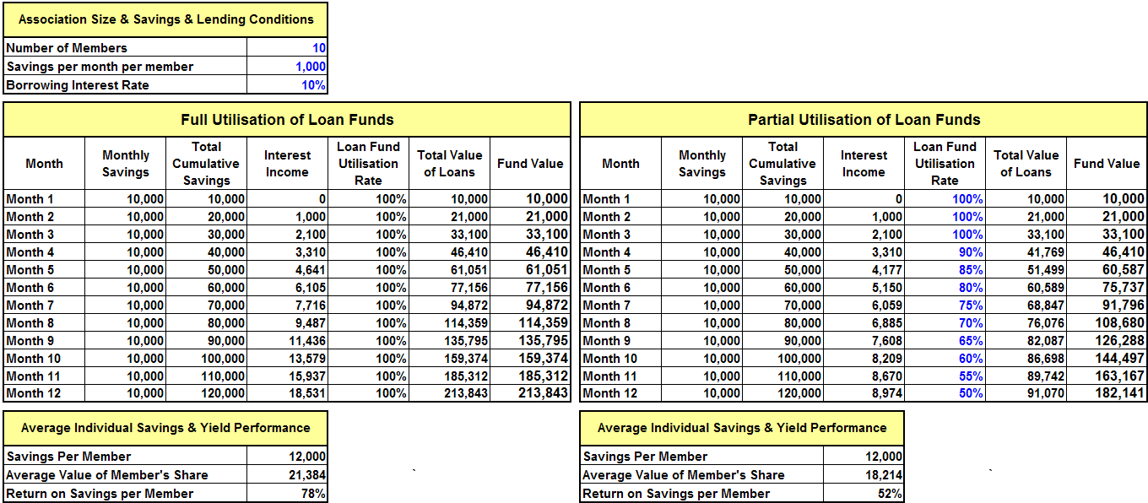

This is a print out of the accompanying Yield Table Excel spreadsheet. The first table (Full Utilisation of Loan Funds), shows a case where all of the funds that are saved are borrowed. As time goes by, however, it is likely that funds will only be partially used. This is shown in the second case (Partial Utilisation of Loan Funds). Text in blue is where data may be entered.
It can be seen that savings become less important than interest earnings in increasing the size of the loan funds, but that this does not happen until late in the cycle. This is clearly shown in the case where all the funds are utilised. It happens in Month 9. In the case where funds are only partially utilised this does not happen during the yearlong cycle. Thus, Associations should be encouraged to start borrowing sooner rather than hanging on to their savings until they have reached a supposedly useful level. Any funds lying idle, however small, are not earning interest. The FO should prepare a version of this table in whatever local currency amounts are appropriate.
Safety of Association Funds
Step 1: The Field Officer can point out that it is obvious that there will be a lot of money managed by the Association. This will be from:
- Savings
- Fines
- Interest earnings
- Profits from Association activities.
It is important that the Association decides how this money will be stored. The Field Officer tells the members that the main reason for concern about the safety of money and the use of a cash box is not because there is a serious risk of theft by robbers, but to ensure that all transactions take place in front of the Association. Story No. 3 (again on page 57) should be told at this point to illustrate the dangers of not having a lockable cash box.
Step 2: Because it is true that a cash box might attract robbers to a member’s house, at this point the Field Officer will show the Association the type of heavy-duty cash-box or lockable canvas pouch that the project will have had manufactured. (S)he tells the Association that they will be provided with a complete kit of equipment so that they can run their savings and lending activities and that the cash box is part of that kit. The Field Officer explains that the cash box/pouch will be held by the Treasurer, whose sole responsibility is to safeguard it between meetings. The cash box/pouch is fitted with three locks and the keys held by selected members of the General Assembly. This means that when it is locked at the end of the meeting and carried away by the Treasurer, (s)he cannot open it because none of the keys will be in his/her possession. The Field Officer shows the members the entire kit. This consists of:
Note: This should not be offered as an option. The lockable boxes or canvas pouches are central to the methodology and for the maintenance of confidence. While very small groups maybe can get along without a secure place to put surplus cash, larger groups cannot. Surplus cash will accumulate and it is a fact that groups that do not have cash boxes tend to run into problems of integrity and cash leakage as time goes by. Bear in mind that most groups will be more worried about dishonesty of their members than the risk of robbery.

- Lockable cash box or heavy duty lockable canvas pouch
- Three good quality padlocks, each with two keys
- Record Keeping Journal
- 30 Member Share Passbooks
- Ruler
- Ink pad and rubber stamp symbol for the Association
- Two ball point pens
- Two pencils
- Eraser
- Calculator
- 4 plastic bowls, at least 30 cm in diameter and at least 15 cm deep
(S)he hands the kit over and tells the Association that it must be paid for during Module 4, when the Management Committee is trained in Record Keeping. (S)he tells them that they must prepare themselves to come with the money. She asks them if they think it is safer to use a canvas pouch rather than a metal box, so that it attracts less attention.
Summary and conclusion:
The Field Officer should ask if the members have any questions
The Field Officer announces the date of the next training meeting, the topic of which will be “Constitution Development” and tells the Secretary that (s)he will be expected to report the day’s proceedings at the next meeting. (S)he also designates six people to remember the titles of the training sessions, telling them that they will be asked to remember the titles at the next meeting.
The Association is thanked for its participation and the meeting is closed.

Stories
Story 1 - Topic: What is a Productive Loan? Zablon is a member of the Ralang C Association. He has three bags of maize in store after harvest. School fees are due and he decides to sell the maize to pay the school fees. The project starts a VS&LA and Zablon is one of the first members. He asks for a loan so that he can pay the school fees. He is told that he can’t have a loan for this purpose because it is not productive. He says that he will keep the maize for a month and its value will go up by 50%. This means that he can pay back the loan, pay the interest and end up with a profit. Do you think that Zablon should get his loan?
Story 2 – Topic: When is interest high and when is it not? Jemima is a member of the Maendeleo Association. She borrows TShs 15,000 at 10% interest for the month. She thinks that the interest rate is high, but knows that it is cheaper than if she borrowed from the village moneylender, who charges 25%. She spends TShs 500 to travel from town to a maize growing area and buys a bag of maize for TShs 12,000. Her transport costs back (carrying the bag of maize) are TShs 1,000. This leaves her with TShs 500. She sells the maize in small pots in the local market and gets TShs 20,000. Her profit is, then TShs 5,500. She does this every week for a month and has made a total profit of TShs 22,000. She pays back the TShs 15,000 and TShs 1,500 in interest and keeps the difference. The table below shows how much she made in total, over 4 trips to buy maize. The yield on the amount borrowed is 9,500/15,000, or 63%. She has been able to pay back her loan, been able to accumulate and pay back the interest. Of course, she took a risk to do so, but do you think she will be ready to take out another loan? When telling this story illustrate with play money.
Table 13: Return on Investment Vs. Cost of Borrowing.

Expenses |  | Income
Transport to buy maize (x4) | 2,000 | Sale of Maize | 80,000
Cost of maize (x4) | 48,000
Transport back to the village (x4) | 4,000
Association loan interest charge | 1,500
Repayment of loan principal | 15,000
Net Profit | 9,500
Total | 80,000 | Total | 80,000

Story 3 – Topic: Security of the Association’s Property. The members of the Semegot C Association entrusted the Association’s money and records to the Treasurer, who was a woman with a reputation for honesty. She took them home in her handbag and always showed up to meetings with the records and with the small amount of spare cash left over after previous meetings. After six months the Association’s funds began to get quite large. They had a net worth of TShs 1,230,000 when loans were counted together with cash on hand. The money was enough to meet most people’s needs and the Treasurer found that she was holding on to TShs 250,000 in a cupboard in her house. Her husband demanded to use a few thousand shillings for his building business and paid it back, without paying any interest. Later he took TShs 50,000, to buy materials but met some friends and drank with them, using up TShs 20,000 of the funds, which he could not pay back. The Treasurer was desperate, and to try and hide this, she altered the records, but the Secretary of the Association noticed the alterations and accused her of forgery and stealing the Association’s money. She confessed what had happened and was allowed to remain in the Association, but lost her job as Treasurer and her family’s reputation was badly affected. What do you think the Association should have done to avoid these problems?

2.3.c Module 3: Development of Association Constitution
General
Objective: at the end of the training session:
- The Association will have developed a Constitution. The Constitution will:
- describe how the Association is governed, by whom it is governed and how the people who govern it acquire their authority
- set out the rules that govern Savings and Loan Policies and Social Fund Policies
B e prepared to spend a lot of time on this. For some Associations it may take two sessions instead of one.
The Field Officer asks the Chairperson, Secretary and Treasurer to call the meeting to order and asks the Secretary to report to the Association what was covered at the last training meeting. (S)he then asks again for the titles of the sessions in the training and fines anyone who fails to remember his/her rule. (S)he then announces the objectives of the present session, telling the members that the goal of the meeting is to understand the importance of having a Constitution to guide them in running the Association.
The members must understand that they create the regulations for themselves, and can modify them in the General Assembly if they prove to be incomplete or ineffective. Once the Constitution is established, and, even if some members of the Association cannot read and write, it should be written and put in the cash box/pouch where it is available to everyone for reference. This builds confidence amongst the members that there is a record that can be referred to in times of crisis or dispute.
So that the regulations will not be forgotten, as the meeting proceeds, the Field Officer will ask each member to remember one or more regulation, and to recite them during the following meeting, so that the others will remember them. Little by little, as the participants internalise the rules, they can use them, discuss them, and eventually change them. Even if the Association is literate this is a useful solidarity-building exercise and a practical way of raising consciousness about the Association’s governance.
A Constitution of an organisation is normally a document that says:
- What are the goals and purpose of an institution
- Who owns the institution
- Who governs it and
- How the people who govern it get their authority from the owners.
A VS&LA is owned by its members and it elects leaders to run its affairs. The Constitution needs to say how this happens.
A VS&LA Constitution differs from those of most businesses, NGOs or political organisations. It contains more than just information relating to ownership, authority and election procedures. It also covers the policies that relate to the Social Fund, Savings and Loans and how the Association shares out its assets at the end of the operating cycle.
The Field Officer thus divides the session into two parts: one relating to Association governance and the other relating to the services it offers.

Governance
Step 1: The Field Officer asks the question, ‘What is a Constitution?’ (S)he facilitates a discussion in which (s)he moves towards the answer that a Constitution is a written document that describes what the Association wants to do, how it will be governed and how the people who govern it will be elected and what their powers will be. It can also be a document that lays out the rules, or policies that cover the way its activities (Social Fund, Savings and Lending) are implemented.
Step 2: The Field Officer asks the Association the question, ‘What is the supreme body that controls the VS&LA?’ It is likely that the participants will say that this is the Management Committee, but (s)he reminds them of Module 1 and draws out the answer that the General Assembly holds ultimate power. (S)he goes from this to say that although the leaders have been elected, they have not actually been given any tasks so far (except calling the meeting to order and reminding the members of the contents of the last training meeting). This is because there is no Constitution that gives them any authority. The purpose of this part of the meeting is, then, to set out rules and procedures that they will then be empowered to implement/enforce. They can enforce the rules because the members of the General Assembly have agreed on the rules and the right of the leaders to enforce them.
Step 3: Use the story 1 on page 65 to show how a school without rules cannot function
Step 4: Ask the members to suggest what sorts of things will be needed in a constitution. List them on a flip chart and make sure that the following are listed.
- Governance
- Basic information on the Association?
- What the purpose of the Association will be?
- What services it will offer its members?
- Who can belong and who cannot?
- What is the governing body and who will serve as leaders on the governing body?
- How will the leaders be elected?
- How will leaders be removed?
- How often will the Association meet?
- How will members leave the Association?
- What happens in the case of death of a member?
- What will constitute an offence for which members can be punished?
- What sort of penalties can the Management Committee impose for what offences?
- Services:
- How will members save and borrow?
- How will a Social Fund be established and run?
Notice that the issues listed above are grouped into those that cover how the Association manages itself (Governance) and those that cover how services will be delivered. Tell the members that they will deal with each one in turn, but point out that decisions relating to the Social Fund and to Savings and Lending were covered in the last meeting. The Field Officer reminds them that (s)he took note of their decisions concerning how these things would be done at that time and that these decisions will be included in the Constitution.
Step 5: The Field Officer tells the Association that (s)he has a written framework that covers the topics listed and that the next step will involve going through the list, with the Field Officer asking the membership to discuss each point and reach a consensus. (S)he reminds them that the Constitution is a document that will bind them into a relationship that will be guided by its provisions and they should not rush through the process. If necessary, a second meeting on the topic to complete the Constitution can be arranged.
Step 6: Discussion and completion of the framework (see below). The Field Officer should expect this activity to take a long time.
Services Offered by the Association
Step 1: The Field Officer refers to the previous meeting in which the Association determined the rules and regulations that would guide the operations of the Social Fund and Savings and Lending. The Field Officer goes over this ground again and asks everyone if what (s)he has written is correct. If there is any disagreement it must be resolved at this point. This activity proceeds rapidly.

Outline of the Key Elements of the Constitution
This outline is intended to be a series of key questions rather than a finalised constitution. Once the key questions have been answered by the members, after discussion, the constitution can be written in final form and everyone who is able will sign, with non-literate members affixing their fingerprints, to ensure that everyone is in agreement with the provisions. See Annex 1 for a blank form allowing the Constitution to be written down.

Governance of the Association
  - BASIC INFORMATION ON THE ASSOCIATION
- Name of the Association?
- What is the address of the Association?
- On what date was the Association formed?
- Date of registration, if any?
  - OBJECTIVE OF THE ASSOCIATION
- What is the reason for the Association to exist?
- What services will the Association provide to its members in order to achieve this objective?

  - WHO MAY BE A MEMBER OF THE ASSOCIATION?
- Upper age limit?
- Lower age limit?
- Gender?
- Residence?
- Common bond?
- Running a business or not?
- Reputation?
IV. COMPOSITION OF THE MANAGEMENT COMMITTEE
- Chairperson
- Secretary
- Treasurer
- Money Counters
V. ELECTION PROCEDURES
- How many terms can any one person serve on the Management Committee
- How often will elections be held
- What is the minimum number of members who must be present to hold an election?
- Will the election procedure use a system that allows everyone’s vote to be secret, or will it be carried out using a show of hands?
- What is the minimum number of people that must stand for each position?
- Should a member be proposed for office by another member before being put forward for election?
VI. REMOVAL OF OFFICERS FROM THEIR POSITION BETWEEN ELECTIONS
- Any member of the General Assembly can call for a vote of no confidence in a member of the Management Committee. If the vote is passed by a majority of the members the member must step down from the Management Committee and another member be elected to the same position.
VII. MEETINGS
- How often will the Association meet to mobilise savings?
- How often will the Association meet to disburse loans?
- How long will the cycle of meetings continue before the Association shares out its assets (cash on hand)?
VIII. MEMBERS LEAVING THE ASSOCIATION
- If a member leaves the Association because they have no alternative (such as if they marry and move away) how will the Association calculate how much they must be paid?
- If a person leaves the Association before the end of the cycle for no good reason, except their preference to leave, how will the Association calculate how much they must be paid?
- If a person is expelled from the Association for failing to make regular savings deposits, how will the Association calculate how much they must be paid
- If a person is expelled from the Association for failing to repay a loan, how will the Association calculate how much they must be paid?
IX. EXPULSION FROM THE ASSOCIATION
- For what reasons should a person be expelled from the Association?
X. DEATH OF A MEMBER
- If a member dies how will the Association calculate how much money should be given to their heirs?
XI. FINES
The following table lists the fines that can be charged for offences committed by members.
Table 14: Schedule of Fines
Offence | Fine Amount (Shs)
Non-attendance at a meeting for personal reasons
Late to meetings
Not memorising Association rules as required by the Chairperson
Failure to make minimum Share/Savings deposit
Chatting through the proceedings
Showing disrespect to Association officers or members of the General Assembly
Not remembering decisions and activities of the preceding meeting
Non-execution of role by a member of the Management Committee
Late deposit or loan reimbursement

- AMENDMENTS TO THE CONSTITUTION
- How many members must agree (as a number) before the constitution can be amended?
- Who can propose an amendment to the Constitution?
Services Offered by the Association
I. SAVINGS
- What is the value of a single share that is the minimum amount that a member must contribute at each savings meeting?
- What is the maximum number of shares that a member can buy at each meeting?
- Where must shares bought by a member to the Association be recorded and by whom?
- What happens when a member cannot meet the minimum share purchase requirements?
II. LENDING
Note: This refers to a relationship between the amount a person has saved and the amount they can borrow (such as double or treble the amount). It is not intended to impose a specific limit on the size of the loan. These will automatically get bigger as time goes by.

- Who is eligible to borrow?
- What is the maximum amount that anyone can borrow?
- What is the maximum length of loan term (in weeks)?
- What rate of interest will be charged every 4 weeks?
- What will happen if a member does not repay a loan?
- After how long should the Association write off a loan that is not repaid and invoke legal action against the defaulter.
III. SOCIAL FUND
- Where will the Social Fund be kept?
- What will be the contribution to the Social Fund and how often will it be paid?
- For what types of emergencies will the Social Fund pay out benefits?
- What will be the benefits for the death of a spouse?
- What will be the benefits for the death of a child?
- What will be the benefits for the death of a parent?
- What will be the benefit for hospital costs, or doctors’ visits?
- What will be the benefit for medicines?
- What other benefits will be considered?
Summary and conclusion:
The Field Officer should ask if the members have any questions
The Field Officer tells the members that the next meeting will be with the Management Committee only, so that they can learn how to run a meeting and can learn how to keep written accounts and Member Share Passbook records. They should be told that the purpose of meeting separately with the Management Committee is so that the time of the whole membership is not wasted when the Field Officer will be concentrating on training only the members of the Committee.
The members are told the date of the next meeting in which everyone participates and are told that the topic will be ‘Meeting Procedures’. The Field Officer reminds the members that the Management Committee can only carry out its training if the kit of equipment is paid for. The cost of the kit is again mentioned and the Field Officer confirms that the Management Committee will have the necessary funds on hand at the time of the next meeting of all the participants (Module 5). At this point, the Field Officer can suggest that the group as a whole commits each member to making the necessary contribution, and helps them calculate the sum that each will have to pay.
Module 5 will be a practice session in which they carry out their savings and loan activities using play money, which will be brought by the Field Officer, and in which the record-keeping system will be explained to the whole Association. This will give them a chance to practice all of the procedures without the risk that members’ money will get mixed up or lost. The Association is thanked for its participation and the meeting is closed.

Topic: A school without rules. A community in M’uranga decided to start a Harambee (self-help) secondary school. The parents contributed money, hired builders and put up 4 classrooms. They then hired teachers and a Head Teacher. The Head Teacher did not believe in bossing people around and decided that the teachers should be left to perform their duties without being told what to do. She hired an accountant and told him to be an accountant, collect school fees and pay bills, but she did not tell him what sort of reports to prepare. Children were left free to decide whether or not to come to class, what to wear and how to behave themselves.
Story
Soon the children started to misbehave. They played music in school time, only attended classes occasionally and were rude to the teachers, refusing to do homework. The teachers became discouraged and started to miss classes because they could not control the children and because they did not have contracts that told them what their duties were. Soon the school became famous in the District for being in a state of chaos and the District Education Officer (DEO) came to visit. He was treated badly by the children and when he tested some of them he could see that they had not been following a curriculum and were far behind other children in the District. He also discovered that the school had been spending far more than was allowed for in the budget, but the Head Teacher was not aware of this. He called the Head Teacher and asked for an explanation. She said that it was very early days as yet and she felt confident that the children and staff would soon see the reason for behaving sensibly and that everything would settle down properly. She was very surprised that the budget was over-spent.
The DEO recommended to the Committee that the Head Teacher should be dismissed. The Committee agreed with this recommendation and sacked the Head Teacher, who took the Committee to court for unfair dismissal. The court awarded the Head Teacher a year’s salary, because the Committee had given her a contract, in which they only specified that she should run the school, without saying why, nor what they expected by way of academic standards, discipline, results or reports. The Committee could not pay this money because the accountant had spent far too much money on food for the school, without consulting the Committee, and there was very little money left. The school had to close down for a year until the parents had saved enough money to pay the Head Teacher. When they started the school again they interviewed candidates for the job of head teacher. What do you think they thought were the most important qualities they were looking for in the person and what do you think they included in the new Head Teacher’s contract?

2.3.d Module 4: Written Record-Keeping and Managing a Meeting
General
Objective: at the end of the training session:
- Each member of the Committee will understand their individual responsibilities
- The Secretary and Money Counters will understand their roles in maintaining written records
T he record-keeping system is made as simple as possible. It does not seek to emulate a full system of accounting, but emphasises transaction record-keeping. In addition, the measurement of Association net worth, which is the final output of the accounting system, only counts current assets and current liabilities, on the assumption that nearly all of the Associations will have very few fixed assets (most of which have negligible salvage value and rarely need replacement) and no long-term debt.
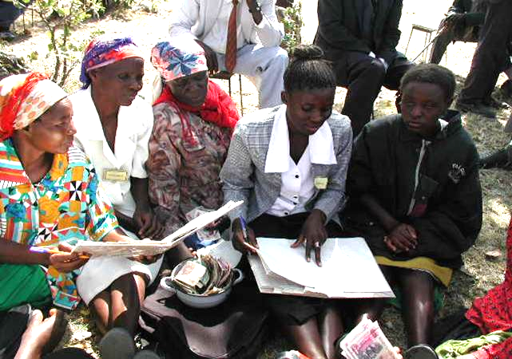
Records are maintained in a single book, which can be prepared with a ruler and ball-point pen: no special printing is needed. The book is divided into sections as follows:
- Register
- Social Fund Ledger
- Savings Ledger
- Fines Ledger
- Loan Ledger
- Cash-Book
- Statement of Association Worth
Thus, using a cash book that summarises each category of transactions, most financial records are double-entered. In addition to the Association Records, every member has a Member Share Passbook.
Preparation
The Field Officer meets with the Management Committee, including the Money Counters, in order to train them in written record-keeping and managing a meeting. It is necessary to carry out these two trainings at the same time because Social Fund, Savings and Loan procedures involve record-keeping at every stage and it is important for the Chairperson, for example, to understand when, during a meeting, time must be left for a record-keeping procedure to be completed.
The Field Officer prepares for the meeting by making sure that the place is quiet, shaded and that it is protected from the wind. (S)he also makes sure that a table is made ready so that the recording of transactions can be done comfortably and the cash-box is visible to everyone. This is not strictly necessary, but a table introduces into a meeting a sense of formality and order. A low table is a better idea than a high table, because it does not create such a barrier between the Committee and the members and also provides a working surface for the Secretary and Treasurer when entering records and share stamps.
It is important not to rush this process: if the Management Committee is unable actually to manage the procedures of a meeting then there will be confusion and demoralisation. It may well be the case that this session needs to be carried out over two meetings
The Kit
The Field Officer prepares for this meeting by bringing along a complete kit of equipment and record-keeping materials for the Association. The kit will have already been shown to the entire membership by the Field Officer, during Module 2: Association Fund Development.
As noted on Page 55 the kit consists of the following:
- Lockable cash box or heavy duty lockable canvas pouch
- Three good quality padlocks, each with two keys
- Record Keeping journal
- 30 Share Pass Books
- Ruler
- Ink pad and stamp symbol for the Association
- Two ball point pens
- Two pencils
- Eraser
- Calculator
- 4 plastic bowls, at least 30 cm in diameter and at least 15 cm deep
The Field Officer receives the money for the kit and formally hands it over, together with a receipt, to the Chairperson. The Association is told that the safety of the kit will be the responsibility of the Treasurer and that (s)he – or her designated assistant - must carry all of it to each and every meeting of the Association. The Field Officer may suggest to the Committee that after each meeting the Treasurer is accompanied to his/her home by other members and escorted to meetings, so as to add to the security of the Association’s property.
Record Keeping
Step 1: The Field Officer tells the Committee that the first step is to prepare the Record Keeping book so that the Association can proceed to enter information. (S)he takes the record books, which are made from hard-covered A4 Counter Books and cuts them in front of the General Assembly, as shown on the following page, leaving tabs for each category of entry. Figure 1 on the following page shows the normal number of tabs that an Association will need to keep useful records. The only tab that is discretionary is the Social Fund tab. An Association may not decide to have a Social Fund, or it may decide to have a Social Fund and also, for example, an Education Fund. Whatever the number of funds it chooses to have, each must have its own section (and tab) in the record books. More than 90% of groups that decide to have a Social Fund do not have additional Funds (such as for education and training), but provision must be made for keeping records if they do. Figure 1 shows the most typical example of a Record book. Pre-printed record-keeping books, laid out exactly as shown, are available from VSL Associates. It is not a bad idea to use a pre-printed book for the first cycle, because it can then be used by the Association as a model to copy when making their own books from locally available stationery.

Figure 1: Typical Record Keeping Book Layout
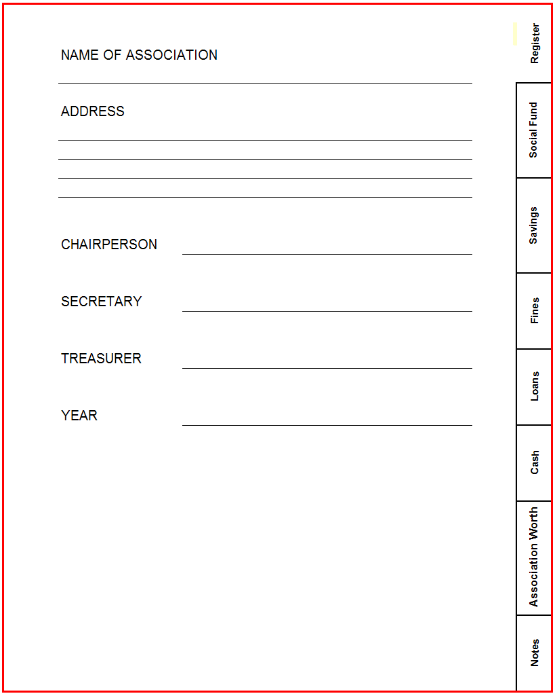
Note the tabs on the right to facilitate easy access to the different sections. The number of pages needed for each tab will depend on how long the Record Book is intended to last and if the Association meets weekly, fortnightly or monthly. The following is a rough guide.

- Register 5 pages
- Social Fund 8 pages
- Savings Ledger 8 pages
- Fines Ledger 1 page
- Loan Ledger 12 pages
- Cash Book 10 pages
- Association Worth 2 pages
- Notes 9 Pages

This number of pages is enough to last an Association that meets weekly at least a year.
Step 2: When the book has been cut, the Field Officer helps the Secretary draw all of the accounting outlines in the book, as shown in Figures 2 – 11 (excluding Figures 4,5 &6, which are for the Share Pass Book) . Although dates are shown in the case study used here (to make it clear to the reader how the entries are made) they are not entered in the new book.
All of the members are expected to attend most meetings and all are expected to make contributions to the Social Fund and to make savings. For this reason the names of all of the members must be written in the Register, the Social Fund Ledger and the Savings Ledger. To save the necessity of writing the names out three times, the Field Officer prepares a fold-out tab that has all of the names of the members. This is pasted in the front cover of the record book and folded out when Registration, Social Fund contributions and Savings contributions are called for. This is shown in Figures 2,3 and 7 on the following pages.
Step 3: The Social Fund Ledger. The Social Fund is discretionary, meaning that an Association can choose to have one or not as it wishes. It can also have more than one type of Social Fund, maybe for School Fees or for Health Insurance. All such funds comprise a record of contribution (in this example the whole Association contributes. Where another type of fund exists, such as an Education Fund, it may be confined to just a few members). The bottom four (shades yellow) lines show income from contributions, payouts made by the fund, reimbursements to the fund and the cumulative total remaining in the Fund. The people benefiting from the payout are not itemised because the Association can be expected to remember to whom the benefits were paid and, in any case, the amounts are usually occasional and small. If an Association wishes to keep a separate record of Social Fund loan liability it can do so in a separate school exercise book: our purpose here was to minimise the number of entries required in a meeting and we have assumed, from experience, that Social Fund payouts and reimbursements involve only occasional small sums and are not worth recording in detail, especially when repayment is not required..

Figure 2: Layout of Record Keeping Book When Opened at the Register. Ralang B VS&L Association
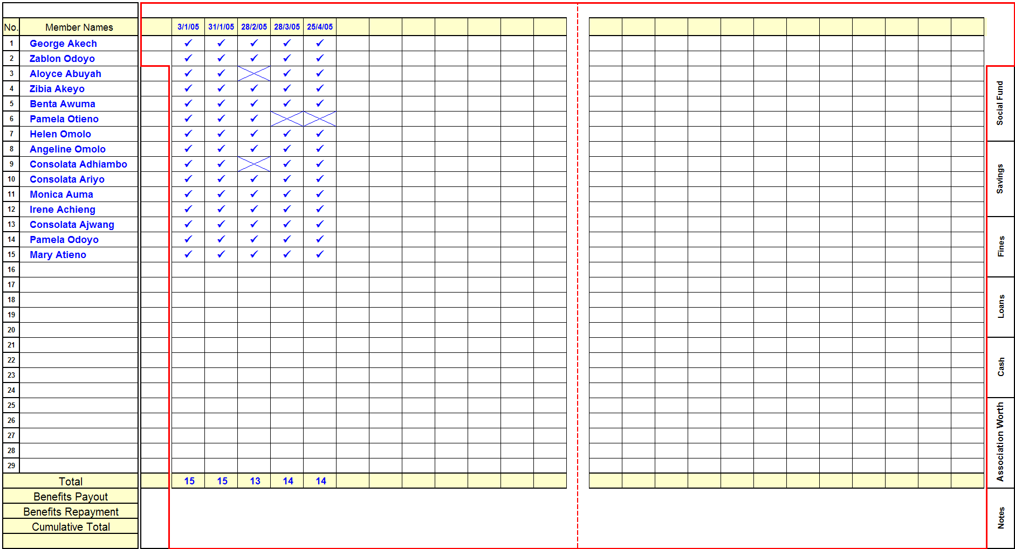
Note: This is a fold-out column pasted into the cover page.
Note: In addition to the names of the members, it lists ‘Total’ ‘Benefits Payout’ ‘Benefits Repayment’ and ‘Cumulative Total’. These last three relate to the Social Fund and Savings Ledger and are ignored for the Register, where only the total number of members is listed
Note: the Register has 12 columns on each page and 29 rows for clients. One header row and one totals row are shown, leaving 3 blank rows below. Only 29 rows are offered because, when the group reaches 30 members it is too large and should sub-divide
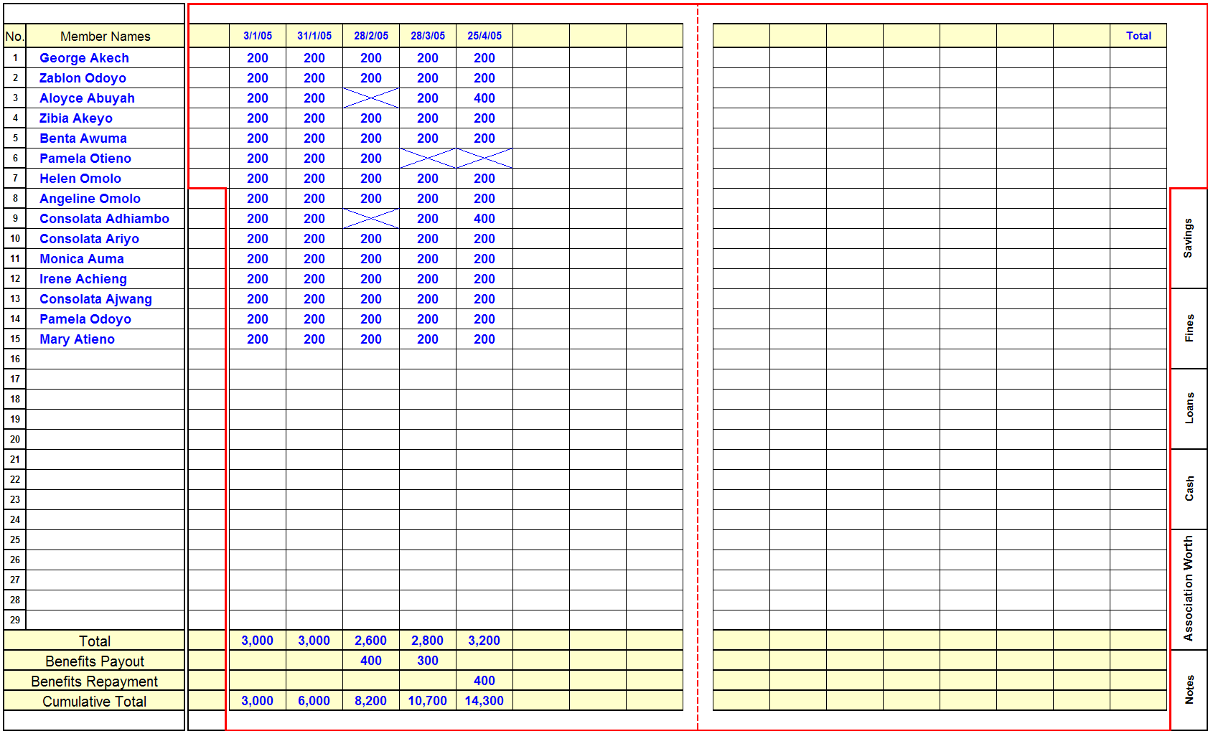
Figure 3: The Social Fund Ledger
Note: This shows that in some cases members made up their missed payments at a later date by paying double.
Note: This shows that TShs 700 benefits have been paid out and TShs 400 reimbursed.
Step 3: The Social Fund Ledger. The bottom four lines show income from contributions, payouts made by the fund and reimbursement. The people benefiting from the payout are not itemised because the Association can be expected to remember to whom the benefits were paid and, in any case, the amounts are likely to be small.
Step 4: Share Pass Books. At this point the Field Officer hands out blank Member Share Passbooks, illustrated below and on the next two pages. The Savings Ledger is used in parallel with the pass-book system, in which a given amount of money is paid for a share. The share is shown as a symbol, such as an arrow, star or a tree etc. stamped in a Share Pass Book, which is exchanged for a given value that the Association may decide. The reason for a passbook system is that experience has shown that while Savings Ledgers are often full of mistakes, Share Pass Books are usually accurate. The cover of a typical Share Pass Book is shown below in Figure 4.
If need be, the Share Pass Books can be made from ordinary school exercise books, so that specialised printing is not needed.
Figure 4: member Share Passbook Cover
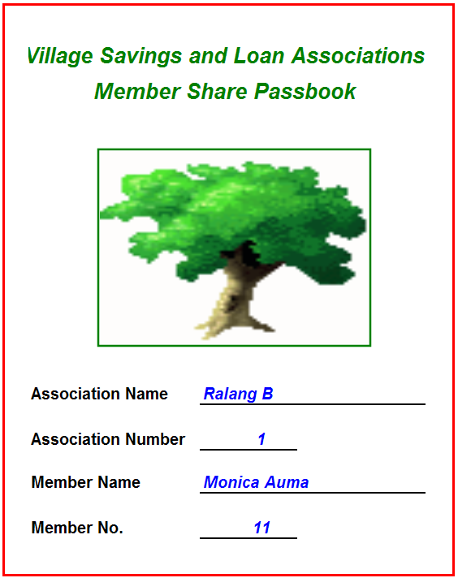
By using a stamped Share Pass Book it is much easier to facilitate the share-out at the end of the cycle, because the value of each share is easily calculated by dividing the total cash available for distribution by the total number of shares. Counting up a small number of shares instead of millions of shillings, (or Meticais, Zimbabwe dollars, UShs etc.) leads to fewer errors.
The example given here is taken from Tanzania. The Associations decided that between 1 and 5 shares could be bought by each member at each meeting. Other programmes (such as CARE’s programme in Zanzibar) allows for any number between 1 and 3 to be bought. Larger ratios are not recommended, to preserve solidarity.

The illustration below shows that there have been 5 savings meetings already in which this member saved 11 shares to date. The symbol chosen by this Association is an arrow (a star or a hoe or a fish are popular) and one stamp of the arrow costs TShs 500 for a member to buy.
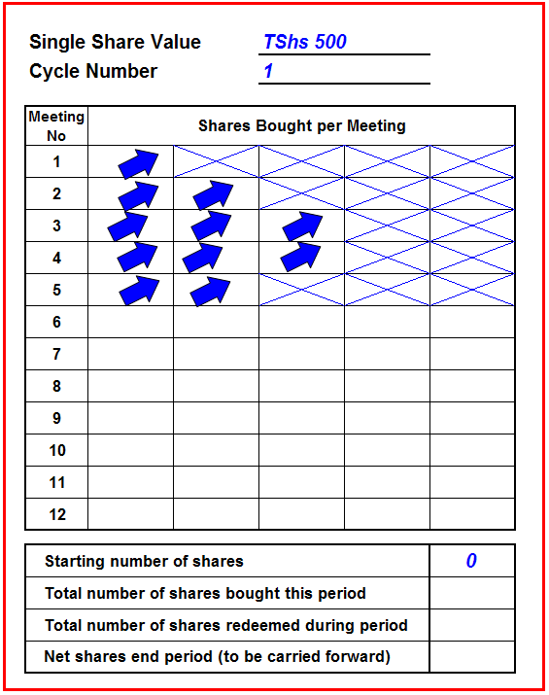
Figure 5: Member Share Passbook with Shares Stamped In
It is normal for the empty spaces to be crossed through at the time of the contribution to prevent fraudulent entry of stamps.
The use of pass-books is not a necessity and has some disadvantages, particularly that the books will have to be specially printed, making the Association dependent on their continuing availability. If it is not certain that Share Pass Books can be printed at low cost and made available through stationers, it is best to use school exercise books, specially ruled for the purpose.
At the end of the cycle, the member’s Share Pass Book will look like Figure 6 on the following page. This shows the member’s total shares bought throughout the 12 months of the current cycle (this Association meets monthly).

Figure 6: Member Share Passbook with Shares Stamped In For 12 Months (1 Cycle)
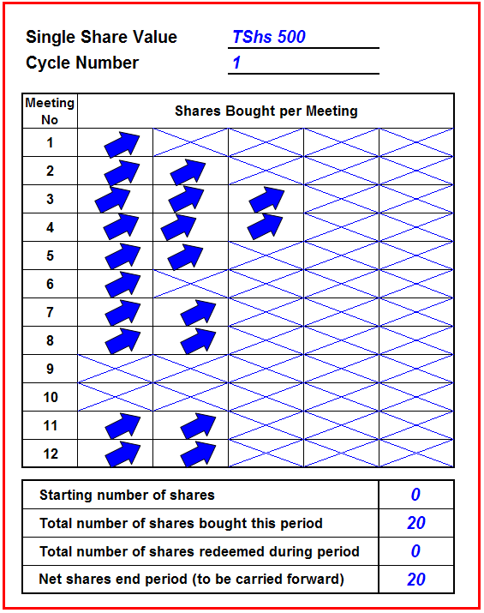
Note also that for two meetings this member (Monica Auma) was unable to make any contribution. This is quite normal, especially during the dry season, usually before harvest, when there may be very little trading activity.
Remember that Associations are likely to want to meet weekly, or every two weeks. The monthly meeting used throughout this example are rare and have been used here to simplify the illustration of the record- keeping system.
The entries in the Share Pass Book are carried out at the same time as the entries in the Savings Ledger are made by the Secretary. As members make their contributions, the Treasurer stamps the requisite number of stamps in their Share Pass Books, while the Secretary enters the value at the time of purchase in the Savings Ledger.
The entries in the Savings Ledger are shown in Figure 7 on the following page. It will be seen that Monica Auma has bought shares worth TShs 5,500, equal to 11 shares to date. She bought one in the first meeting (TShs 500), 2 in the second (TShs 1,000), 3 in the third (TShs 1,500), three in the fourth and two in the fifth (TShs 1,000). In this way, the members have a personal record of savings that confirms book balances.
Figure 7: The Savings Ledger
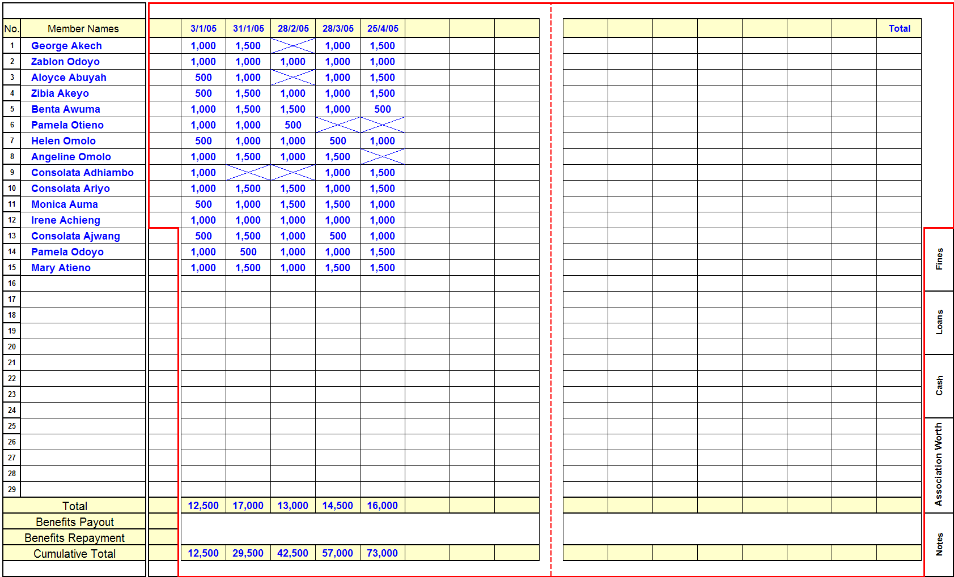
Note: When members fail to contribute, the space where the contribution is normally recorded is filled out with a large ‘X’. This acts as a reminder for the Secretary to ask for the missed contribution at the next meeting.
Note: In cases where the cycle lasts longer than 15 meetings (groups that meet weekly or fortnightly) the Cumulative Total is carried forward to the next sheet, under ‘c/f’ (Carried Forward). Subsequent pages allow for 14 entries, because the first column is the ‘Carried Forward’ column, while the final column is a ‘Total’ column.

Note: Ignore Benefit Payout and Benefit Repayment lines. These do not apply to savings.
Step 5: The Fines Ledger. This is more or less self-explanatory. Fines are collected in a bowl and the total amount collected is noted in each meeting. Version 1.0 of this manual itemised fines by type of offence and by name of the member. This is generally not necessary and over-complicates the work of the secretary. It may also needlessly humiliate the offender. For these reasons it has been dropped.
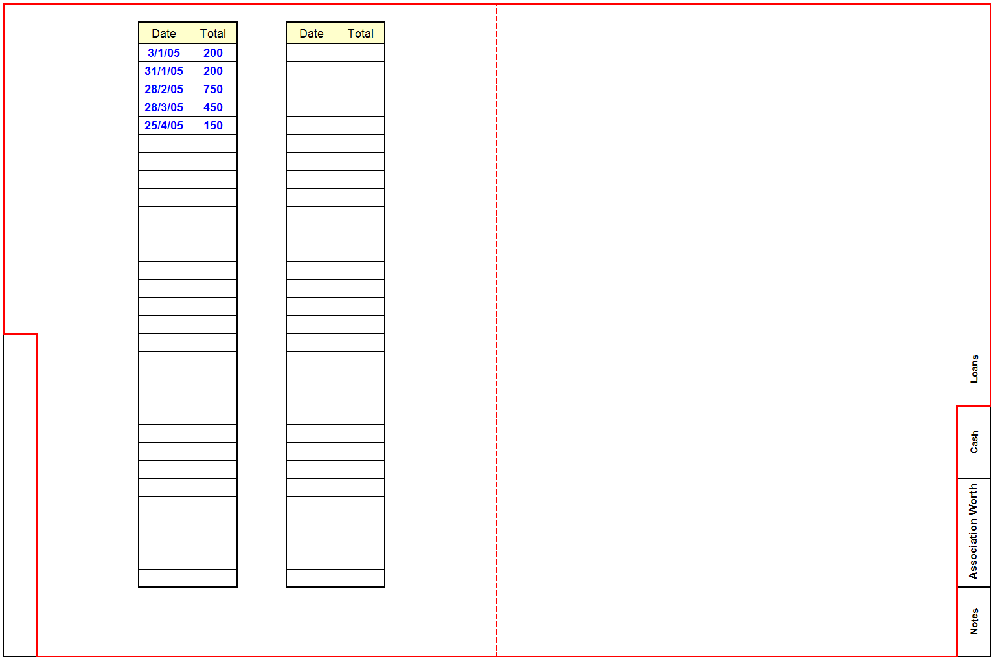
Figure 8: The Fines Ledger

Step 6: The Loan Ledger. The loan ledger is rather complex, although conceptually simple. The Loan Ledger is where errors are most likely to occur and should receive intensive and careful attention by the trainer. The following pages show, step-by-step and meeting-by-meeting, how it evolves.
The example below shows the first page of the Loan Ledger and the first entries. It shows that three people borrowed money on 3.1.2, agreeing to pay it back 4 weeks later on 31.1.5. They agreed to pay it back with 10% interest.
Figure 9: The Loan Ledger (1)
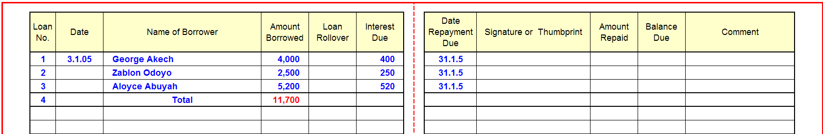
The example below is a record of the next credit meeting, a month later. It shows that the first three borrowers paid back in full and on time and that a further TShs 30,000 was borrowed by four people, each of whom were due to pay back in a month’s time. The interest and principal is combined in the ‘Amount Repaid’ column. Any balance left unpaid will be carried over to the next month as a new loan, whether or not this is planned. At this point no-one is in arrears.
Figure 9: The Loan Ledger (2)
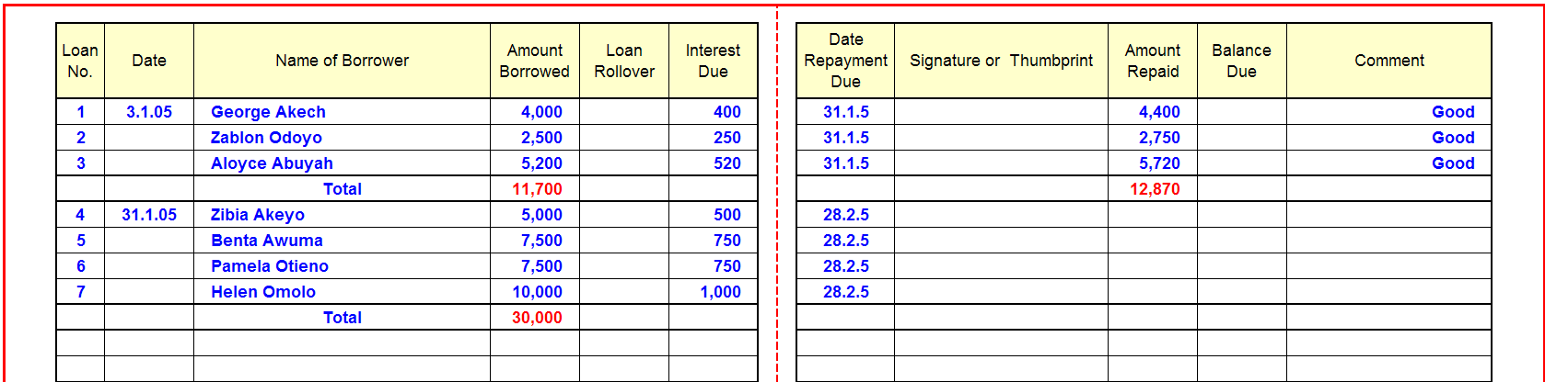
After another 4 weeks the Association meets again, but begins to experience some repayment problems.
Figure 9: The Loan Ledger (3)
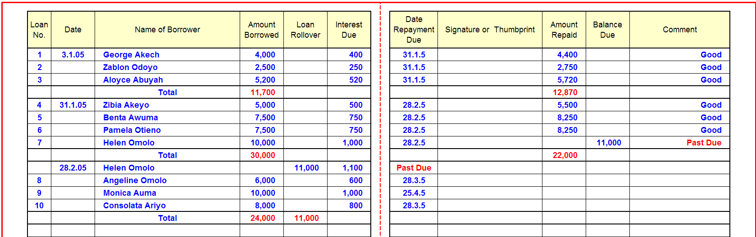
Note that loan No 7 is Past Due: Helen Omolo borrowed TShs 10,000 to trade in vegetables but was unable to repay either principal or interest on the due date. The Association deals with this in the following way. First of all they note in the ‘Comment’ column that the loan is ‘Past Due’. Ideally they do this with a red pen. This indicates that in some way the loan repayment has fallen behind schedule.
Then, the whole amount of the original loan that remains unpaid (TShs 10,000), plus interest accrued (TShs 1,000), is treated as if it is a new loan issued on 28.2.5, in the sum of TShs 11,000, but entered in the ‘Loan Rollover’ column and not the ‘Amount Borrowed’ column. Putting it in the ‘Loan Rollover’ column is done to avoid counting this as a new loan. This ‘Rollover’ loan is classified as Past Due in the ‘Date Repayment Due’ column. Because it is a rollover loan it is not given a new number.
At the end of the meeting we can see that TShs 22,000 was repaid (‘Amount Repaid’ column) and TShs 24,000 disbursed in new loans (‘Amount Borrowed’ column). But the total of loans outstanding is TShs 35,000: This is made up of TShs 24,000 from the Amount Borrowed column + TShs 11,000 from the Loan Rollover column.
This system of rolling over the loans means that all Loans Outstanding can be calculated by adding the value of all new loans issued (‘Amount Borrowed’ column) and all loans rolled over that month. Thus, the Field Officer can very quickly find out total Loans Outstanding, and Loans in Arrears simply by consulting the current month’s figures, avoiding the need to trace back loan history to its origins. Note that one new loan is for two months (Monica Auma). We know this because the repayment date is two months in the future.
After another 4 weeks there is another loan meeting and the loan records show the following:
Figure 9: The Loan Ledger (4)
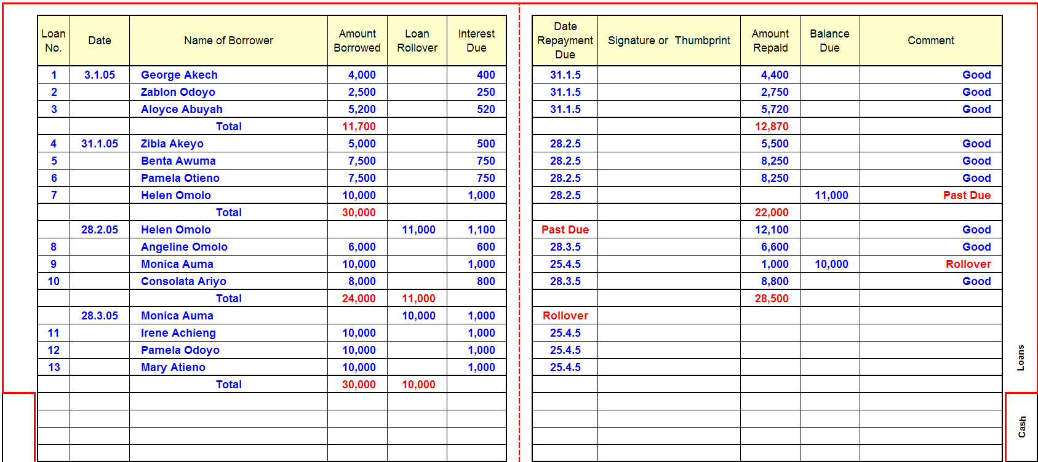
This time everyone pays back as requested (Shs 28,500). Monica Auma (Loan No. 9) pays her Interest on the loan (TShs 1,000) and in the ‘Comment’ column it is noted that the loan is a rollover, but is not past due. Because this was a two month loan, agreed as such from the start, there is no fine levied and the loan is not considered ‘Past Due’

The most recent entry is shown below. Repayments total TShs 38,000, but Pamela Odoyo is partially past due (she paid TShs 5,000 and has a balance of TShs 6,000), and four new loans were given out (Shs 30,000). The past due amount is entered as a new loan in the ‘Loan Rollover’ column for TShs 6,000 and interest will be TShs 600). The Field Officer can easily see which clients are delinquent and how much principal is owed. Loans Outstanding are TShs 36,000, with TShs 6,000 past due. The Portfolio at Risk is 16.7% (TShs 6,000/TShs 36,000)
Figure 9: The Loan Ledger (5)
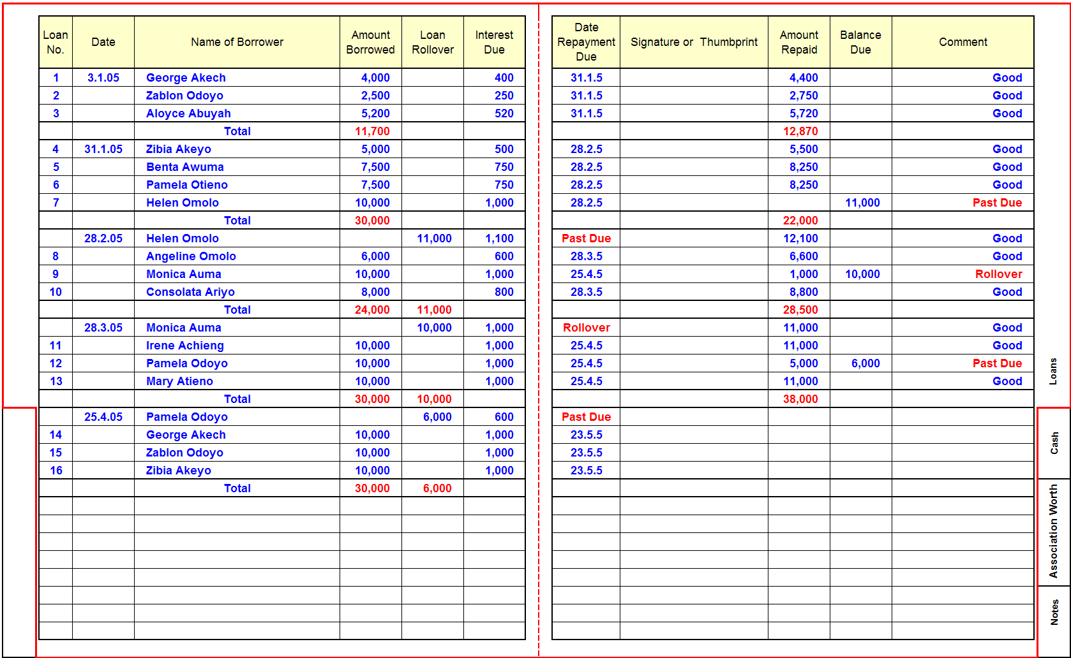
Note: To avoid counting rolled-over loans as being newly disbursed, they are shown in a separate column, but their value is included in the Statement of Association Worth as an asset (Page 83)
Step 7: In much the same way that the Member Share Passbook is used to record the total number of shares, the back of the passbook is used to record loan information. It is unnecessary to record all of the things that might happen to a loan in a member’s passbook, when a group keeps written accounts. The passbook is used only to keep basic information on a loan as shown in Figure 10 below, so that the borrower acknowledges liability and has a reminder of what is owed.
Figure 10: Member Loan Record

The example on the left is that of Monica Auma, who borrowed TShs 10,000 on the 28th. February 2005. The loan attracts TShs 1,000 interest every month. The number of the loan is the same number as the number shown in the Loan Ledger. She signed for the loan when it was received. What her signature here indicates is that she agrees that she has received the TShs 10,000 and will pay TShs 1,000 interest every month, no matter how long the loan lasts.
The loan can only be cancelled when the Secretary strikes out the loan and adds his/her signature or thumbprint to that of the borrower.
Note that this does not include a loan repayment schedule, but only the monthly interest liability. This is because the time taken to repay will vary from member to member.
If Monica Auma pays back part of the loan and has a smaller balance than TShs 10,000 principal owing, the Secretary cancels out the loan as shown, by crossing it out and putting his/her signature and enters the balance as a new loan, but with the same loan number. When a new loan is issued, after full reimbursement of earlier loans, a new loan number is written in .
If the Association’s records are lost or destroyed the member share passbook will act as a record of contributions and will record the asset (savings) and liability (loans) situation of the member. This will allow the assets that remain to be fairly apportioned at the time of the shareout. If the Association’s records are lost the Member Share Passbooks permit the complete reconstruction of the Association’s records, apart from miscellaneous expenditure and donations. It can be argued, convincingly, that Associations (especially non-literate Associations) can function quite well using only pass books for records. So long as cash is controlled in a lockable box very little leakage can occur and all assets and liabilities can be identified, obviating the need for transaction record-keeping. We cannot yet state unequivocally that this will, in fact work for non-literate Associations, but so long as members are numerate and can identify themselves by their member number, there is no reason why this should not be the case.
At the time of writing this system is being launched and results will be available, we hope, within the year.
Step 8: The Cash Book. As each set of transactions are completed (Savings, Reimbursement, Fines, Disbursements etc) and recorded in the relevant ledger, the totals are entered in the Cash Book. The Secretary should immediately record these totals as they may otherwise be forgotten. Note that reimbursements include interest payments. It is not necessary to record them separately because the system is balance-sheet based and does not need to generate a Profit and Loss Statement – only net worth.
Figure 11: The Cash Book
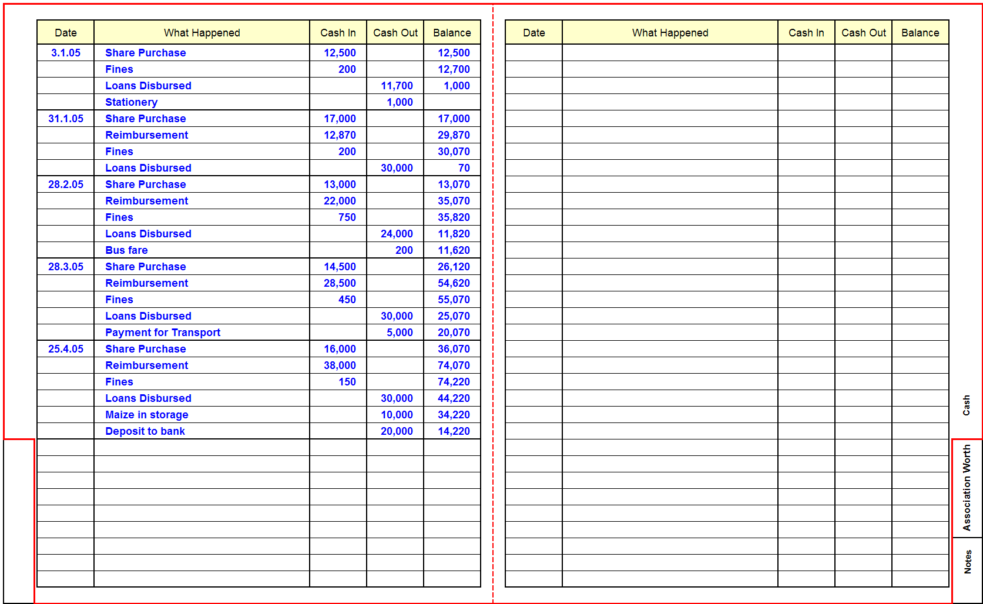

Note: Transaction recording in the Cash Book follows the sequence of activities in a meeting. Thus, Share Purchase (savings) are first recorded, because this is the first activity, followed by Loan Reimbursement. Fines are recorded before being added to the funds available for lending and then loans are disbursed. Money provided for miscellaneous expenses (such as bus fares or buying grain to put in storage) is then recorded before the final balance is noted. The final balance must always match the cash in the cash/box/pouch. Income to the Social Fund is not recorded here, because it is not related to the savings and loan cash flows, but shows up on the Statement of Association Worth, as an asset.

Step 9: Statement of Association Worth. This is a statement that is filled out after all transactions are completed. It is intended to show how much the Association’s wealth has changed from one meeting to the next, meeting by meeting. It is also intended to show how the wealth of the Association is comprised: Cash on Hand and at Bank, Current Loans, plus the value of the Social Fund, less anything that the Association owes (Debts).
Figure 12: Statement of Association Worth
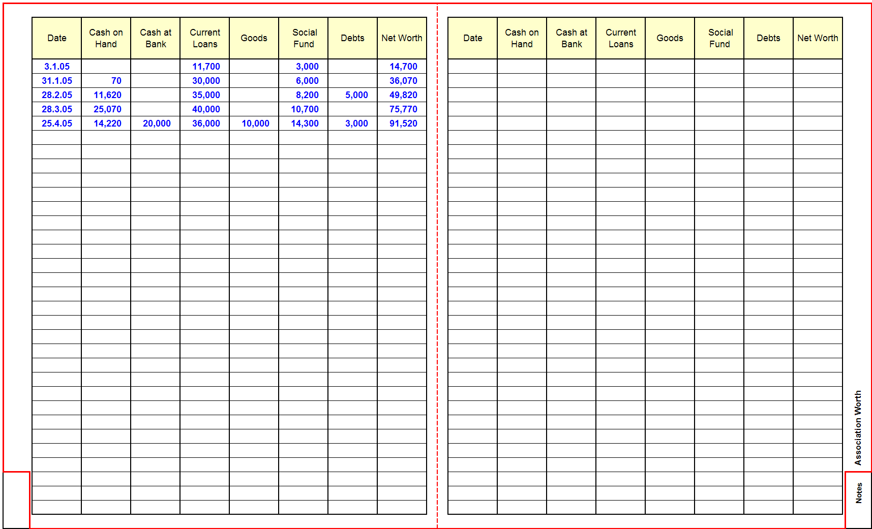

The Statement of Association Worth is not a Balance Sheet, but a statement of current assets and liabilities, because it takes into account neither fixed property (this is assumed to be negligible) nor accounts receivable. It also presumes that shares (savings) are an asset and not a liability since the owners of the shares are the owners of the Association. It is an output of the accounting system that shows what the members own and manage collectively.
Debts are included for safety and reminder reasons. It is filled out at the end of the meeting as the last entry before the books and the cash are locked up in the cash box. The Field Officer tells the Secretary that most of the entries are taken from other parts of the record keeping system, except the net worth amount, which must be calculated. The sources are as follows:
- Cash on hand Cash Book
- Cash at bank Cash Book – recorded as a transaction
- Current loans Loan Ledger – sum of amount borrowed in a meeting (note: this does not include rollover loans
- Goods Cash Book – this will show how much was paid for them
- Social Fund Social Fund Ledger
- Debts There is no record of this because no money has been paid. This will depend on the Secretary knowing what the Association owes (such as for transport services)

Figure 13: Record Book Cover
Note: As already noted, the accounting book can be made by cutting an A4 hard-cover horizontally ruled Counter Book. VSL Associates has a stock of soft-covered books, which are pre-cut and printed in English, French, Portuguese and Spanish and can be given to groups to set a standard that they can copy. These books cover a single year of operations (or more if meetings are less frequent than every week). By that time they should be sufficiently familiar with the use and organisation of the books to be able to make their own, using locally available stationery.

Meeting Procedures: General
The Management Committee is then trained by the Field Officer in how to manage a meeting. If the Record Keeping training has taken a long time, another meeting at a later time may be called to go through procedures. The type of training in meeting procedures will depend on how frequently the Association meets, how often it chooses to save and how often it chooses to lend to its members. To simplify matters the Field Officer deals with each type of activity separately (Social Fund, savings/share contributions and loan disbursement), but follows the sequence of activities as shown on Tables 15 and 16. Be careful to follow each step in the correct order
Step 1: Savings Meeting. The Field Officer points out that every meeting involves savings. If the Association has meetings weekly, fortnightly or monthly to mobilise savings, but only provides loans monthly, then (s)he emphasises that savings meetings are also part of credit meetings, when loan repayment and disbursement are both due.
Table 15: Procedures for a Savings Meeting

Step | Share/Savings Meeting Procedures
Opening | - The General Assembly is called to order by the Chairperson  - The agenda is announced by Chairperson  - Any Other Business items are called for and noted
Balance verification | - The cash box is normally on hand at the start, so the Chairperson calls on the designated Keyholders to open the box.  - The cash-box/pouch is opened by the designated Key Holders  - The Attendance register roll is called by the Secretary at the request of the Chairperson  - The Secretary asks the General Assembly how much money was left in the box/pouch at the end of last meeting and notes the amount.  - The Secretary confirms that the same amount was recorded in the Cash Book.  - Once this is done the amount of money actually in the cash box is counted by the Money Counters and announced to the General Assembly by the Secretary. It must tally with the members’ recollection and the amount written in the Cash Book.
Social Fund | - The Chairperson then announces that contributions will be made to the Social Fund.  - The Secretary asks the General Assembly if they remember how much money remained in the Social Fund at the end of the last meeting. As with the savings balances, this is confirmed by the General Assembly and by the Secretary through reference to the Social Fund Records. The Social Fund cash is normally kept in a separate bag from all of the other cash in the cash box/pouch. This emphasises that it must not be mixed with other cash and must not be disbursed as loans. It is then replaced in its fabric or plastic bag and put in the cash box.  - Again, the Secretary calls each member by name. They give their contributions to the Money Counters. The Money Counters confirm the amount and place it in a bowl that is specifically designated for the Social Fund. The amount paid is recorded by the Secretary in the Social Fund ledger against the member’s name.  - Once all the members have made their contributions, the Money Counters count the total and announce this to the Secretary, who confirms that it tallies with his/her records. The amount is announced to the General Assembly.  - Anyone needing support from the Social Fund is invited by the Chairperson to make his/her case to the General Assembly.  - If approved, the money is provided according to the conditions laid out in the Association’s Constitution and handed over to the recipient by the Secretary and recorded in the Social Fund Ledger.  - After all benefits have been paid, the total amount remaining in the Social Fund is announced to the Association. It is then replaced in its separate bag and put in the cash box.  Note: The Social Fund is not recorded in the Cash Book as income, but only in the Social Fund records and on the Statement of Association Worth. While this is not standard accounting practice, it avoids the money being mixed up with loan funds. If this happens (and it is common) the Social Fund money may not be on hand when an emergency arises.
Savings | - Once the Social Fund contributions have been paid, the Chairperson announces that Shares/Savings will be contributed.  - The Secretary calls up each member by name or by number. They give their contributions to the Money Counters who verify that the amount is what the member claims. The amount must be a multiple of the base share value, agreed on by the Association. The Money Counters announce the amount contributed and the Secretary writes the amount against the member’s name in the Savings Ledger, while the Treasurer stamps the correct number of share symbols in the Member Share Passbook. The Money Counters place the money into the Share/Savings bowl.  - Once everyone has made their contributions, following the same procedure, the total amount contributed is counted by the two Money Counters. The Secretary adds up the total amount of money recorded as having been saved to confirm that it tallies with the amount counted by the Money Counters.  - Once these sums tally, the Secretary announces how much money was saved as shares in the meeting and how much money in total has been saved by the Association members since the start of the cycle.
Fines | - Once the Social Fund and Share/Savings activities are completed, the Chairperson calls on the Money Counters to count up any fines that may have been levied up to that time and put in the fines bowl, which has been placed on the floor at the start of the meeting. These are counted and the total announced to the Secretary who announces the amount to the General Assembly and records the amount in the Fines section of the record-keeping book.  Note: When the Chairperson levies fines, the infringements, and the amount charged, must be those listed in the Constitution. The Chairperson has no discretion to charge more or less.  Note: If the meeting also involves credit, the procedure continues as listed in Table 16 on the next page and the collection of fines should be deferred to after loan reimbursements are collected.
- Expenses | - The Chairperson then asks the Secretary if there will be any expenses before the next meeting (i.e. for bus fares and stationery purchases). If there is, this money is handed over to the Secretary by the Money Counters and recorded in the Cash Book as an expense. (Note: when the next meeting is called the Secretary is expected to show what has been bought and produce a recipt and any change. This is then put into the cash box and recorded as income in the Cash Book)
Statement of Association Worth | - All cash remaining on hand after savings, credit and expense procedures are complete is counted and totalled by the Money Counters and announced to the Secretary, who announces it to the General Assembly.  - Once this is done, the Secretary prepares the Statement of Association Worth and, at the request of the Chairperson, announces to the General Assembly how much the Association is now worth, going through the statement item by item (i.e. Cash on Hand, Cash at Bank, Loans Outstanding, Social Fund, Goods on hand, minus any Debts). The last to be announced is the result of these sums – the Net Worth of the Association  - The Secretary then repeats how much money in total remains in the cash box, telling members to be ready to recall this at the next meeting.  - The Record Book and Member Passbooks are put into the cash box, together with the Cash on Hand and the Social Fund money (in its own separate plastic bag) and the Key Holders are called by the Chairperson to lock the box.
Closing | - The Chairperson then calls on the Association members who may have raised items of Any Other Business to present them to the Association and facilitates any resulting discusions.  - Once AOB is finished, the Chaiperson announces that the meeting is over and that people are free to leave.
Step 2: Savings and Loan Meeting. When loans are to be issued, all steps for a Savings meeting are followed, up to the contribution to the Social Fund (see note in Social Fund box in Table 15). At that point the procedure changes to the procedure noted in Table 16 below.

Table 16: Loan Procedures
Step | Loan Meeting Procedures
Loan repayment | - Once fines have been counted and recorded, the Chairperson asks the Secretary to list the loans that are due for repayment  - The Secretary reads out the names of the people who are due to repay (either principal and interest, or interest only) and the amounts in question.  - When his/her name is called, the borrower gives his/her loan reimbursement (principal and interest) to the Money Counters. The Money Counters count it and announce it to the Secretary who enters the reimbursement in the ‘Amount Repaid’ column in the Loan Ledger for the previous month. The Money Counters deposit the money into the loan reimbursement bowl.  - The amount of money that the borrower is able to pay is then deducted from what he/she owes (including accrued interest) and the net sum remaining (principal owing plus interest owing, minus amount paid) is noted in the ‘Outstanding Balance’ column for the previous month.  - If the loan is past due (or less was paid than what is owed) it is noted as such in the ‘Comments’ column for the previous month and listed as ‘Past Due’ in the current month in the ‘Date Repayment Due’ column. If the loan has not been reimbursed because it is not due until a later date, the Outstanding Balance is copied into the ‘Loan Rollover’ column of the current month and noted as ‘Rollover’ in the comments column of the previous month.  - Once all the loans outstanding have been repaid (either in full or in part) the Money Counters count the money in the reimbursement bowl and announce it to the Secretary, who confirms that the amount is the same as what (s)he has entered as a total in the ‘Amount Repaid’ column of the Loan Ledger.
Loan disburse-ment | - Once the loan repayments have been made the Money Counters then combine the cash in the cash box with money in the Share/Savings contributions bowl, Loan Repayments bowl and Fines bowl. They do not include the money in the Social Fund. This has already been placed in its separate bag and put into the cash box/pouch.  - The amount of cash on hand is announced to the Secretary, who notes it down and announces it to the General Assembly.  - The Chairperson then announces that applications for loans can be made.  - Individual members then put forward their loan requests. No loan is given out until everyone who wants one has said so. They must also say for what purpose and in what amount and for how long they want it, and members of the General Assembly are asked to comment  - The Secretary compares the total of loans requested with the total amount in the cash box/pouch. If the total loans requested are greater than the amount available in the cash box, (s)he proportionately reduces loan values so that everyone who requests a loan, gets a loan. (S)he may also encourage discussion amongst members if, for example, a member needs money for a seasonal activity, while others only need it for an activity that is not affected by seasonal considerations. Once it is decided how much each applicant will receive, the Secretary announces the name of the borrower and the amount to be borrowed. The Money Counters count out the amount of the loan and hand it to the borrower. The borrower counts the money and then signs the loan agreement in the Loan ledger.  - Once the loans have all been given out the Secretary calculates the total amount loaned and announces it to the General Assembly.
From this point onwards the procedure remains the same as for the Share/Savings meetings, with the Secretary preparing a Statement of Association Worth and the Chairperson going through the closing procedures, including Any Other Business.

Step 3: The Field Officer says that the next meeting will be a practice meeting with the Association, at which all of the Social Fund, savings and lending transactions will be carried out by the membership.

Summary and conclusion:
The Field Officer summarises the savings and lending procedures and tells the Management Committee that the next meeting will be a practice for all procedures. It will be the final meeting before the Association actually starts to save and to lend.
The Field Officer asks if the members have any questions
The members are thanked for their participation and the meeting is closed.
2.3.e Module 5: Meeting procedures
General
Objective: at the end of the training session:
- Each member of the General Assembly will understand how both Savings and Loan Meetings are normally conducted
- The members of the Management Committee will understand the procedure to be followed in Savings and Loan Meetings and will understand their particular roles.
T he Field Officer asks the Chairperson, Secretary and Treasurer to call the meeting to order and asks the Secretary to report to the Association what was covered at the last training meeting. After this is done, (s)he thanks the members of the General Assembly for their patience in having to wait till the Management Committee training is completed. (S)he tells the Association that today’s meeting will not be a real savings and lending meeting, but a meeting at which the members will practice savings and lending procedures.
This meeting must be conducted in a meeting room with walls, so as to allow for posting the 7 flip charts needed for illustrating the accounts.

Practice
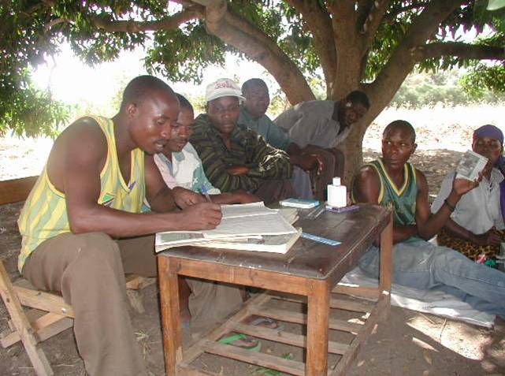
Step 1: The Field Officer seats everyone in place, facing the Management Committee, with the Money Counters sitting on a mat in front of the Committee table.
The Treasurer is asked if (s)he has brought along the kit that was handed over during the Management Committee training (Module 4).
The Field Officer then shows the kit to the General Assembly and asks the General Assembly to select Key Holders. These should be three people who are reliable and likely to show up at all Association meetings. This can be done by discussion and does not call for a vote. Key holders may not be the Chairperson, Treasurer or a Money Counter. Once the Key Holders have been selected each one is given two keys to his/her lock. A spare key is retained by the Field Officer in case of loss.
The Field Officer announces that in this meeting the Association will practice savings and credit procedures and hands out play money to all of the members of the Association, including the Management Committee. The total given out in play money notes is TShs 4,000, comprised as follows:

- 2 1,000 Shilling notes
- 4 500 Shilling notes
- 8 100 Shilling notes
- 4 50 Shilling Notes
The Money is printed out by the Field Officer prior to the trip from the master to be found in Annex 2. (S)he explains that they are using play money to avoid any risk of loss, while learning is taking place. (S)he also explains that the Association will pretend that they meet every week for savings and lend money every two weeks. This may not be what the Association actually does (most will meet weekly and lend monthly), but doing it this way reduces the number of mock meetings needed in this session and keeps the time to a reasonable level.
Step 2: The Field Officer announces that from this moment onwards (s)he will not be playing a leadership role in the meeting, but will be there to guide the Association as it goes through the process of holding a meeting. (S)he tells the General Assembly and Management Committee that at any time she may take the initiative to assist the process, but that anyone can turn to him/her at any point to seek clarification and guidance. The Field Officer can work with an assistant. The Field Officer takes responsibility for facilitating the meeting procedures, while the assistant takes responsibility for helping the Secretary keep records.
Step 3: The Assistant steps to the back of the Association and sets up 7 flip charts, which are pre-boarded with large examples of each of the record-keeping sheets (See Section 2.3.d Pages 69 - 84).
- Register
- Social Fund
- Share/Savings
- Fines
- Loans
- Cash Book
- Statement of Association Worth
Each member also receives a Share Pass Book. Throughout the meeting, the Secretary enters data in the records and enters stamps in the Member Share Pass Books, helped by the Assistant, who stops the meeting as needed to clarify any points that (s)he does not think are clear, or as anyone may ask.
Step 4: The Field Officer facilitates a Share contribution/Savings meeting, starting with a formal opening of the meeting, taking registration and proceeding to receive member contributions in the form of the play money, collecting fines and developing a Statement of Association Worth and then closing the meeting. The procedures this are listed in Table 15. At the end of each step and at the end of the meeting the Field Officer points out that the cash on hand must be the same as the ending cash figure in the accounts.
Step 5: The Field Officer then facilitates a Share contribution/Savings and Credit meeting. This is done by following the procedures listed in Table 15 and Table 16. Because there are no loan repayments due at this time, the loan repayment procedures in Table 16 are ignored and the Loan Disbursement procedures are followed. Once again, the Statement of Association Worth is completed and the meeting closed, as per the last two steps in Table 15. The Field Officer asks the Association how much money there is in the cash box and emphasises, again, that this must match the closing balance in the Cash Book.
Step 6: The Field Officer facilitates another savings meeting as per Step 4.
Step 7: The Field Officer facilitates a savings, reimbursement and credit meeting as per Tables 15 and 16.
Step 8: The Field Officer then shows the whole Association how the final accounts have meaning. (S)he shows how shares (in the member passbooks) and savings (in the records) have accumulated, the total of the Social Fund (kept in a separate bag), and shows how the Association’s wealth is composed. This is in terms of Cash (on hand and at bank) Loans Outstanding, Goods and Social fund. The Field Officer then shows how this sum may be reduced if the Association has any debts.

Summary and conclusion:
The Field Officer summarises the savings and lending procedures and tells the Association that the next meeting will be the first opportunity that the membership will have to save and to borrow actual cash and that everyone should prepare themselves for the meeting with their savings contributions and Social Fund contributions. The Field Officer asks if they have any questions
The members are thanked for their participation and the meeting is closed.
2.3.f Module 6: First Savings, Loan and Repayment Meetings
General
Objective: At the end of the training session:
- Each member of the General Assembly will have saved and those who wish to will have taken out the first loans
T his meeting will either be a Share contribution/Savings meeting (referred to hereafter simply as a Savings meeting), or it will be a Savings and Loan Meeting. This will depend on whether or not the Association has decided that each meeting will be for savings and lending, or if they wish to save more often than they borrow. Thus, Associations that meet weekly to save and monthly to borrow will have three Savings meetings before they carry out a Savings and Loan meeting. Associations that meet fortnightly and permit borrowing every four weeks will have one Savings meeting and then a Savings and Loan meeting, repeating this sequence throughout the cycle. Those that want to allow savings and lending at every meeting (whether they meet weekly, monthly or fortnightly), should be able to do so. The role of the Field Officer is to clarify whatever process is agreed and then to structure the training accordingly to ensure that meeting procedures are followed and that records and Member Share Passbooks are accurately maintained.
Note: It is common to cluster Associations from this point forward as they enter the Supervision phase. This leads to greater Field Officer efficiency, allowing many more Associations to be supervised than when they meet only with one. There are real dangers in pursuing this approach. As the number of Associations that cluster increases, the quality of supervision declines. Many errors go uncorrected because Field Officers do not have the time thoroughly to check on the accuracy of records. It is strongly suggested that Field Officers do not cluster Associations until they have demonstrated that they can maintain their records without error, and, when clustering does take place, it is with a maximum of three Associations.

Savings and Lending Activities
Step 1: T he Field Officer asks the Chairperson, Secretary and Treasurer to call the meeting to order and asks the Secretary to report to the Association what was covered at the last training meeting.
Step 2: The Field Officer allows the Association to proceed as per the procedures laid out in Module No. 4. In this meeting the Field Officer will play an active role, reminding the members of the management committee how to proceed at each step. Over time, the need for directing the meeting will diminish.
Once the proceedings are concluded the Field Officer announces the date of the next meeting. (S)he may ask the Management Committee to remain behind to cover any points of difficulty. If the Field Officer is generally satisfied with the way in which this meeting went (s)he tells the Association that from now on they are entering the intensive part of the Supervision phase and that training is concluded. (S)he reminds the Association about how the three parts of the Supervision phase will be carried out (as outlined in Tables 2,3 and 4 under Schedule of Operations, pages 21-23) and confirms the date of the next meeting.
It is wise at this time to confirm the arrangements for the security of the Association’s cash-box/pouch and to accompany the Treasurer to his/her home to ensure the safe arrival of the Association’s resources.
This is the end of the first 6 training modules. Module 7, First Action Audit and Graduation is carried out at the end of the Maturity component of the Supervision phase: Section 2.4.d, page 103.

2.4 Supervision Phase

There are three steps involved in the Supervision Phase:
- Intensive supervision
- Development supervision
- Maturity supervision

Table 17 on the following page illustrates the sequence of the three stages.

Table 17: Schematic of Supervision Phase
Supervision Phase: maximum 44 weeks
Development

Maturity

This period lasts for 16 weeks
The Development phase is chiefly characterised by a change in the role of the Field Officer. While the Field Officer plays an active role in the Intensive Phase, he/she visits less often during the Development phase, only intervening in the process if it veers off track or if the members seek advice.
If it seems that the Association is not operating as well as it should, particularly in terms of written record-keeping and in terms of the roles and responsibilities of the Committee, the Field Officer may undertake re-training in the relevant module
This period lasts for a maximum of 20 weeks, but may be less, depending on whether the group shares out its funds before a year is completed
Three visits are made during this phase. The Field Officer visits to verify that the Association can run successfully for long periods without supervision or support.
The second visit is made to evaluate the Association’s preparedness to become fully independent from Implementing Organisation, and is conducted by the Field Officer and his/her supervisor. The final visit will usually coincide with the Association’s first share-out, where the Field Officer plays an active supervisory role. Ceremonies are also usually conducted to mark the transition of the Association to full independence.
Intensive

This period lasts for 16 weeks
The Intensive phase begins on the date that Module No. 6 is delivered. This constitutes the first full meeting of the Association at which savings and loan procedures are followed
The Field Officer plays an active role in guiding the Association, through advice to the Management Committee and through close supervision of record-keeping and the maintenance of Member Share Passbooks

2.4.a Supervision: Intensive

This phase lasts at least 16 weeks. In the case of Associations that meet weekly the Field Officer should attend at least the next 6-8 meetings, but can reduce in frequency to meeting fortnightly thereafter – if the Association is capable of running meetings without a hitch and keeping accurate records. In the case of Associations that meet fortnightly or monthly, the Field Officer attends all meetings for the first 16 weeks (8 or 4 meetings respectively). During the period of intensive supervision the Field Officer plays an active role. (S)he actively participates in meetings and intervenes to help the Management Committee in terms of procedures and record keeping. His/her presence makes the members feel confident that they are on track and in good hands, capable of solving any difficulties that may emerge.
It is particularly important that the Field Officer helps the Association to maintain accurate records: especially the Savings Ledger and Share Pass Book records. Once these are badly kept the members will quickly become confused and lose confidence in the methodology. If the Field Officer feels that the Secretary is unable to maintain records for the long-term, without supervision and support, (s)he may suggest that an understudy be trained, and help in the selection. It has also proven highly effective for Community Volunteers, who receive a small stipend from the Associations themselves, to maintain Association records where there is insufficient capacity and skill to do some amongst the membership.
By the end of the Intensive part of the Supervision Phase, the Field Officer and the Field Officer’s Supervisor will need to participate jointly in evaluating the Association’s readiness to move on to the next phase, in which they will run about half of the meetings without the Field Officer present. In order that this process may be smoothly conducted, an objective means of measurement, the Change of Phase form illustrated on the next page, is used. (This is reproduced from Part 3.1 Operational Administration, as part of the package of administrative forms).
This form gives an overview of:
- The members’ level of participation
- Respect for the Association’s rules and meeting procedures
- Adherence to savings and loan policies, procedures and conditions
- Accuracy and use of Association records
If an Association does not succeed in reaching a ‘passing’ grade, the Field Officer must discuss with his/her supervisor what type and amount of remedial training and supervision is needed. It needs to be stressed that this is not a pro-forma exercise. No Association should move from one phase to another without undergoing this evaluation, which must be done by the Field Officer’s supervisor.
Note: It is not the purpose of this manual to insist on too much a prescriptive step-by-step approach to training and the conduct of Association meetings. It is, however, of vital importance to be clear about operational procedures and to be very insistent that they are followed at the start of Association operations. As Associations become very confident they may decide to dispense with some of the more cumbersome procedures but, if they know what they are, they will be able to return to them if things go wrong at a later date.

Association Health Diagnosis and Change of Phase Form

Name of Field Officer:

Name of the community:

Name of the Association:

Number of the Association:

Date of visit:

Issue |  | Points
1 Did at least 80% of the members attend the meeting?
2. Did at least 3/4 of the members arrive on time?
3. Did the management committee play its role well?
4. Was the Constitution followed?
5. Did the members of the Association participate in the discussions?
6. Were Share contribution/Savings procedures followed?
7 Did at least 80% of the members regularly buy shares since the start of the cycle?
8. Member Share Passbooks up to date and accurate?
9. Were Association Records up to date and accurate
10. Did the Secretary summarise the financial position of the Association at the end of the meeting?
Total points:
Points Key  1 = bad/no  2 = average  3 = good/yes | Condition:  Good health 21-30  Uncertain health 11-20  Sick 0 - 10
Signature of the Chairperson:
Signature of the Field Officer:

Observations

2.4.b Supervision: Development

The second part of the Supervision phase, the Development phase lasts another 16 weeks. For Associations that meet monthly, the Field Officer attends all meetings, but for Associations that meet fortnightly or weekly the Field Officer attends every second meeting, making sure that (s)he attends all loan meetings. The purpose of this phase is for the Association to take over full responsibility for running meetings, with the Field Officer acting more as a consultant to the members: responding to their concerns and questions rather than actively guiding the meetings.
The purpose of this is to consolidate the Association so that it can be confident in its capacity to manage operations.
If there is a problem, it may be necessary to examine the situation in more depth. Discuss with the participants in order to decide how best to proceed in solving the problem.
When the problem is related to a lack of comprehension, the Field Officer returns to the topic that was not well understood. If not, confusion will reign and impede the Association’s progress.
Even if the participants say that everything is working well, the Field Officer should periodically ask some questions which will allow him/her to uncover potential issues.
For example:
- Do the participants attend meetings when the Field Officer is not there?
- Are the weekly Share/Savings deposits regular?
- Is the Constitution (for example, payment of fines) respected?
- If the management committee fulfilling its role?
- Is there any confusion in the operation of the loan disbursement and repayment methods?
- Are the written records being maintained properly and accurately and is the Secretary providing an informative report on the state of the Association’s finances?
- Are there any disputes that are causing difficulties?
- Do they need technical support?
- If yes, what kind of support?
After each monitoring visit, the weak points are analysed and the Association is informed of them. The Field Officer discusses them with the participants so that they can address the problem and, if need be, make arrangements for re-training.
At the end of the Development Supervision phase the Field Officer once again uses the “Association Health Diagnosis and Change of Phase Form”, which (s)he fills in, again in the company of his/her supervisor. Movement on to the next phase, the Maturity phase depends on a satisfactory assessment by the Field Officer and his/her supervisor. This is a particularly important changeover. The Field Officer is telling the Association, in effect, to operate for long periods of time without support. If there are any weaknesses or lack of cohesion they must be addressed at this point by the Field Officer and his/her supervisor who should prescribe remedial training and an extension of the Development Supervision phase. Field Officers and their supervisors must not be tempted to ignore any issues that emerge at this stage.
2.4.c Supervision: Maturity

By the time this part of the Supervision phase arrives there is no need at all for regular interaction with the Association. But by maintaining occasional contact with Associations, the Implementing Organisation is identifying/agreeing on a point of future evaluation to check and see if the Association manages to run successfully, without supervision, for long periods of time. It is also to ensure that the Implementing Organisation can help the Association when it comes time to share-out their funds, if this is what they want to do.
A first meeting is scheduled about 1/3 of the way through this 12-week phase (in week 36), just to maintain contact with the Association and reassure them that the Implementing Organisation is still involved with them and interested in their progress.
A second meeting is an evaluation meeting and will take place 8 weeks into the phase. This is attended by the Field Officer and his/her supervisor. At this point, they check the written records (including the Member Share Passbooks) and ask the Secretary to give them a report on the activities (deposits, loans disbursed and reimbursed) that have taken place in the absence of the Field Officer.
During this visit the Field Officer can, if necessary, help resolve any problems that the participants faced in the preceding meetings. If (s)he observes that the management committee is having difficulties, (s)he can propose a retraining.
The results of the evaluation will guide the Field Officer and his/her supervisor in making their decision as to whether or not the Association should become independent.
The decision is announced to the participants and a date is set for the last meeting at which the Implementing Organisation will have any official responsibility, after which the Association will be fully independent. This will coincide, usually, with the first Share-out/Action Audit and involves celebrations to mark the Association’s graduation from dependency to independence. The Share-out/Action Audit procedure requires training and is the last of the training modules. It is separated from the rest of the training modules because it takes place 10 months after the original training.

2.4.d Module 7: Action Audit (Share-out) and Graduation
General
Objective: at the end of the training session:
- Each member of the General Assembly will have received his/her share of the total amount of group assets that the group has agreed to share-out
- The group is officially made independent of Implementing Organisation.
At the final meeting of the cycle, the Association conducts its normal savings and loan activities, except that after loans are reimbursed, no new loans are given out. The Association should be informed at the start of the Maturity stage of the Supervision Phase that it must not give out any new loans that cannot be repaid before this final meeting. Thus, if the members decide to Share-out/Action Audit in early December and give loans of between 1 and 3 months duration, no three-month loans can be given later than early September and no two-month loans later than early October.

Procedure
Step 1: Once the group has completed all of the Social Fund, savings, loan reimbursement and fines procedures the Chairperson calls on the Money Counters to count the total amount of money in front of the members.
Step 2: The Secretary then announces that this money will be shared out amongst the members. (S)he first of all discusses with the members how much, if any, of the money will remain in the Association’s fund, so as to kick start lending at a higher level during the next cycle. The members must all agree on this and the money is set to one side.
Step 3: If any member owes the Association money (from loan arrears), the shares equal in value to his/her debt are cancelled in his Share Pass Book and from the Savings ledger. In this way the defaulting member is penalised, because the cancellation of the shares means that he/she will not receive the profit on those shares, but only the shares remaining.
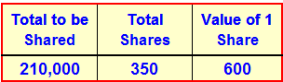
Step 3: The Secretary then takes each of the members’ passbooks and counts the total number of shares that have been bought. Using the calculator in the kit, (s)he then divides this number into the total amount of money on the table and announces the result as the current value of a single share.
Step 4: She then takes each individual passbook and announces the number of shares that a person owns. She then multiplies this number by the value of a single share (again using the calculator) and announces the amount to the General Assembly.
Step 5: The member then comes forward and receives the money from the Money Counters. At the same time the Secretary removes the value of the shares from the Member Share Passbook by striking them out as shown in Figure 6 on the following page.
Figure 6: Cancelled Shares
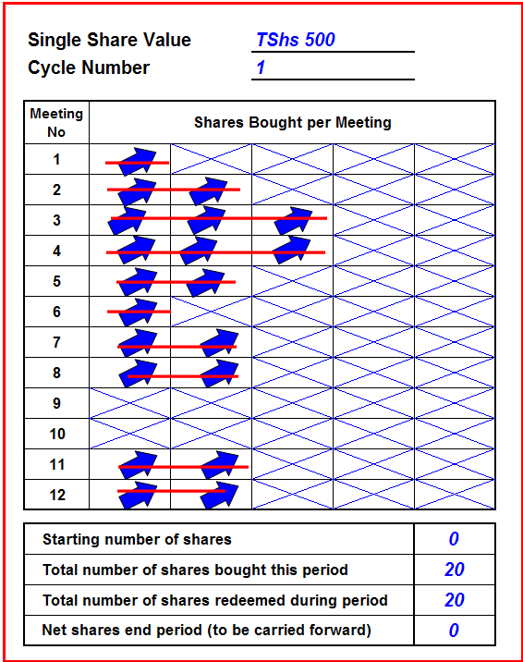
Figure 6, on the left shows that shares have been physically cancelled with a pen and, also, that in the box below the 20 shares bought during this cycle, 20 have been redeemed (cashed in). This member (Monica Auma) will thus receive TShs 600 x 20 = TShs 1,200

Step 6: Once the Share-out/Action Audit is completed, The Money Counters announce the amount of money left in the cash box/pouch. This is comprised of what the members have decided to leave in for the next cycle and also any money left in the Social Fund.
Step 7: Any member who has failed to pay contributions, or has loans outstanding that remain unpaid will be called to pay what remains owing from the money he/she received from the Share-out/Action Audit. This will then be added to the money in the cash box as the Association’s property.
Step 8: The box is locked
Step 9: The Field Officer officially announces that the Association has graduated from the Implementing Organisation’s support and is now fully independent. (S)he tells the members that the organisation will maintain contact from time to time for follow-up purposes (especially if the Association is part of the Monitoring and Evaluation (M&E) sample). The Field Officer hands over a certificate of independence and accomplishment.
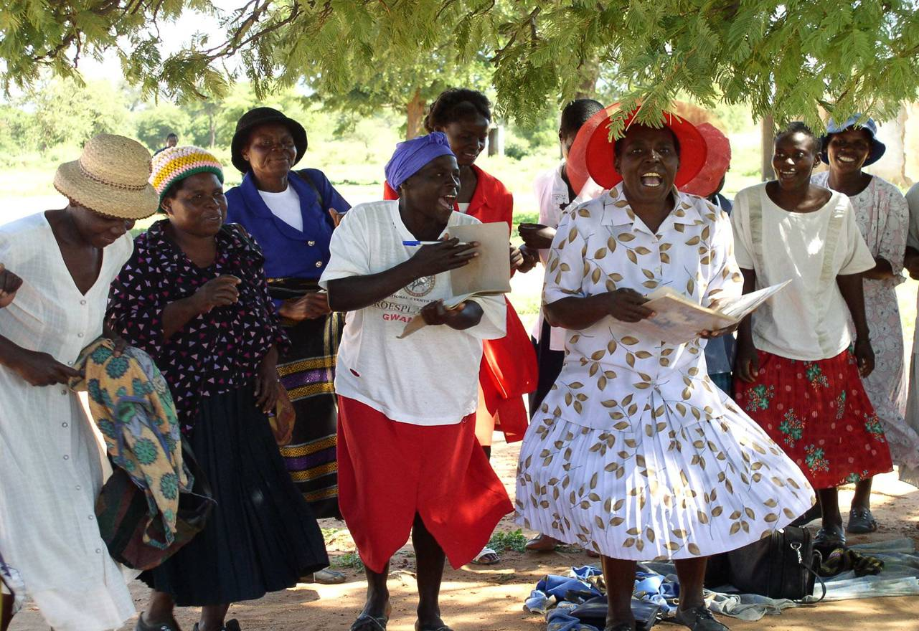
Step 10: The Association may decide to hold a party to celebrate their accomplishment and this is to be encouraged. The Field Officer participates and should make a contribution towards the costs.

Conclusion
Before leaving the participants, the Field Officer can give some advice:

- Promote exchange and dialogue among the members of this Association and others.
- Give technical support to participants who are not members, but who want to create VS&LAs.
- Alert the project to the existence of these Associations so that the project can provide training
- Continue savings and loan activities with the VS&L system.

Part 3: Programme Management

3.1 Operational Administration
The forms that follow are part of the Management Information System (MIS) for a VS&L project, but use qualitative data to evaluate the Association performance and Field Officer performance.

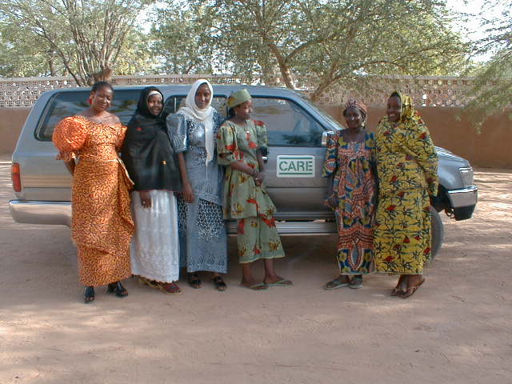

Monthly Report by VS&LA

Name of Field Officer:

Name of the community:

Name of the Association:

Number of the Association:

Phase and Stage:

Date of Visit:

Field Officer’s summary

1 –Number of meetings held in the month (if meetings were not held, explain why)

2 –Topics of meetings held.

3 –Problems encountered.

4 –Visit by technical service or others (explain).

5 –Is there a demand for the creation of new Associations?

6 –Did you ask your supervisor’s help in solving a problem? If yes, explain how.

Monthly Report by District Covered by Field Officer

Name of Field Officer:

Name of District:

Number of Associations in District:

Number of Associations formed in the last month:

Number of Associations ‘liberated’ in the last month:

Number of Associations visited during the month:

1-Describe problems that appear to be common to a number of Associations

2-How did you deal with these problems?

3-What recommendations do you propose for a long-term solution?

4-What additional support do you need?

5-What opportunities do you see for improving the efficiency of your work?

Monthly Programme of Activities

Field Officer:

Month: Year:

N.B. The name of Associations to be visited, administrative time and project staff meetings should appear on this form

Week | Monday | Tuesday | Wednesday | Thursday | Friday
1
2
3
4
5

Association Health Diagnosis and Change of Phase Form

Name of Field Officer:

Name of the Community:

Name of the Association:

Number of the Association:

Date of visit:

Issue |  | Points
1 Did at least 80% of the members attend the meeting?
2. Did at least 3/4 of the members arrive on time?
3. Did the management committee play its role well?
4. Was the Constitution followed?
5. Did the members of the Association participate in the discussions?
6. Were Share contribution/Savings procedures followed?
7 Did at least 80% of the members regularly buy shares since the start of the cycle?
8. Were Member Share Passbooks up to date and accurate?
9. Were Association Records up to date and accurate
10. Did the Secretary summarise the financial position of the Association at the end of the meeting?
Total points:
Points Key  1 = bad/no  2 = average  3 = good/yes | Condition:  Good health 21-30  Uncertain health 11-20  Sick 0 - 10
Signature of the Chairperson:
Signature of the Field Officer:

Observations

Staff Supervision Form

Name of Field Officer:

Name of the Field Officer’s Supervisor:

Name of the Association:

Number of the Association:

Phase:

Date of Visit:

Was the Field Officer’s work plan for the month prepared? Yes No

Was the objective of the meeting attained? Yes No

Did the participants understand the purpose of the meeting? Yes No

Did the Field Officer encourage member participation? Yes No

Did the Field Officer deal properly with questions and problems? Yes No

Did the Field Officer ensure that proper procedure was followed? Yes No

Did the Field Officer allow the Committee to run the meeting or
did (s)he tend to dominate? Yes No

Feedback with the Field Officer

Issues arising

Solutions recommended

Signature of Field Officer:

Signature of Supervisor:

3.2 Management Information System

Performance data needs to be generated by the Associations, so that they can manage their savings and loan portfolios. This should be the sole source of data that feeds into the VS&LA database. The form on page 116 is the most important for a project, because it is the source data, controlled by the project, enabling it to evaluate scale, performance and efficiency. The Form defines the information to be gathered and its source (to assist the Field Officer). It will be seen that most of this data can be gathered from the Association’s Record Book, from the project’s own data base and by direct observation. It is collected in raw form on the Portfolio Analysis Data Collection Form, illustrated on the following page. The Field Officer carries out no analysis of this data but passes it on to the Data Capture Clerk. Once collected the data is input into the project’s VS&LA database, using an Excel Spreadsheet.
Once entered into the database, the output is a spreadsheet that can be sorted in a number of ways to provide management information. This is the Consolidated Association Performance Analysis tool, which is passed on by the project manager to the Field Officers who can use it to compare their efficiency and effectiveness with each other. The project manage can use it, sorted in as many ways as (s)he wishes, to analyse the performance of each Field Officer and to identify the major characteristics of any given Field Officer’s portfolio.
Flowing out of this is a form that is automatically generated by the spreadsheet. This consolidates the performance of each Field Officer into a programme wide analysis.
Table 18 shows the MIS process. This shows what data is used, who creates it, who receives it and when it is generated.

Table 18: MIS Matrix : Programme

What | Who Creates | Who Receives the information | When
Field Officer Data Collection Form | Field Officer from Association Documents:  - Attendance Register  - Social Fund Ledger  - Share/Savings ledger  - Fines Ledger  - Loan Ledger  - Cash Book  - Statement of Association Worth | MIS/Data Capture Clerk | As soon after visit as possible
Consolidated Association Performance Analysis | MIS/Data Capture Clerk | Manager, passed back in summarised form to Field Officers | Monthly
Overall VS&LA Project Performance | MIS/Data Capture Clerk/ Manager | Director of Programme, Field Officers, external audience | Monthly

Module 4 (Record Keeping and Managing a Meeting – Page 66) shows a set of records for a particular Association, Ralang B. The Field Officer is Nelly Otieno. The tables that follow show how relevant data is captured and used as a management tool. Once this data is collected it is entered into the project’s database.
The paragraph on the following page shows the MIS information flows in schematic form. This rather complicated diagram shows how information is derived from the Association accounts and the flows from the Field Officers to the Data Capture Clerk, who processes it into usable information for feedback to the Field Officers and onward transmission to managers, senior managers and an external audience. It also shows how planning information is prepared as well as Association-level narrative reports by Field Officers and transmitted on to Supervisors and Managers. Finally, it shows how information flows from Managers to Field Officers
Figure 13: Information Flows
1
2
3
4
5
Data Capture Clerk/ M&E Officer
Field Officer Supervisor/ Project Manager
Field Officers
Monthly:
Association Portfolio Data entered in MIS from FO Data Collection Form
Monthly:
Performance Summary from MIS

Monthly: Detailed Performance Analysis derived from MIS
Periodic:
Field Officer Performance Feedback
Monthly:
Narrative Reports and Plan of Activities
Programme Coordinator/ Country Director
Periodic:
Overall Performance from MIS
External as needed:
Overall Performance from MIS
VS&L Associations
Scheduled Visits:
FO Data Collection Form from Association accounts
MIS and Operational Reporting: Information Flows
Supervisory and Reporting relationships
MIS Information Flows
Field Officer Management and Planning
Field Officer Data Collection Form
The Field Officer visits the Association and collects information at each visit. Some of this data is obtained from the project’s database (i.e. date of Association start-up), some of it relates to observations made during a visit (i.e. number of members). Some of it is obtained from the Association’s financial records, or by questioning the members. The Field Officer Data Collection Form guides the Field Officer as to where the data can be found. In no case is the Association expected to generate any data that it does not need for its own financial management purposes.
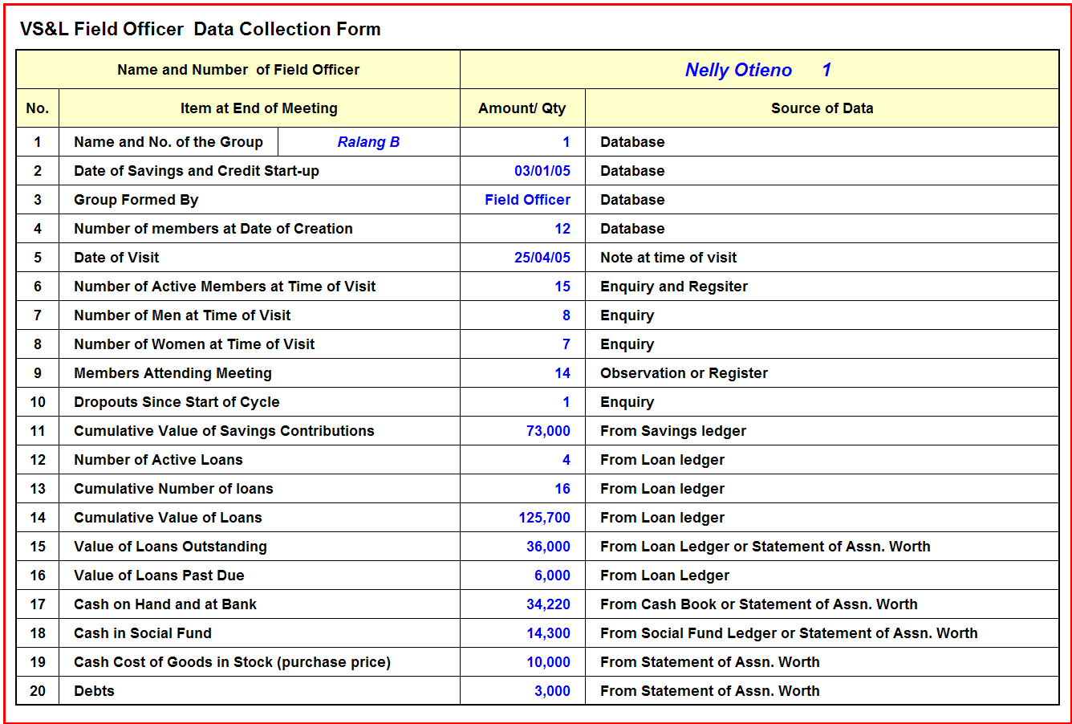
Figure 14: Filed Officer Data Collection Form
The Field Officer fills out the form and, once back in the office, hands in the form to the data capture clerk, who notes items 1-20 above and enters each datum in the column of the same number in the relevant Field Officer Performance Analysis sheet, in the accompanying MIS software. The pages that follow show how the MIS is used, how data is entered and how the various outputs may be used to analyse performance.
The Field Officer fills out this form at each visit. (S)he does not need to analyse it in any way. It is also not important if visits are irregular, because the method of analysis looks at performance data that are not affected if visits are made irregularly. It is, however, the case that data becomes more accurate and meaningful after 3 months of savings and lending activity and is considered highly reliable in the closing 3 months of the cycle.
The example that follows uses the data from Ralang B and shows how this relates to the overall Field Officer portfolio information, which looks at all the Associations that (s)he is training and supervising. This is then combined into programme level information. The same example is followed throughout in the explanation of how to use the MIS.
    - Portfolio Tracking System
Figure 15: Opening Screen
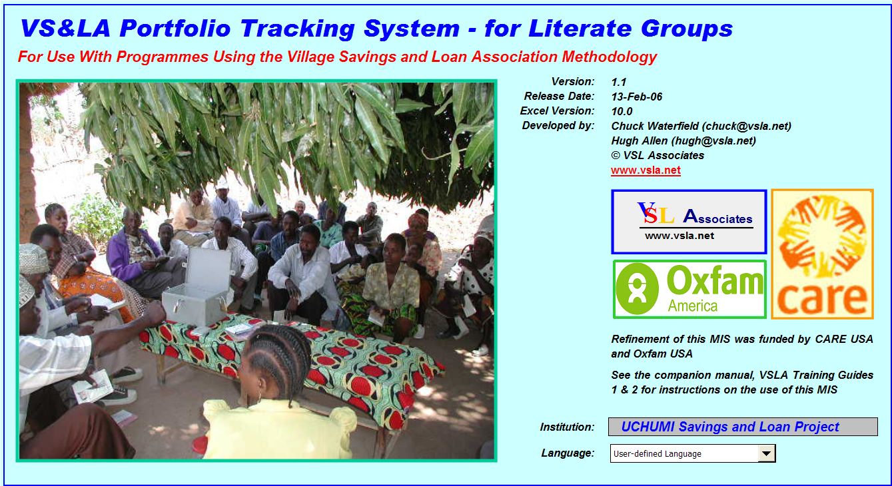
Figure 15 above allows the Data Capture Clerk/Analyst to enter the name of the organisation and the language in which the MIS is configured. English, French and Portuguese are currently catered for, with Spanish under construction. The user can also set up the sheet to include another language, by clicking on ‘user-defined language’ in the Language cell. This takes the user to a translation sheet where (s)he is free to enter translations against any other language in the grey cells. Only grey cells in the spreadsheet permit data entry.
Colour Coding
The Portfolio Tracking system is an Excel file that accompanies this manual: Programme Level MIS 1.1 Literate
When the file is loaded the screen on the previous page appears. This indicates that the version is a first release of the software. Users should be aware that it is still under testing and will undergo upgrading and revision. Because it is still under testing by users, backups of any information used should be maintained on the pre-existing system in use by a project until the system has fully proven itself.
The MIS is to be used solely for tracking the performance of Associations that follow the VS&L methodology and record-keeping system, because its design is closely integrated into the specific procedures and systems developed for this Programme Guide. The file is protected so that none of the formulae may be altered without the permission of the designers. While the users are free to enter data and to save the resulting file with whatever name they wish, data can only be entered in the unprotected cells. All unprotected cells are shown with grey backgrounds and when text is entered it is blue; cells that show an output are coloured beige and have black text, while the background to the worksheet is blue and no data can be entered or generated here. Light green indicates important headings.
The following segment of one of the sheets shows how this colour coding appears.
Figure 16: Colour Coding
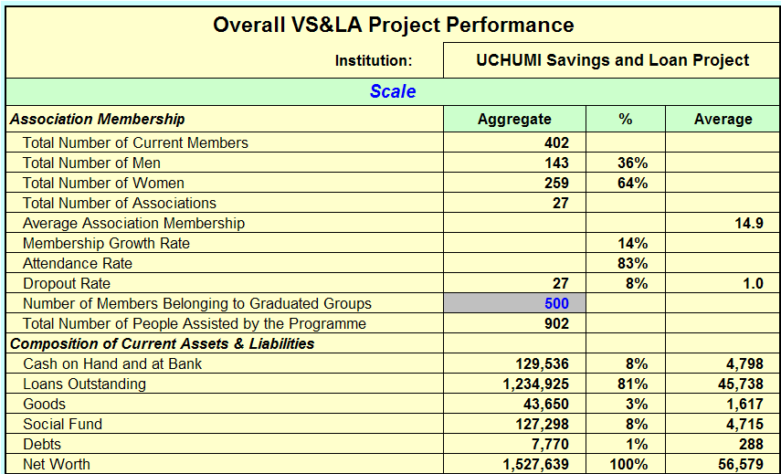
This example (incomplete) is part of the Programme Performance Sheet. Because it is an output sheet it is beige with black text. The grey cell with blue text (number of clients belonging to graduated Associations) shows where data can be entered, while the background seen on the screen is the light blue border to the left, top and right. The category heading ‘Scale’ is shown on a green background, with blue text. This convention is used throughout.
Data Inputs: Field Officer Portfolio
When the Analyst has opened the file, (s)he clicks on the worksheet tab entitled ‘FO Sheet (1)’. The following page shows how this screen initially appears.
Figure 17: Initial Data Entry (1)
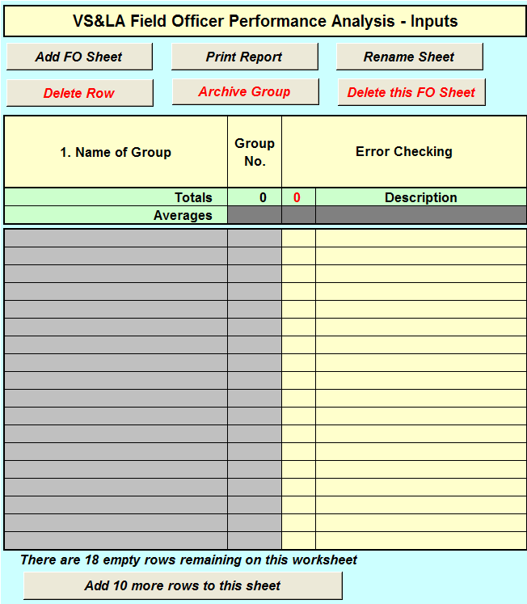
This is the main sheet in which data is entered and from which an analysis is produced of the individual Field Officers’ portfolio.
The part of the sheet on which data is entered is headed ‘VS&LA Field Officer Performance Analysis – Inputs.’
What is shown in Figure 17 is the part of the screen that is horizontally frozen. All other parts of the worksheet – the 19 additional data columns and the output table all can be seen to the right of these columns and move with the movement of the space bar or arrows on the Numeric pad.
There are 7 macro buttons on this sheet – six at the top of the table entitled, respectively ‘Add FO Sheet’, ‘Print Report’, ‘Rename Sheet’, ‘Delete Row’, ‘Archive Group’ and ‘Delete this FO Sheet’ At the bottom of the table is another button, ‘Add 10 more rows to this sheet’.
Each macro needs explanation.
- Add FO Sheet: When this button is pressed the existing sheet is automatically copied and reproduced as a new worksheet, automatically named in ascending numerical sequence. Thus, while the parent worksheet is called ‘Field Officer the next worksheet will be called ‘FO Sheet (1)’. It is important to note that when the worksheet is copied, everything in it is copied, including all data entered by the Analyst.
- Delete this FO Sheet. This is self-explanatory, but the first sheet cannot be eliminated. Only additional worksheets can be removed
- Print Report. This allows the Analyst automatically to print the worksheet. It will not print all worksheets, but only one by one as the Analyst requires. This also applies to the final output sheet in which the programme’s performance is summarised (Programme Performance).
- Rename Sheet. This allows the Analyst to name the sheet in the name of the Field Officer. This cannot be done by using the normal Excel sheet renaming convention.
- Delete Row. This is self-explanatory. It is used when the Analyst removes a group from the sheet that (s)he does not want to archive (see below)
- Archive Group. This allows Associations that have graduated from the programme or who have stopped their activities to be removed from the Field Officer’s worksheet and for the data to be transferred to an archive worksheet that allows for continuing follow-up. The Analyst may choose to move all Associations that have left the programme or graduated to be archived, or only those that will be followed up for the long-term
- Delete this FO Sheet. This is self-explanatory, but the first sheet cannot be eliminated. Only additional worksheets can be removed
The first thing the analyst does is to enter the name of the Field Officer and then, one by one, the names of the Associations with which (s)he works, including their number. Each Field Officer numbers his/her Associations as they are recruited. This means that a master record of Associations must be taken in which the numbers are collated with the Field Officer to create a master roll. This is not done by this worksheet.
The data is entered by a Data Capture Clerk or an Analyst, and is taken directly from the Field Officer Data Collection Form. The table shown below shows what this Field Officer’s portfolio would look like, with each Association name and number entered.
Figure 18: Initial Data Entry (2)
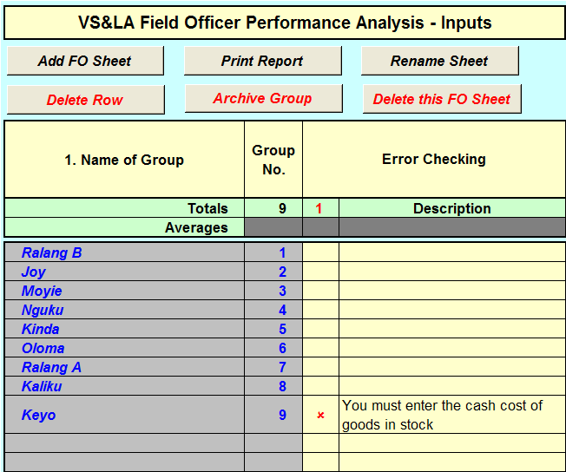
Note that under the ‘Group No.’ title, the total number of Associations is created automatically.
To the right of the Group No. column are two error checking columns. If the red number is ‘1’ this shows that the data is not yet completely entered and describes what data must next be entered. If all of the data is fully entered the error message will disappear and the red number will change to ‘0’.
In this case, the Analyst/ Data Capture Clerk has completed data entry to column 19, but needs still to fill in column 20.
From this moment onwards the Analyst/Data capture Clerk moves the cursor to the right of these columns and enters data in the subsequent 19 columns (2-20) in exactly the same sequence as they appear in the Field Officer Data Collection Form. On the following page the 19 columns to the right of the columns shown above are reproduced. In this case the data is now completely filled out for all of the Associations, including Keyo Association.
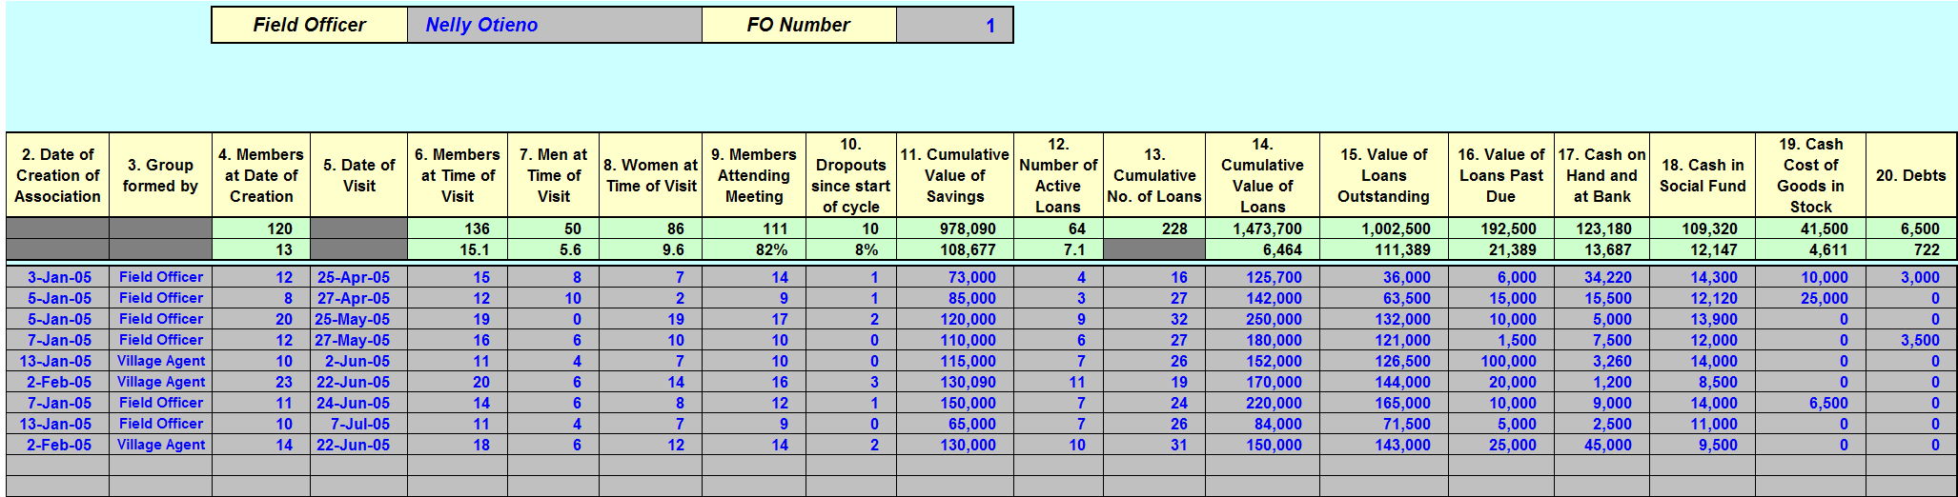
Figure 19: Completed Data Entry Sheet (initial data entry of group name and number omitted)
It will immediately be seen that the data on the Field Officer Data Collection Form is the same as for the first Association, Ralang B. Each column is clearly headed with exactly the same number and similar words as those appearing on the FO Data Collection Form.
What is shown here is a snapshot of the Field Officer’s Portfolio, but mainly in terms of raw data. No analytical result is shown in this table, except for totals and averages that describe the portfolio in aggregate and average terms. These aggregates and averages are shown in the green horizontal band at the top of the page, with totals on the top line and averages on the bottom.. Where individual cells are shown in grey, this is because no meaningful result can be obtained. It is, for example, illogical to have an average of column 5, since, by definition it is not susceptible to averaging nor totals
Once the Analyst/Data Capture Clerk has done this, (S)he needs to do no further analytical work, because the output will show up further to the right as Outputs. This starts on column Z. The Outputs occupy 24 columns, which makes the text very hard to read in hard copy form. The Analyst need only print those of specific interest by hiding the columns that are not vitally important and may choose to print different versions of the same table for different audiences.
Outputs: Field Officer Portfolio
The table immediately below shows the complete set of outputs for Nelly Otieno’s portfolio.
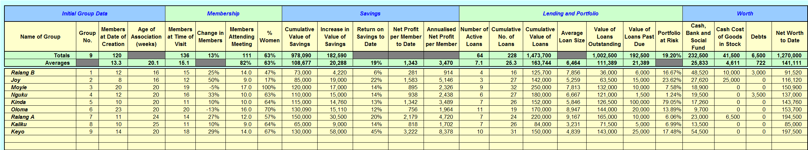
Figures 20 and 20a : Output Sheet
The same information is shown again below, but with fewer output columns, so that it can be more easily read. The Analyst can vary the presentation according to the needs of the audience receiving the information. Note that the information is divided into five categories:

- Initial Group data: information on the Associations
- Information on the Membership: numbers, change in the number of members and gender
- Savings: amounts, rates of increase, returns and profits
- Lending and Portfolio information
- Worth. The net worth of the Associations

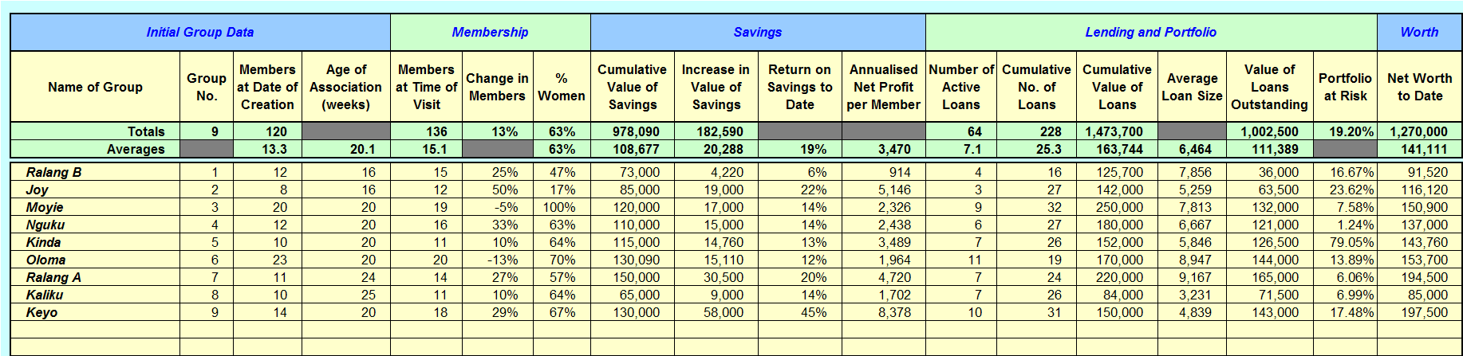

Sorting Outputs: Field Officer Portfolio
When portfolio information is listed only in the order in which the Associations were recruited into the project it is obvious that the performance of each will vary as a result of many other factors (level of local economic activity, infrastructure, market opportunities etc.) If the analysis is to be useful to the supervisor of the Field Officer it is necessary that (s)he has the means to rank the Associations by other criteria.
To do this, the analyst enters the letter designation of the columns (s)he wishes to sort (in this case Column AWP, Return on Savings to Date) and, using a pop-down menu on the direction of the sort chooses either ‘Ascend’ of ‘Descend’. The next step is to press the ‘Sort Info’ button and the entire table will sort as needed. This provides Field Officer Supervisors with a powerful tool. In this case, for example, the Supervisor might ask what distinguishes Ralang A and Ralang B. Since they come from the same village there must be some reason for their very different performance. It might also be reasonable to ask why Keyo is so very much more profitable than others, or why Olome, with the largest loan portfolio provides one of the lowest rates of return.
The example given here shows a number of columns hidden by the Analyst for purposes of clarity.
Figure 21: FO Table Sorted for Return on Savings to Date
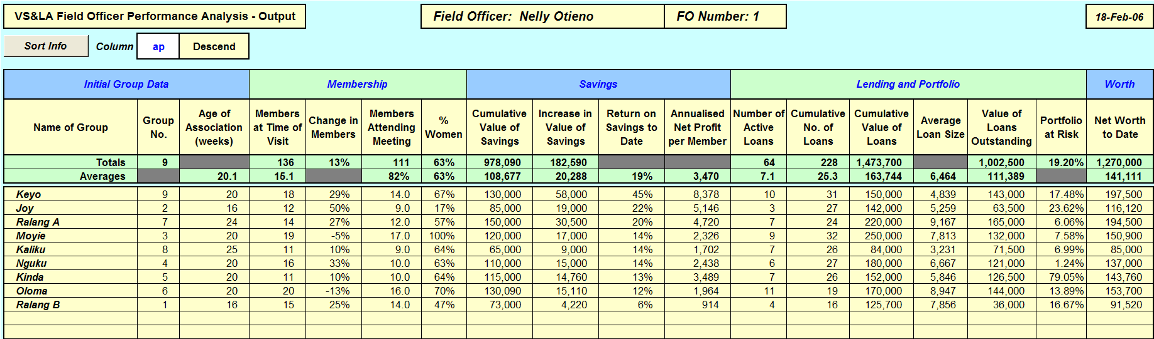

Field Officer Comparison
At the end of each reporting period it is useful to compare the performance of all Field Officers. This can be done by analysing each of the FO worksheets, but is greatly simplified when only the key results pertaining to efficiency and portfolio quality are summarised. When the Analyst clicks on the FO Comparison Sheet, all of the Field Officers’ performance summaries are compared. In the case study illustrated here it looks as follows:
Figure 22: FO Comparison
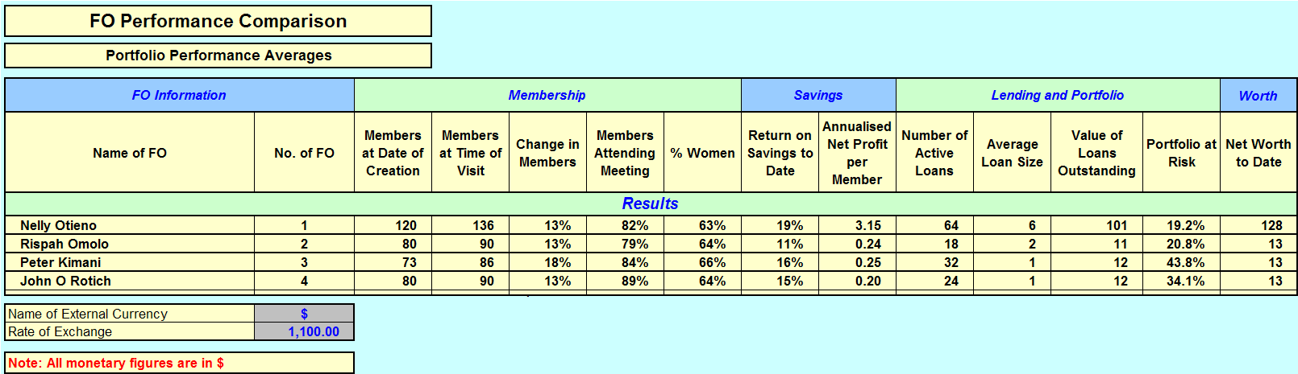
It can clearly be seen that in terms of scale, portfolio quality and return on savings to date, Nelly Otieno is significantly out-performing all of the other Field Officers.
Note that all of the monetary figures have been converted into US Dollars. This is done simply by entering the type of currency against which the local currency is being measured in the upper grey cell (Name of External Currency) and, in the cell below, entering the rate of exchange. This is useful, because it allows for cross-programme comparisons and is particularly useful in places where inflation is high because, month by month, it indicates if the purchasing power parity of profits, Loans Outstanding and Worth is being maintained – all of which are critical factors in maintaining motivation and participation. In this case it is clear that somehow, Nelly Otieno is providing a service that is likely to maintain client interest, while there is grave risk that all of the other Field Officers are doing less well, especially since their Portfolio at Risk figures are so high. These results should immediately provoke a review of the reasons for such disparate performance. This might simply be that Nelly Otieno works in a high potential area, while the others do not, but this, in itself, might lead to revisiting the targeting policy of the project.
Programme Performance
Programme Performance takes the information from each Field Officer’s individual portfolio and does two things with it:
- Amalgamates all the Field Officer Output information into programme totals, percentages and averages
- Presents this information in a form that describes the overall programme in more general terms, divided into categories that have meaning for country offices, overseas head offices, Board members, donors and external observers.
Thus far we have described what happens at the level of the individual Field Officer. Most programmes have more than one field officer and it becomes necessary to do two things with this information:
- Compare the performance of each Field Officer
- Merge all portfolio information so that the scale, financial performance, efficiency and the staff profile can be described, to give an overall snapshot of the programme at least on a monthly basis.
The first of these uses has been described in the previous sheet. Merging this information is done on the Programme Performance sheet and looks as follows for a typical VS&LA project with 4 Field Officers.
Most of the information here is automatically generated, except for the data entered in blue font in the grey cells.
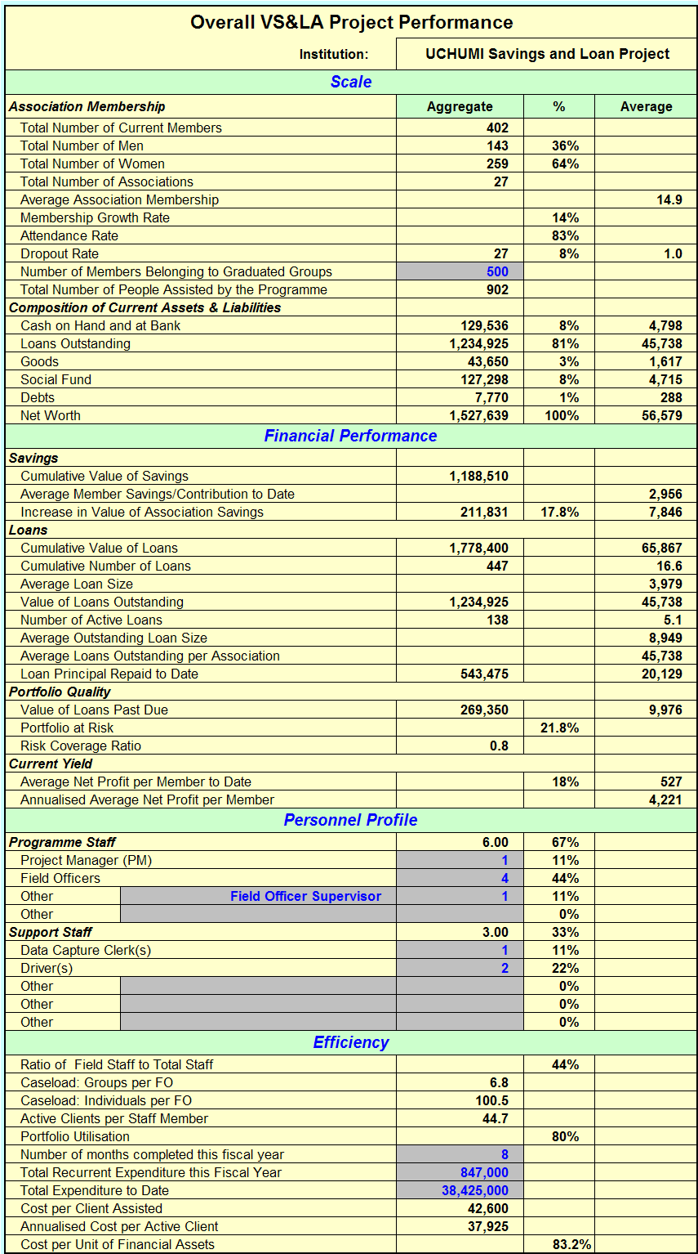
Figure 22: Overall Project Performance

Performance Ratios
The Small Enterprise Education and Promotion (SEEP) Network has been instrumental in creating performance ratios for MFIs, now codified in the Format for Reporting, Analysis, Monitoring and Evaluation (FRAME) tool. Similarly, Community-based microfinance programmes are in the process of developing performance indicators that allow for cross- programme comparison and measurement of Effectiveness, Financial Performance and Efficiency. They do not measure sustainability, because Savings-led Community-Based Organisations are inherently sustainable, because there is no institution to support that derives revenue from lending – except the CBO.
The following Performance Ratio table is automatically generated by the MIS.
Figure 23: Performance Ratios
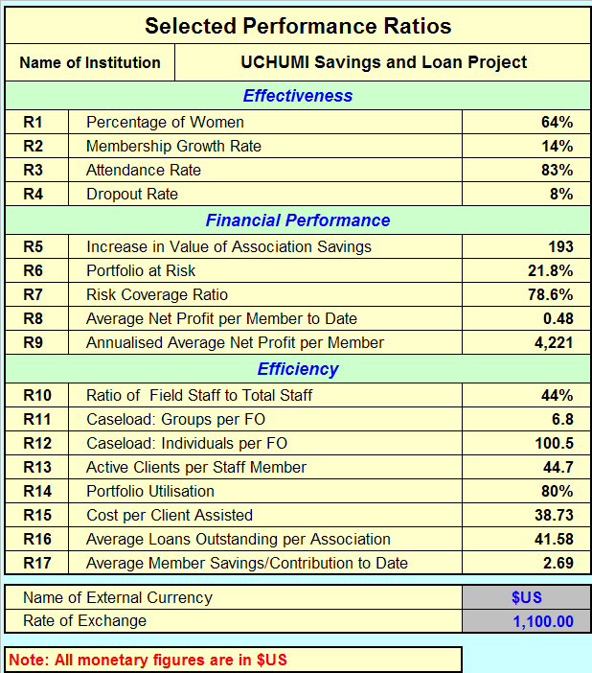
These ratios may change over time as an industry consensus emerges that supports the interests of many organisations to compare performance.
Note that again a US Dollar exchange rate is used to reduce all financial figures to an international currency. The Euro or Yen would also be appropriate, since each would permit ready conversion.
It is the long-term intention of the informal consortium of practitioners to develop this tool in 2006 for common adoption in each organisation.

Archiving
The MIS is intended solely to capture the performance of Associations that are not yet independent and autonomous. Once Associations graduate (or drop out), they should be eliminated from the MIS. This is done simply by placing the cursor on the row occupied by the group to be eliminated and clicking on the red ‘Delete Row’ button at the head of the Field Officer sheet. Once this is done the row is deleted and all data is lost. Once this action is done, it cannot be reversed.
If the Analyst determines that an Association will be followed up for the long-term, (s)he places the cursor on the group row, in any cell, and presses the red ‘Archive Group’ button. Once this is done, the Association and all the data pertaining to it is transferred automatically to the ‘Graduated Group Archive’ sheet. New data can be entered for groups that are transferred to the ‘Graduated Group Archive’ sheet, but the results of any changes in the data are not any longer integrated into the performance figures for the programme. If the Analyst wishes to consolidate data for graduated groups for long-term follow up, (s)he must copy the input data to a new version of the MIS. In such a case there is no need to enter multiple sheets for Field Officers, but simply to create a ‘Long-term Follow-up’ sheet in lieu of a Field Officer and to ignore programme cost data on the Programme Performance sheet. It is the intention of the authors to create a customised ‘Graduated group MIS’ in 2006 that focuses solely on long-term Association-level performance.
Figures 24 a and b show the Archive sheet with one Association’s data transferred here. No data can be entered, even though the shading of the data entry cells has been transferred from the FO sheet.
Note that output sorting is possible, to facilitate analysis of sample grouping.
Figure 24a Archive Sheet: Data Input Side
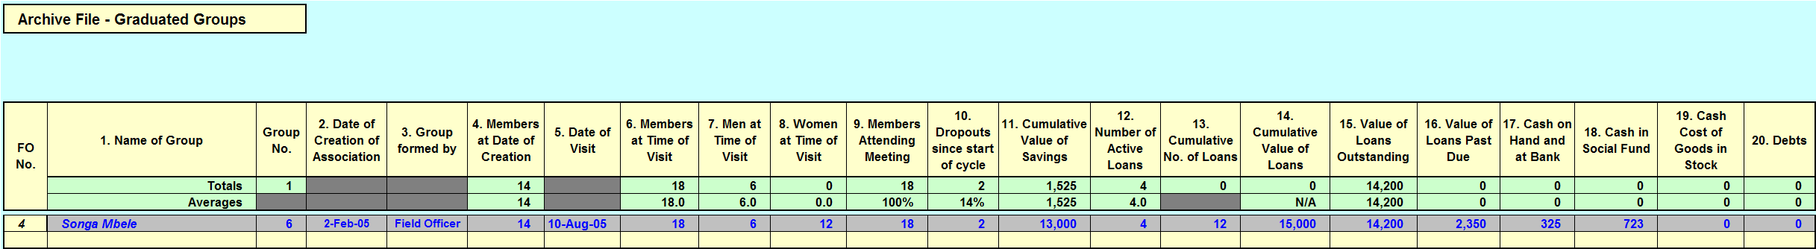
Figure 24b Archive Sheet: Data Output Side
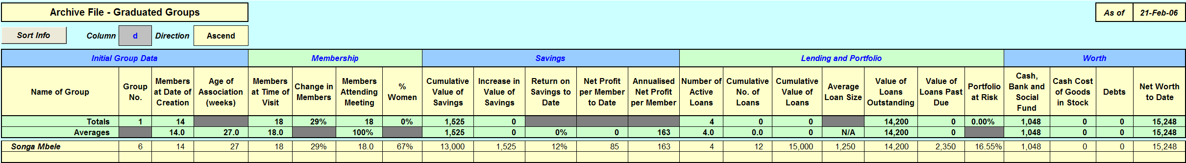

Part 4: Annexes
Annex 1: Constitution

Governance of the Association

I. BASIC INFORMATION ON THE ASSOCIATION
      - Name of the Association
      - Address:

      - The Association was formed on:
      - Date of registration:
II. OBJECTIVE OF THE ASSOCIATION
- The reason for the Association to exist is to

- The services the Association provides to its members in order to achieve this objective are:

III. WHO MAY BE A MEMBER OF THE ASSOCIATION?
- Upper age limit
- Lower age limit
- Gender
- Residence
- Common bond
- Running a business or not
- Reputation
IV. COMPOSITION OF THE MANAGEMENT COMMITTEE
- Chairperson
- Secretary
- Treasurer
- Money Counter 1
- Money Counter 2
V. ELECTION PROCEDURES
- The maximum number of terms any one person serve on the Management Committee are:
- Elections be held every:
- The minimum number of members who must be present to hold an election are:
- The election procedure will use a system of casting votes as follows:

- The minimum number of people that must stand for each position is:
- A member must be proposed by another member before being put forward for election

VI. REMOVAL OF OFFICERS FROM THEIR POSITION BETWEEN ELECTIONS
- Any member of the General Assembly can call for a vote of no confidence in a member of the Management Committee. If the vote is passed by a majority of the members the member must step down from the Management Committee and another member be elected to the same position.
VII. MEETINGS
- To mobilise savings the Association will meet every:
- To disburse loans the Association will meet every:
- The Association shares out its assets every:
VIII. MEMBERS LEAVING THE ASSOCIATION
- If a member leaves the Association because they have no alternative (such as if they marry and move away) the Association will calculate how much they must be paid using the following principle:

- If a person leaves the Association before the end of the cycle for no good reason, except their preference to leave, how will the Association will calculate how much they must be paid using the following principle

- If a person is expelled from the Association for failing to make regular savings deposits, the Association will calculate how much they must be paid using the following principle

- If a person is expelled from the Association for failing to repay a loan, the Association will calculate how much they must be paid using the following principle

IX. EXPULSION FROM THE ASSOCIATION
- The reasons for which a person should be expelled from the Association are:

X. DEATH OF A MEMBER
- If a member dies the Association will calculate how much money should be given to their heirs using the following principle:

XI. FINES
The following table lists the fines that can be charged for offences committed by members.
Schedule of Fines
Offence | Fine Amount
Non-attendance at a meeting for personal reasons
Late to meetings
Not memorising Association rules as required by the Chairperson
Failure to make minimum share/savings deposit
Chatting through the proceedings
Showing disrespect to Association officers or members of the General Assembly
Not remembering decisions and activities of the preceding meeting
Non-execution of role by a member of the Management Committee
Late deposit or loan reimbursement

- AMENDMENTS TO THE CONSTITUTION
  - The number of members who must agree before the constitution can be amended is:

  - The people who can propose an amendment to the Constitution are:

Services Offered by the Association
I. SAVINGS
- The value of a single share (which is the minimum amount that a member must contribute at each savings meeting) is: TShs

- The minimum amount that a member must contribute at each savings meeting is: TShs

- The maximum number of shares that a member can buy at each meeting is:

- Shares bought by a member to the Association must be recorded in the Savings Ledger and the Member Share Passbook by:

- When a member cannot meet the minimum share purchase requirements the following principle will apply

II. LENDING
- Those eligible to borrow are:

- The maximum amount that anyone can borrow is defined by the following principle:

- The maximum length of loan term (in weeks) is:
- The rate of interest will be charged every 4 weeks (month) is:
- When a member does not repay a loan the following principle will apply:
- A loan that is not repaid will be considered uncollectible after:
III. SOCIAL FUND
- The Social Fund will be kept
- The contribution to the Social Fund will be:
- It will be paid every:
- The types of emergencies for which will the Social Fund will pay out benefits are:

- The benefits for the death of a spouse will be:
- The benefits for the death of a child will be:
- The benefits for the death of a parent will be:
- The benefit for hospital costs, or doctors’ visits will be:
- The benefit for medicines will be:
- Other benefits will be:

Name: Signature:

Name: Signature:

Name: Signature:

Name: Signature:

Name: Signature:

Name: Signature:

Name: Signature:

Name: Signature:

Name: Signature:

Name: Signature:

Name: Signature:

Name: Signature:

Name: Signature:

Name: Signature:

Name: Signature:

Name: Signature:

Name: Signature:

Name: Signature:

Name: Signature:

Name: Signature:

Name: Signature:

Name: Signature:

Name: Signature:

Name: Signature:

Name: Signature:

Name: Signature:

Name: Signature:

Name: Signature:

Name: Signature:

Annex 2: Game Money

The Field Officer prepares enough of this money to enable each person in the Association to have TShs 5,000, made up of the following:

- 2 1,000 Shilling notes
- 4 500 Shilling notes
- 8 100 Shilling notes
- 4 50 Shilling Notes

1,000 Shillings

100 Shillings

100 Shillings

1,000 Shillings

500 Shillings

500 Shillings

50 Shillings

50 Shillings

Annex 3: Impact Evaluation

Impact evaluation should be considered at three levels:
- Association
- Household
- Individual
Impact measurement tools are built into routine project operations and focus on the measurement of financial change at the level of the Association. Portfolio performance data can be generated amongst Associations with whom projects maintain a training and supervision relationship, because otherwise additional staff will be needed to follow up graduated Associations. Using this approach the data gathering function can be carried out as part of routine visits by field staff to active Associations and is thus a Field Officer responsibility
Impact goes beyond the financial benefits derived from savings and the yield on those savings. It must also capture benefits derived from loans. In order to capture the totality of benefits from Association membership and to be sure that this translates into improved livelihood security it will be also be necessary to conduct surveys of individual households and individuals clustered in focus groups, with the focus groups being comprised of one complete Association, chosen randomly. These can be selected by capturing every 10th Association inducted into the programme during the first year, with a reduced rate of induction thereafter, leading to coverage of approximately 4-5% of the total client group over time. Follow-up should then be done annually at approximately the same time of year as the earlier interviews.
Table 20 on the following page is an evaluation framework. It looks at households and at individuals. At the household level there is a focus on income, assets, welfare and the profitable allocation of labour to new economic activities. At the level of the individual, by contrast, the issues are more in the social domain, taking into consideration improved control of decision-making and resources by women and improved social capital amongst all participants. Increased productivity of labour is also considered.
The following table summarises the types of research that VS&L programmes should conduct; who will do it; who will be interviewed; when the interviews will take place and what type of interviewing technique will be used.

Table 19: Research Matrix

What | Who | Sample | When | How
Area Survey | Field Officers and Project Manager | n/a | Start of project | Rolling baseline using household interviews
Impact Survey | Project Manager | 5% sample of VS&LAs | Mid term and end of project | Focus groups and individual household interviews
Satisfaction survey | Evaluation team | Random stratified sample | Mid term and end of project | Focus groups
Consolidated Association performance analysis | Field Officers and Data Capture Clerk | All Associations | Throughout project | Monthly data capture and analysis

The impact assessment approach is summarized in the chart below.

Table 20: Impact Assessment Matrix

Area of Inquiry | Hypotheses | Method of Measurement | Assumptions
Household | Participation in VS&L programme leads to:  - Increased household assets: goods and transport, savings  - Increased household welfare: housing, education, food, health  - Increased allocation of household labour to new income-generating activities | - Impact survey consists of determining the degree to which household and individual problems have been addressed by the VS&L programme  - Method is small (10-15 member) focus group discussions with sample of Associations and/or individual household interviews if budgets permit  - Sampling 10% of first year’s intake. 5% life-of-project intake.  - Control groups not required – use of subjective comparison approach in which members compare themselves to non-member families | - the economic environment is conducive to profitable micro-investment by participants  - the social environment is conducive to the formation and operation of Associations  - Female participation is not restricted  - That literacy and numeracy levels are adequate to permit the use of this methodology
Individual | - Increased control of resources by women, including enterprise resources, business and loan decision making and household decision making  - Increased self esteem and social capital  - No negative impacts on children’s labour  - Increased productivity of labour without negative consequences

Both the household and individual focus group discussions will take place at the same time with the same people. Both are a mixture of quantitative and qualitative data. This is a challenge for coding open-ended responses but is worth it.

Annex 4: Area Mapping

The purpose of area mapping is, primarily, to develop data on the following factors:

- Population density
- Level of economic activity
- Infrastructure, particularly accessibility to markets

Population density is a crude measure of market size, because a high population density means that many people can be reached at low cost and is also an indicator of market activity and higher levels of disposable income. This information should be available from secondary sources. If not from Government, then from other NGOs working in the area.

Levels of economic activity and household livelihood security. VS&L cannot work in a non-cash economy; nor does not work well in places where the levels of poverty are driving people towards dependency on emergency services. The higher the level of economic activity, the higher the level of disposable income and savings capacity and thus the level of household livelihood security. The evidence of economic activity is shown by:

- Local Economic Environment
- Frequency and size of local markets
- Widespread investment in cash crops
- Density of permanent small shops
- Household Livelihood security
- High density of primary schools and high enrolment rate
- Relatively good quality housing
- Provision of public, NGO and private health services and high general levels of health
- High asset levels of the family. These can comprise:
- Agricultural tools and buildings
- Savings in cash, stored grain and livestock
- Consumer durables such as furniture
- Productive non-farm fixed assets such as sewing machines, freezers, bicycles etc.
- Social capital
- Presence of active community groups, including NGOs and ROSCAs and high frequency of membership by household

Infrastructure.
- Density of good quality roads linking population centres to markets.
- Frequency of public transport facilities linking communities to markets and frequency of use by traders buying agricultural produce.

Existing Sources of Financial Services

There is no need to conduct this exercise in an over-complicated way: often common sense is a good guide to the potential viability of starting VS&L in a given environment

Table 20: Area Mapping Framework

Item | Category of Data Required | Specific Information | Type of Data | Means of collection | Who
Population Density | Density of population by Zone | - Government census data  - NGO studies  - University studies | - Quantitative | - Collection of secondary data through direct contact | - Project Manager
Levels of Economic Activity and Household Livelihood Security | Local economic environment | - Frequency and size of local markets  - Prevalence of cash crops  - Density of permanent small shops  - Prevalence of barter  - Inflation rate | - Quantitative  - Qualitative  - Qualitative  - Qualitative  - Quantitative | - Observation and mapping  - Observation and mapping  - Observation and mapping  - Observation  - Key informant discussion | - Field Officer  - Field Officer  - Field Officer  - Field Officer  - Project Manager
 | Household Livelihood Security | - Target group economic activities  - Density of primary schools  - Local Primary school enrolment rate  - Housing quality  - Health service provision  - General quality of health  - Household Assets  - Social capital | - Qualitative/descriptive  - Quantitative  - Quantitative (%)  - Qualitative  - Qualitative  - Qualitative  - Quantitative  - Qualitative | - Project data, focus group discussions research  - Government Education Statistics  - Focus group discussion  - Observation and mapping  - Focus group  - Focus group discussion questionnaire  - Focus group discussion  - Focus group discussion | - Field Officer  - Field Officer  - Field Officer  - Field Officer  - Field Officer  - Field Officer  - Field Officer
Infrastructure | Road quality and provision plus use | - Road provision in target zone  - Road quality by type  - Public transport facilities  - Frequency of visits by traders to markets | - Quantitative  - Qualitative  - Qualitative/Quantitative  - Qualitative/Quantitative | - Mapping  - Observation  - Focus group discussion  - Focus group discussion | - Project Manager  - Field Officer  - Field Officer  - Field Officer
Inventory of Services | Financial Services | - NGO credit programmes  - MFIs and banks  - Traditional systems of savings and credit | - Qualitative/descriptive | - Secondary data  - Visits to institutions  - Primary data, secondary data | - Project manager  - Project manager  - Project Manager and Field Officers

Annex 5: Payout for Member Leaving the Programme in Mid-Cycle

Members leaving the programme for reasons beyond their control will, normally, be entitled to receive the following:

- Total value of their share. This is calculated by taking the total value of cash, loans outstanding and total value of assets purchased. They may not receive reimbursement of their contribution to the Social Fund.

The means of calculation is as follows:

(Total cash in cash-box/pouch + Total value of loans outstanding + Total value of assets purchased) / number of members

Thus a case might be as follows:

An Association has a member who is leaving to get married. The following are the data.

- Number of Members 10
- Cash in the cashbox at the beginning of the meeting TShs 54,000
- Total value of loans outstanding TShs 478,500
- Cost of grain bought and stored by Association TShs 50,000
- Debts owed by the group TShs 5,000

Total payout to departing member = TShs (54,000+478,500+50,000-5,000)/10

= TShs 57,700

The 57,700 is paid, less any debts owed by the member to the group, such as the balance of any loan principal outstanding

Annex 6: Efficiency Norms and Benchmarks

The table below provides guidance on issues of efficiency. The workshop held in Nairobi between 16 – 19th February 2004 selected the following indicators and benchmarks towards which the VS&L projects should strive. They are pitched approximately half way between the efficiency of Niger and Zimbabwe.
Programme managers need to use these measures with discretion. Programmes operating in remote rural areas where clients are hard to reach and economic opportunities for client investments may be few will not have as good a record as programmes operating in economically advanced high-density peri-urban settlements.
Table 21: Efficiency Benchmarks
Efficiency Measures | 18 months | 36 months | 5 years
Clients per Field Officer | 250 | 400 | 500 -1,000
Return on total savings | 40% | 50% | 60%
Clients graduated per year/Field Officer | 200 | 350 | 500 -1,000
Cost/Client | $100-125 | $40-60 | $15-40
Field Officers to Total Staff | 50% | 60% | 65%
Average Length of supervision period | 15 | 14 | 12
Drop out rate (Associations ceasing to operate) | 2% | 4% | 6%

Note: the degree to which efficiency is achieved depends on a number of factors:
- Frequency of meetings
- Whether or not groups are clustered for meetings
- Use of local BDS providers/village agents (usually paid by the groups)

Using BDS providers and clustering enables caseload efficiencies to rise to above 750 clients per Field Officer. Further increases are possible if meetings are less frequent than weekly. It is, however, important not to exceed about 800 clients per Field Officer if Association quality is to be assured.

16 mm Ø with 8 mm pin
35 mm
110 mm
30 mm
65 mm
6 mm
11 mm Ø hole
225 mm Internal Width
Lid displaced upwards, leaving 1.0 mm gap from bottom rim, to be sure that lid opens easily. Lid is 1.0 mm longer and 1.0 mm wider than base to prevent jamming

Note rounded corners to lockplates
Annex 7: Drawings of Typical Cash Box
10 mm Ø m.s roundbar
End Elevation
18-19 mm Ø with 10 mm handle

A ROSCA is a self-selected informal group of people who contribute equal amounts of money on a regular basis. At each meeting, after the contributions have been made, the money is allocated to a single member, either through drawing lots or according to a schedule agreed at the start of the cycle. The money is not repaid.
Usually between 8 – 12 months.
At the time of writing (February 2006) the confirmed numbers of participants in Africa alone stood at 506,800. This is comprised as follows: Niger 182,000, Benin 121,000, Zimbabwe 62,000, Tanzania 35,000, Rwanda 17,300 Mozambique 15,000, Mali 15,000, Ethiopia 12,000, Uganda 10,400, Malawi 9,000, Kenya 6,000, Afghanistan 5,800, Angola 4,000, Eritrea 4,000, Zanzibar 4,000, Lesotho/South Africa 3,000, Sierra Leone 1,300. CARE also has a programme in Burundi, but client numbers are not available. A further 333,000 are in CARE India’s CASHE project. With continuing growth since these figures were generated in 2005 it is reasonable to assume that in total VS&L participants are about 865,000.
There is a history of spontaneous ASCA development in coastal West Africa, from Ghana to Senegal as well as in South Africa through Stokvels and in Ethiopia, through some urban Iddirs.
On average, two years after the completion of training and starting to operate independently, 96% of groups remain in operation.
Self-help groups in India have over 20 million participants, completely dwarfing the better-known programmes of Grameen and BRAC (Bangladesh). They differ from VS&LAs in Africa because it is intended from the start that they should be linked to credit from formal sector banks (assisted by NABARD to promote SHG linkages), which capitalise a loan portfolio that is managed by the group. African VS&LAs, by contrast, are not usually linked to the financial markets because they tend to operate in rural areas of Africa where banks are few and far between. Such groups are entirely responsible for mobilising their own loan capital from member savings.
In Tanzania CARE is using a common VS&L methodology in 8 different projects. In some cases the VS&L activity is stand-alone and in others it is integrated into projects that may deal with apparently unrelated problems, such as HIV/AIDS. The main distinguishing characteristic of CARE Tanzania’s VS&L methodology is that members do not save, as such, but buy shares. They may buy as many or as few shares at each meeting as they wish and share their assets at the end of the operating cycle on the basis of individual shareholding. The system works very well indeed and, in addition, CARE Tanzania has successfully used village-based trainers to increase project efficiency. CARE Zimbabwe promotes monthly meetings and clustering of groups for supervision. As a result both CARE Tanzania and CARE Zimbabwe have Field Officer case-loads in the range of 500-1,000 clients. There are pros and cons to both approaches, but each is worth studying.
DFID 1999
This has proven to be a contentious issue. Many programme designers have achieved quick success in setting up independent VS&LAs and then seek to enlarge on that success by linking them to the formal sector. This is commonly the case in India. It is not necessarily a bad thing to do this, but it is important, first and foremost, to set up autonomous VS&LAs, so that if linkages to formal sector lenders prove to be problematic, the VS&LAs can fall back on their own inherent strength. If a programme decides to create linkages to the formal sector it must expect this to be an arduous task, requiring a lot of extra investment per participant. It is only practical where there is political will and material commitment at the highest levels of Government (and financial institutions), supporting the creation of financial infrastructure eager to engage with the poor. VS&LAs’ most precious asset is their independence and the self-confidence that comes from achievement on their own terms. It should not be compromised, except for sure and substantial benefit.
It is important to understand that the purpose of the cash box/pouch is not primarily to reduce the risk of theft by outsiders. It is to ensure that cash transactions and the process of record keeping can only be carried out in group meetings and to reduce the risk of misuse of funds by the Treasurer. To limit the risk of theft by outsiders in insecure areas, a heavy duty canvas pouch that is easily concealed can be used instead of a large metal cash box.
Refers to such things as buying and storing a few bags of maize or sugar for later sale, or buying a stock of wool that members can access for the individual knitting activities. It does not refer to a group-managed economic activity that dominates the whole work of the group. Generally it is not a good idea to encourage group-managed economic activities because they are prone to failure and are a common cause of dispute.
It is increasingly common that children orphaned by AIDS form VS&L Associations in Zimbabwe, usually mentored by a member of another VS&LA.
Africa-wide experience indicates that a group that is larger than 25 members tends to be less cohesive than those with fewer members. When groups are large, meetings can take a long time and the work of the Management Committee is onerous. Having said this it is also the case that very small groups are expensive to train and expensive to visit. Larger groups are to be found in settled communities where people live in villages. Smaller groups are often necessary in very low population density areas or where the level of trust (as in refugee camps or urban slums) may be low. Taken by and large, it is desirable to aim for groups of not less than 10 members and not more than 25.
Weekly meetings require a great deal of the participants’ time, but enable them easily to accumulate the small amount of savings required. Monthly meetings require much less of the participants’ time (leading to better attendance at meetings), but it is often difficult to accumulate the larger amount of money that infrequent meetings demand (4 times as much for a monthly meeting as for a weekly meeting). Two weeks between meetings is a common compromise, and groups that start out meeting weekly will often reduce the frequency of meetings to once every two weeks, after the first cycle. In general, monthly meetings are common in low-density rural areas and urban slums (where time is money). Weekly and fortnightly meetings are common in medium to high density rural and peri-urban areas.
Usually groups decide to end their cycle close to a major religious holiday such as Christmas or Id il Fitr and this may mean that the first cycle is quite short if the training took place long after these festivals. But subsequent cycles are usually for a year. Groups are not obliged to liquidate all or part of their funds at the end of the cycle, but it is recommended strongly that they do so for at least two cycles. This is because liquidation avoids the risk of a large unused surplus of funds accumulating that may be at risk of theft and that may need complex record keeping to manage. It also increases group enthusiasm and motivation..
One-month loan terms will limit the types of activities in which members can invest. In places where economic activities revolve around agriculture, longer loan terms may be needed (up to 6 months). In subsequent cycles groups may allow longer-term loans, but it is not advisable for these to exceed 6 months because this will tie up capital that other members may want to borrow.
In Sierra Leone, traditional ASCAs often do not allow their members to borrow more than they have saved, but because interest earnings increase the value of the fund, and because not all members want to borrow to their full entitlement, it means that a large percentage of the funds available for lending lie idle. By allowing members to borrow more than they have saved, a higher percentage of funds will be put to use – and thus will earn more interest. This also increases the efficiency of the rural financial system, allowing funds that are in excess in the local economy to be productively invested. It also increases risk and needs increased vigilance and discipline.
$US 0.40 to $US 0.45. A typical weekly contribution in Africa will be about $US 0.35, but can be as little as $0.10 and as much as $2. In the first cycle groups are often very cautious about setting a high level of contributions. They want to see if the system will work and they want to be sure that they can easily maintain their contributions without difficulty. It is usually the case that after the first cycle groups become sure that the system works and they can easily maintain their individual contributions. They are also anxious to increase the level of share purchase so as to increase their returns and usually increase the minimum contribution level.
In the formal banking system no one is forced to save, and everyone is free to save according to his or her means. This should be a goal of VS&L programmes: allowing people to save whatever they can, as often as they are able. To start with groups may be reluctant to allow variable share purchase, and want to stick to saving the same amount but de facto variable share purchase takes place as some people fail to make the minimum contribution. Programmes must accommodate this reality: not fight it. Conformity, in this case, serves no purpose and inhibits the optimal growth of group capital for lending.
Zimbabwe is the only country using the VS&L methodology in Africa, where monthly meetings, in which savings and credit are carried out simultaneously, are the norm for all groups. The Zimbabwe programme, Kupfuma Ishungu, operates in low-density rural areas where the distances needed to walk to meetings are quite large and investment opportunities constrained. Monthly meetings are common in Sierra Leone amongst traditional VS&LAs, and in the urban areas of Luanda and Nairobi.
The confirmed numbers of members, by CARE country are: CountryClientsCountryClientsIndia333,000Uganda10,400Niger182,000Malawi9,000Benin121,000Kenya6,000Zimbabwe62,000Afghanistan5,800Tanzania35,000Zanzibar4,000Rwanda17,300Angola4,000Mali15,000Eritrea4,000Mozambique15,000Lesotho/South Africa3,000Ethiopia12,000Sierra Leone1,300Sri Lanka11,400Estimated Total February 2006874,200In addition there are an unknown number of clients in Burundi, Guatemala and Honduras
In this section the words ‘group’ and Association’ are both used, but they are not interchangeable. When the word ‘group’ is used it refers to a number of people who have associated themselves for a common purpose that may or may not have anything to do with savings and lending. Where the word ‘Association’ is used it refers to a group that has formed for the principal purpose of implementing a programme of Savings and Lending.
The first phase is in fact the preliminary meetings phase. The operational phases that follow are an additional three, listed in this manual as phases 2,3 and 4. For the purposes of explanation the phases subsequent to the preliminary meeting are here referred to as phases 1,2 and 3.
This will not be true of Village Agents who may be drawn from the Community (at a later stage)
It is vital that Field Officers avoid using words such as ‘literate’ or ‘illiterate’. This may humiliate the participants and make them feel that they are somehow inferior to other groups if they cannot keep written records. It is important to present the choice in a value-neutral fashion.
This must be handled with care, because the Field Officer does not want to discourage participation. The purpose of raising the issue is to hand over to the group, at an early stage, the responsibility for making and enforcing their own rules. If there is strong resistance to this notion the Field Officer may need to defer the question to Module 3.
The Field Officer should be very careful not to encourage most types of group-managed income generating activities because they are usually unsuccessful and cause disagreement. If the group wants to do this they should choose something that does not call on them regularly to spend time in the activity. Thus, for example, storing a few bags of grain waiting for the price to increase is fairly safe, but running a shop or livestock rearing, both of which need constant attention, are not advisable.
Throughout the document Tanzania Shillings (TShs) are used in all examples. In countries other than Tanzania the Field Officer should ensure that local currency equivalents in appropriate amounts are used. The rate of exchange at the time of writing in January 2006 was TShs 1,100 = $US 1
(S)he should also emphasise that having too many members from one family in an Association can lead to problems, because they may start to dominate it and not be objective in enforcing the by-laws against a family member. The Field Officer points out that if they do this they must be sure to be able to make the regular contributions to the Association.
When this happens, some people join more than one Association, but it is inefficient, because it takes up more of their time.
In Bushenyi, in Uganda, where VS&LAs have been operating independently for twenty years, loan terms can be as long as 12 months. This occurs as groups accumulate capital over time.
In Sierra Leone it is common to limit the amount a person can borrow to the amount that (s)he has saved. Because not everyone will want to borrow and not everyone who borrows will go to this limit, this means that a large percentage of the Association’s funds will not be used and will, therefore, not earn interest.
In economies suffering from hyperinflation, such as Zimbabwe, the interest charged is usually not less than 20% a month. Allowing for normal rates of loan fund utilisation, this will yield not less than 150%, which is far higher than rates paid by commercial banks. The point is, that local economic conditions will influence interest rates and yields and that VS&L systems always provide much higher returns than formal sector alternatives. Banks in Zimbabwe, for example, pay only 5% on deposits and charge 450% to borrow. They have, quite literally, a licence to print money.
A common strategy is for the Treasurer to rotate the responsibility for looking after the box amongst members. This is usually effective and highly informal
It is not necessary that the Association is charged the full value of the kit, but at least the cost of the items that need renewal. It is important that the Associations start out by recognising that self-reliance begins with paying for what they are provided with. It is also important that the kits are put together by the programme and not by the Associations, who are likely to buy the cheapest equipment of inadequate quality. Programme implementers need to help the Associations standardise, informing them of the places where the equipment may be obtained so that they can replace worn out or used up items.
In urban areas, where there is a higher level of crime than in most rural areas, it is generally the case that people prefer to use a canvas pouch, or make use of a local bank,. It is also the case that when balances in the cash box/pouch build up to high levels, some Associations in rural areas open bank accounts in the nearest town to store the surplus.
See page 99 for an example of how the share-out is calculated.
Note that if there are other Funds, such as an Education Fund or Orphans welfare fund these would also show up on the Statement of Association Worth.
This is repeated, since it has already been mentioned during the Statement of Association Worth.
This is at the discretion of the members. Some prefer it if they keep their Share Pass Books themselves so as to sure they have a record of their contributions stored separately from the Association’s records. Other prefer to keep the Share Pass Books in the lock-box to avoid the risk of the Share Pass Book getting lost or being damaged.
Use local currency equivalents in values that represent popular denominations, ensuring that the note equivalent to TShs 500 is the value of one share.
This has been done successfully by CARE in Niger, Tanzania and Mozambique. In most cases Community Volunteers receive transport and per diem support but for the long-term this calls for the groups themselves to be willing to pay for the service. The results to date are encouraging and gets round the problem of high-cost, long-term supervision.
It is common in VS&L projects that Field Officer supervision of group records is inadequate and that, often, meeting procedures are not carefully followed. Programme managers need to be aware of this and insist on careful monitoring of group performance by supervisors.
This is likely to have been discussed at different points throughout the cycle. Associations may decide to buy group assets such as cattle, or a large store of grain for later re-sale. It is not the job of the Field Officer to demand that the Association shares out its assets, but to advise them as they make their decisions as to what to do with their fund. It has, for example, been shown that Associations do well when they trade in commodities that have low risks (i.e. do not rot in storage, or not easily subject to disease – such as cattle and goats). Associations do not have a good track record when they engage in complex enterprise activities, such as running a production enterprise.
It is unfair to the other members if the delinquent member pays up at the last meeting in order to obtain an equal share of the Association’s assets at the time of Share-out/Action Audit. Their money has not been available to lend and has therefore done no work. But to work this out will be too complex for the group. They might consider a special fine that deters this sort of behaviour, but this must be written in their Constitution.
Note that it is not important to collect data from every group on a monthly basis. This is not practical because many groups will be visited less frequently, especially as they enter the Maturity stage of the Supervision phase. Data can be collected less frequently because the operating principle of this tool is to compare group performance by annualising key data, especially with respect to individual earnings and percentage yields on savings. Wherever possible, however, it is a good idea to collect data that was generated at a certain date and to do so quarterly. Thus, a programme may decide to collect data valid as of March 31st, and even though the actual visit to an Association is made maybe a month or two later, data can be collected as of March 31st. This is particularly useful in the case of programmes operating in hyper-inflationary environments.
CARE, CRS, Oxfam USA, Pact and Plan International.

